**Data Structures** are different ways of organizing data on your computer, that can be used effectively.

**Algorithms –** set of steps to accomplish a task. In CS, it’s a set of rules for a computer program to accomplish a task.

What makes a good algorithm?

* Correctness
* Efficiency

**Types of Data Structures**

1. Primitive data structures – built in the programming language itself and are available to the programmer e.g. integer, float, character, string, and Boolean
2. Non-primitive data structures – user defined data structures, combine two or more data structures divided into:

Linear data structure – data items are arranged in memory in a linear sequential manner and can be static or dynamic. Static linear DS – structured associated memory locations are fixed in the runtime but in dynamic linear DS memory locations change.

Non-linear DS – data item is connected to several other data items.

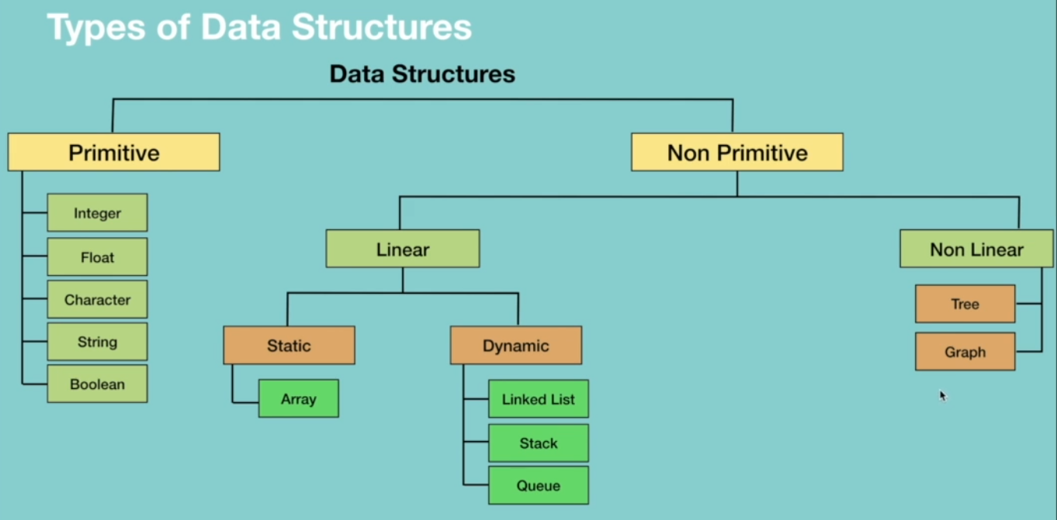



**Types of Algorithms**

They are classified either based on the type of problem they are trying to solve or based on the problem-solving technique.

They include:

* Simple recursive algorithms
* Divide and conquer algorithms
* Dynamic programming algorithms
* Greedy algorithms
* Brute force algorithms
* Randomized algorithms

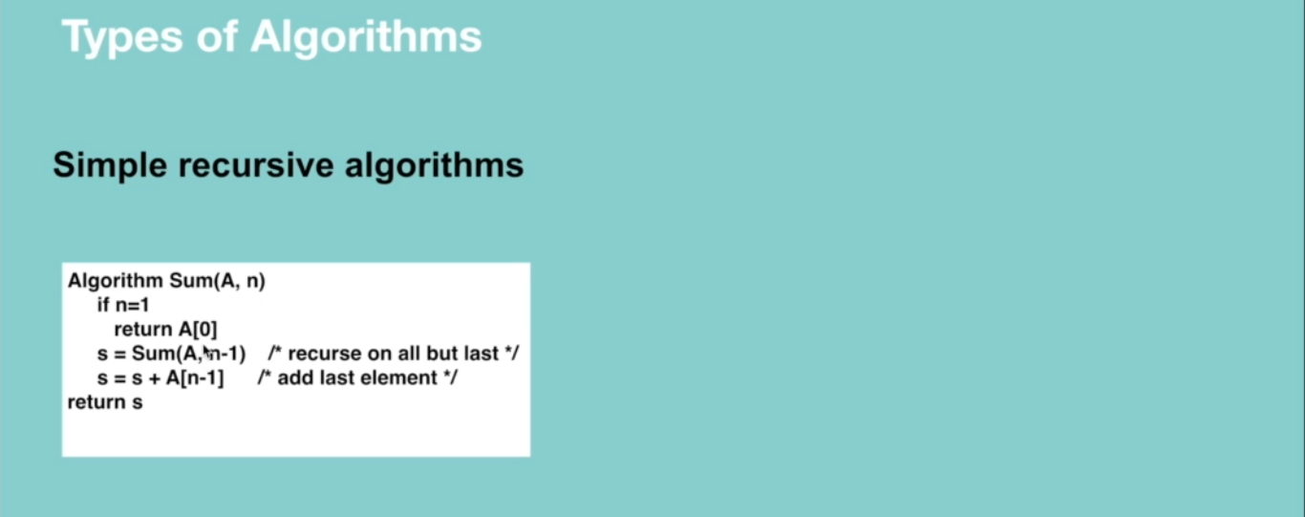

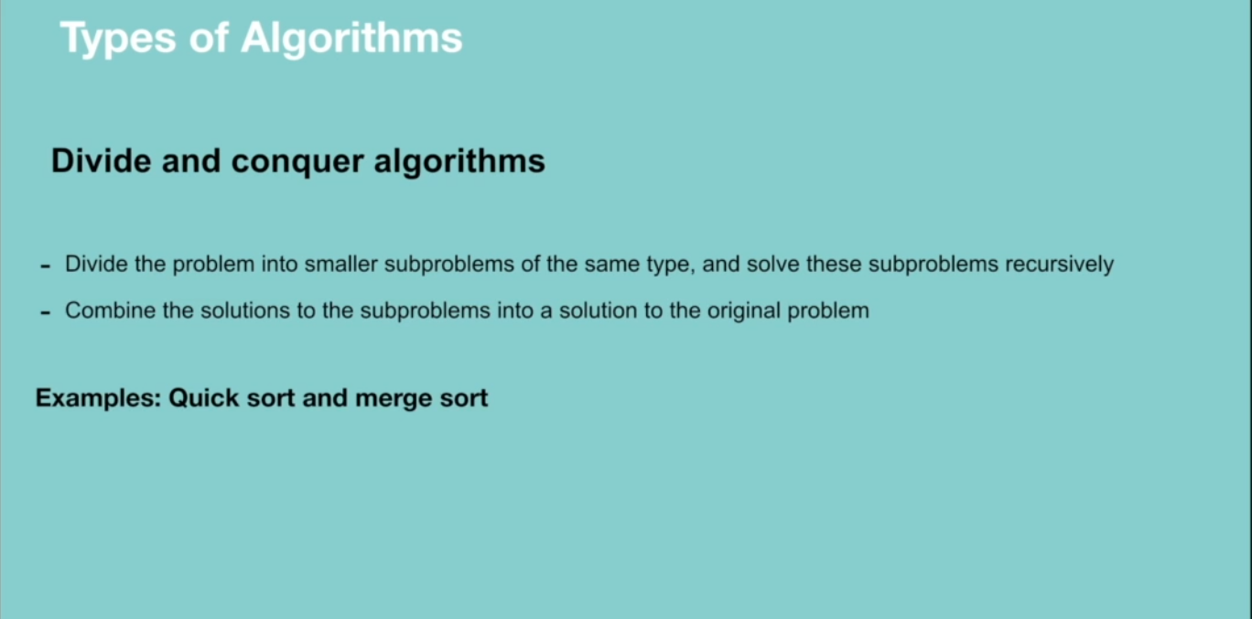

Dynamic programming works on memoization which means the algorithm remembers the past results and use them to find new results. It’s generally used for optimization problems i.e. to find the best solution among multiple solutions.

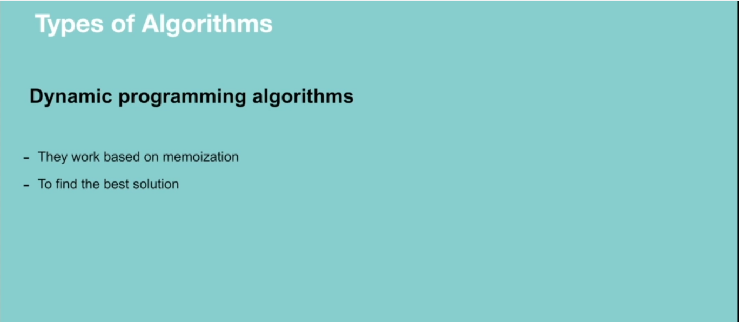

Greedy algorithm works in phases. It’s also used for finding the best solution i.e. optimization problems.

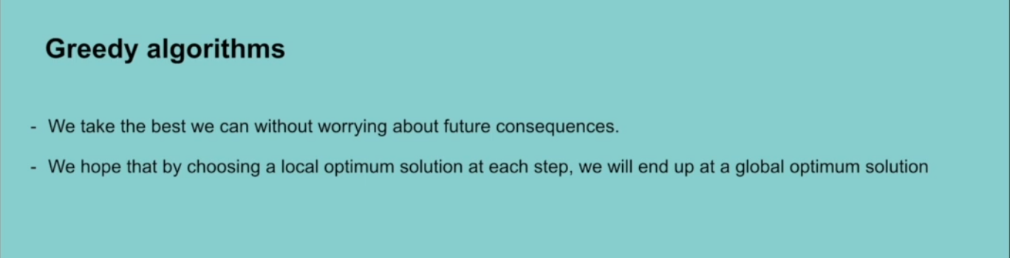

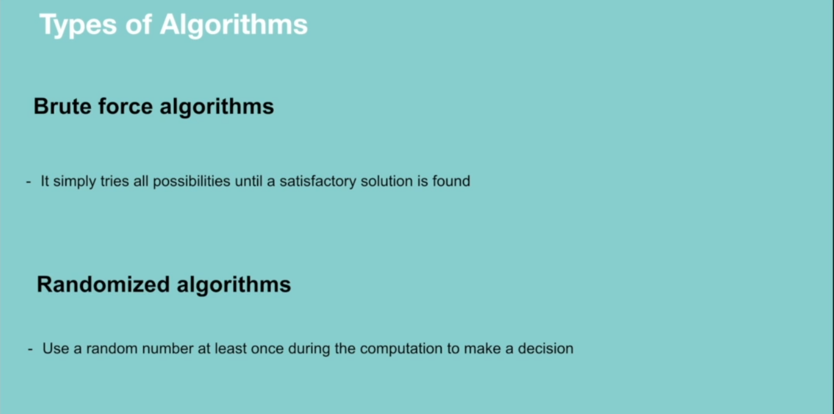

**RECURSION**

A way of solving a problem by having a function calling itself.

**Properties of recursion**

* Performing the same operation multiple times with different inputs.
* In every step we try smaller inputs to make the problem smaller.
* A base condition is needed to stop the recursion.

**Why Recursion?**

* Recursive thinking is really important in programming and it helps you break down big problems into smaller ones and easier to use. Note: There are situations when iterations perform better than recursion.

When to choose recursion – when you can divide the problem into similar subproblems. The subproblem must be similar otherwise recursion is not a choice.

**How do you know that the subproblem is similar in nature?**

* Design an algorithm to compute nth…
* Write code to list the n…
* Implement a method to compute all.

**Why Recursion**

* The prominent usage of recursion in data structures like trees and graphs.
* Many big companies ask questions in relation to recursion in the interviews.
* It is used in many algorithms (divide and conquer, greedy and dynamic programming)

**How Recursion works**

When designing a recursive call, we have to consider two conditions:

* A condition where a method calls itself with similar values.
* A condition to exit from the infinite loop.

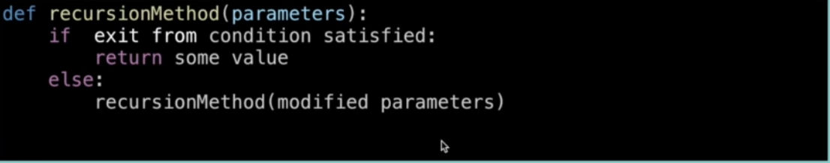

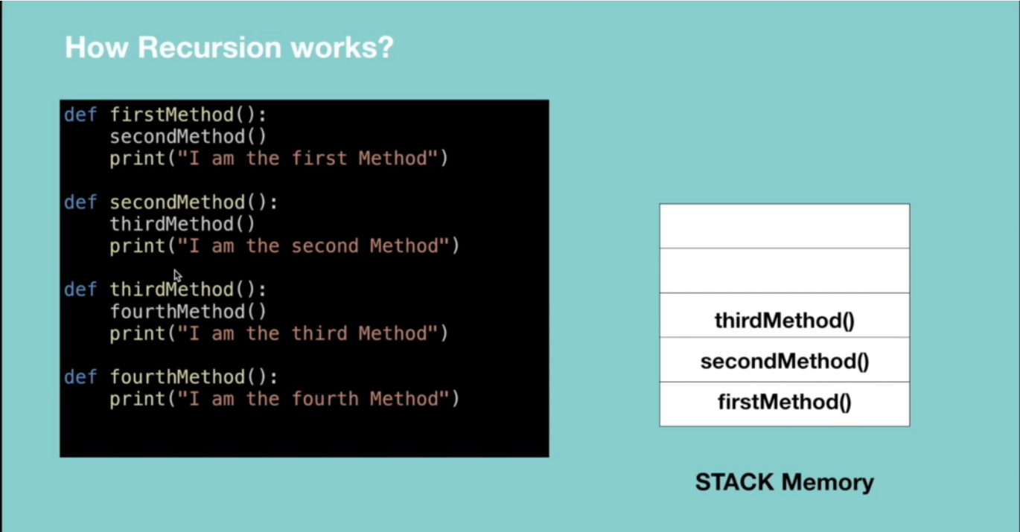

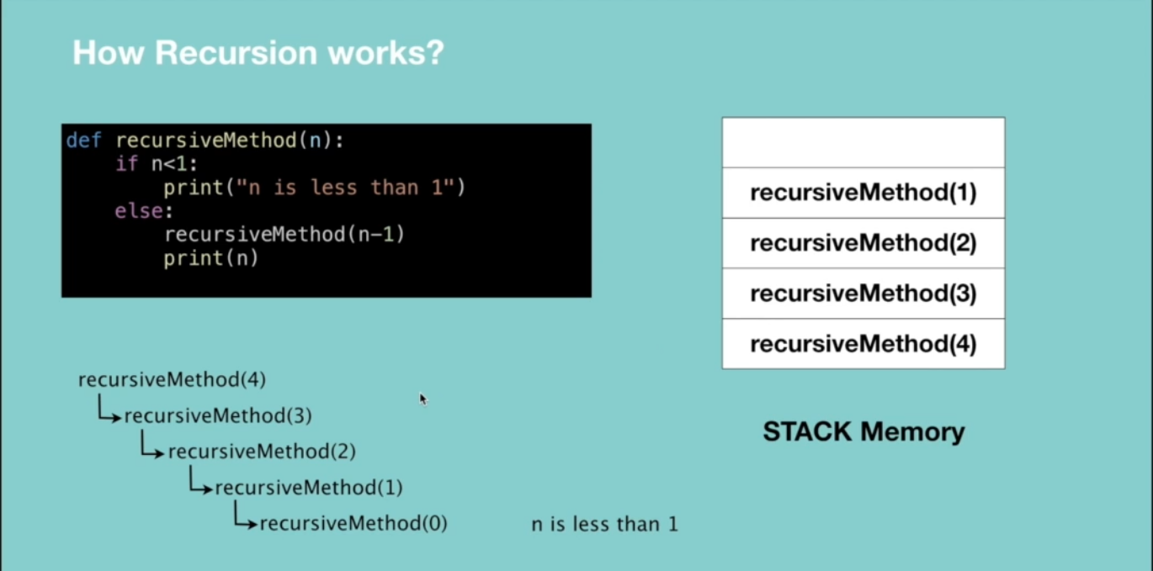

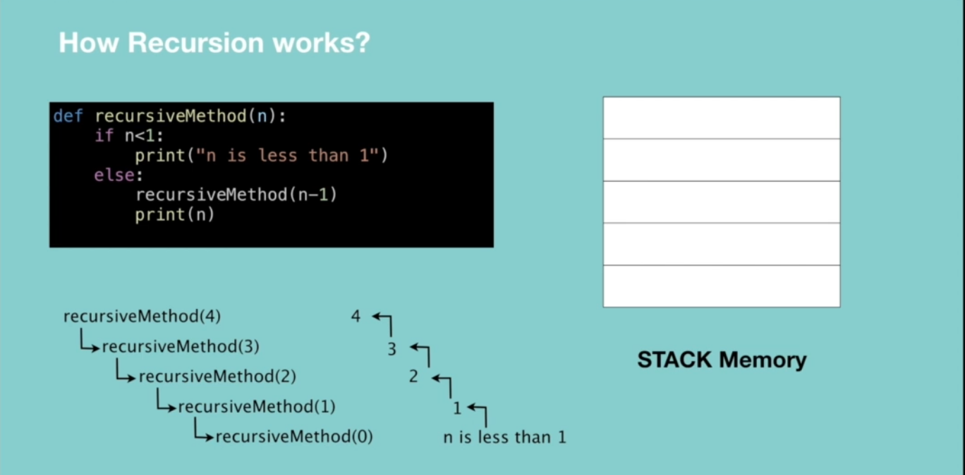

**Recursive vs Iterative solutions.**

All recursive methods can be implemented iteratively.

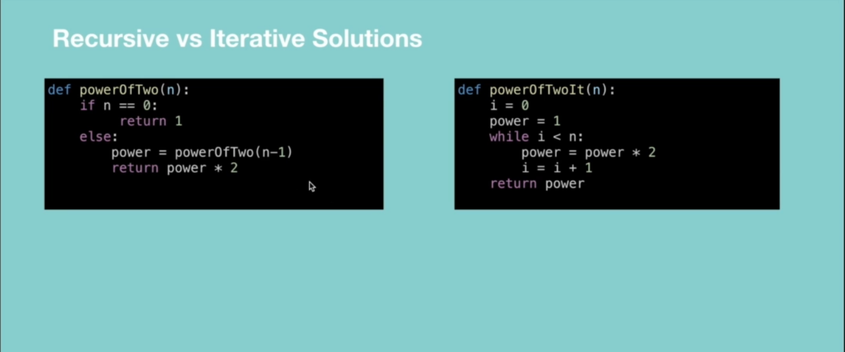

* In recursion, a conditional statement determines the termination of the function while in iterative solutions a controlled variable value decides the termination.
* In recursion, infinite recursion can lead to a system crash while infinite iterations consume CPU cycles.
* Recursion repeatedly invokes the mechanism consequently overhead of method calls, this is expensive in both processor time and memory space while iteration does not.
* Recursive algorithm can be very space inefficient. i.e. if your algorithm resources to the depth of N, it uses at least O(N) memory hence it’s better to implement recursive algorithm iteratively.

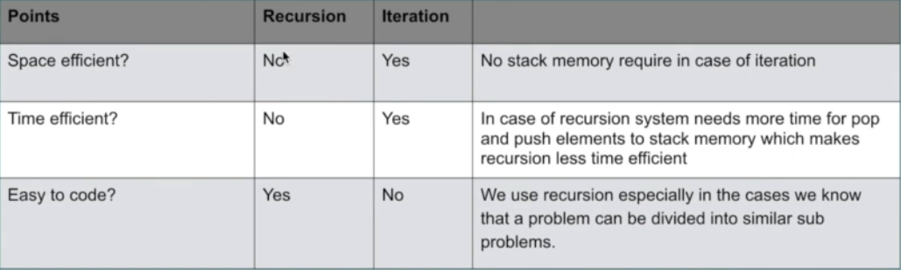

**When to Use/Avoid Recursion?**

**When to use it?**

* When we use memoization in recursion – this reduces the time complexity.
* When we can easily breakdown a problem into similar subproblem
* When we are fine with extra overhead (both time and space) that comes with it. Note when you are developing a mobile app which should run on low memory devices, then here recursion is not advisable. If you’re designing a critical system like an airbag in the car, don’t use recursion.
* When we need a quick working solution instead of efficient one e.g. factorial and Fibonacci numbers.
* When traverse a tree

**When avoid it?**

* If time and space complexity matter for us.
* Recursion uses more memory. If we use embedded memory. For example, an application that takes more memory in the phone is not efficient.
* Recursion can be slow.

**How to write recursion in 3 steps**

Factorial => the product of all positive integers less than or equal to n.

**Step 1: Recursive case – the flow**

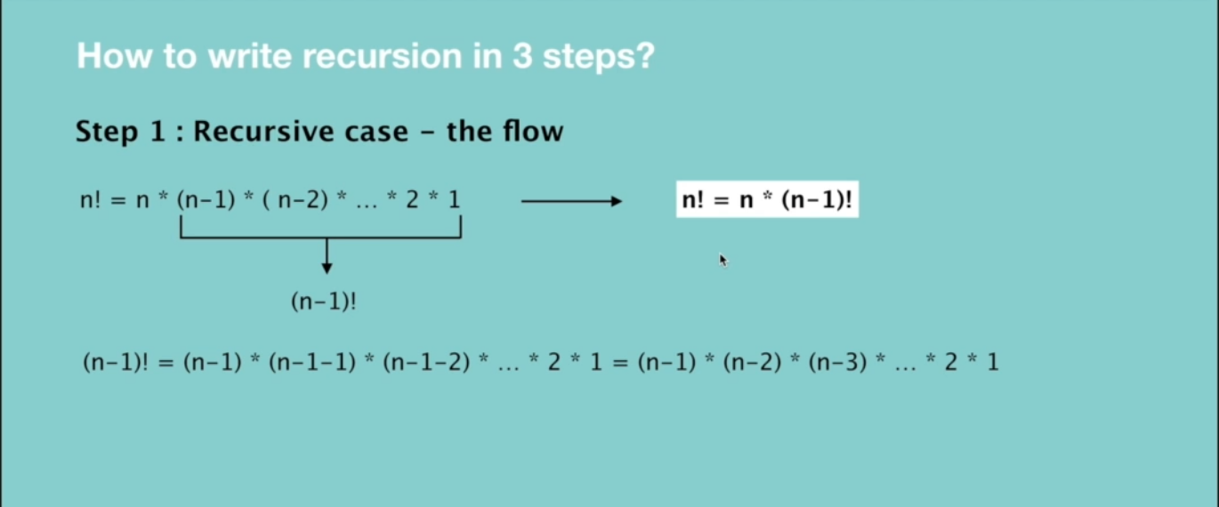

**Step 2: Base case – the stopping criteria**

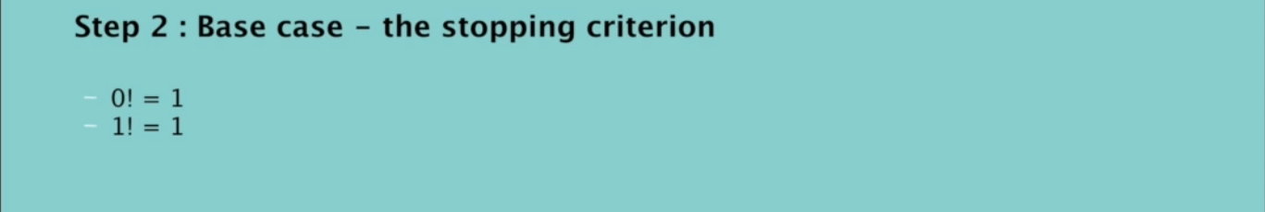

**Step 3: Unintentional case - the constraint**

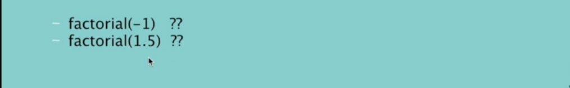

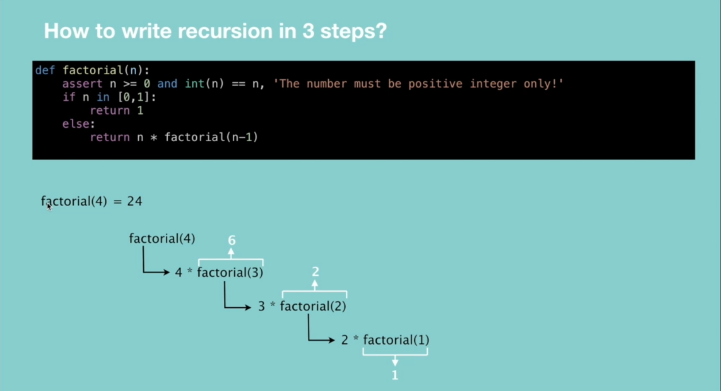

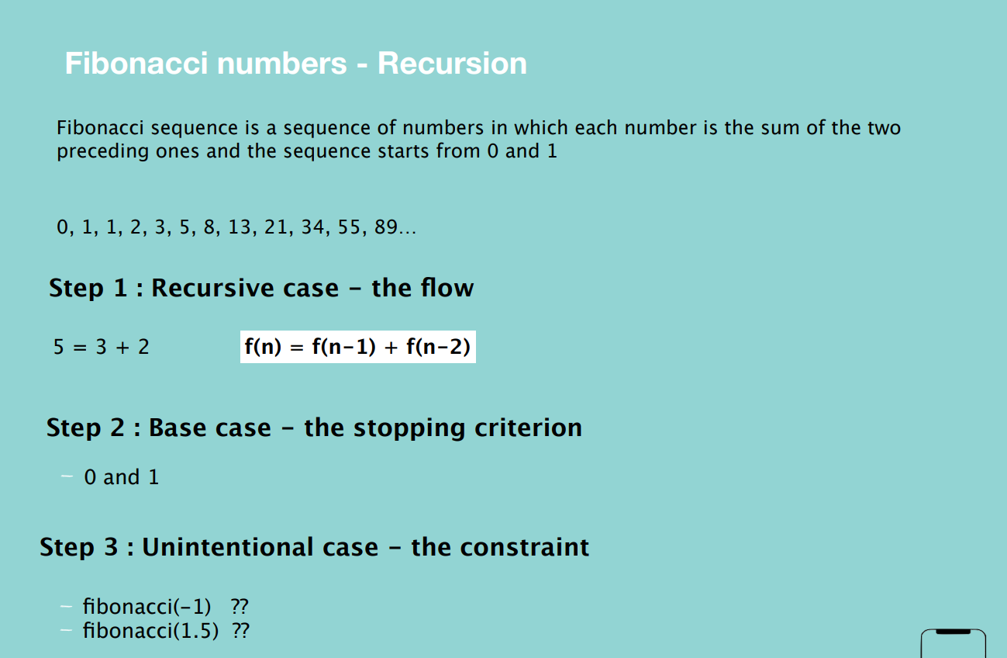

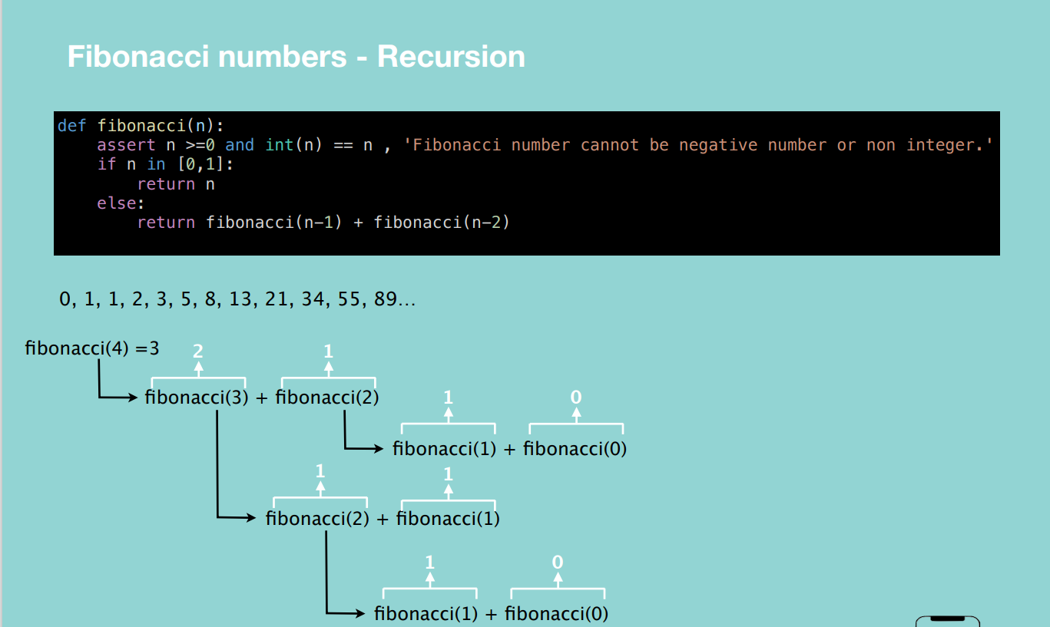

**Interview Questions**

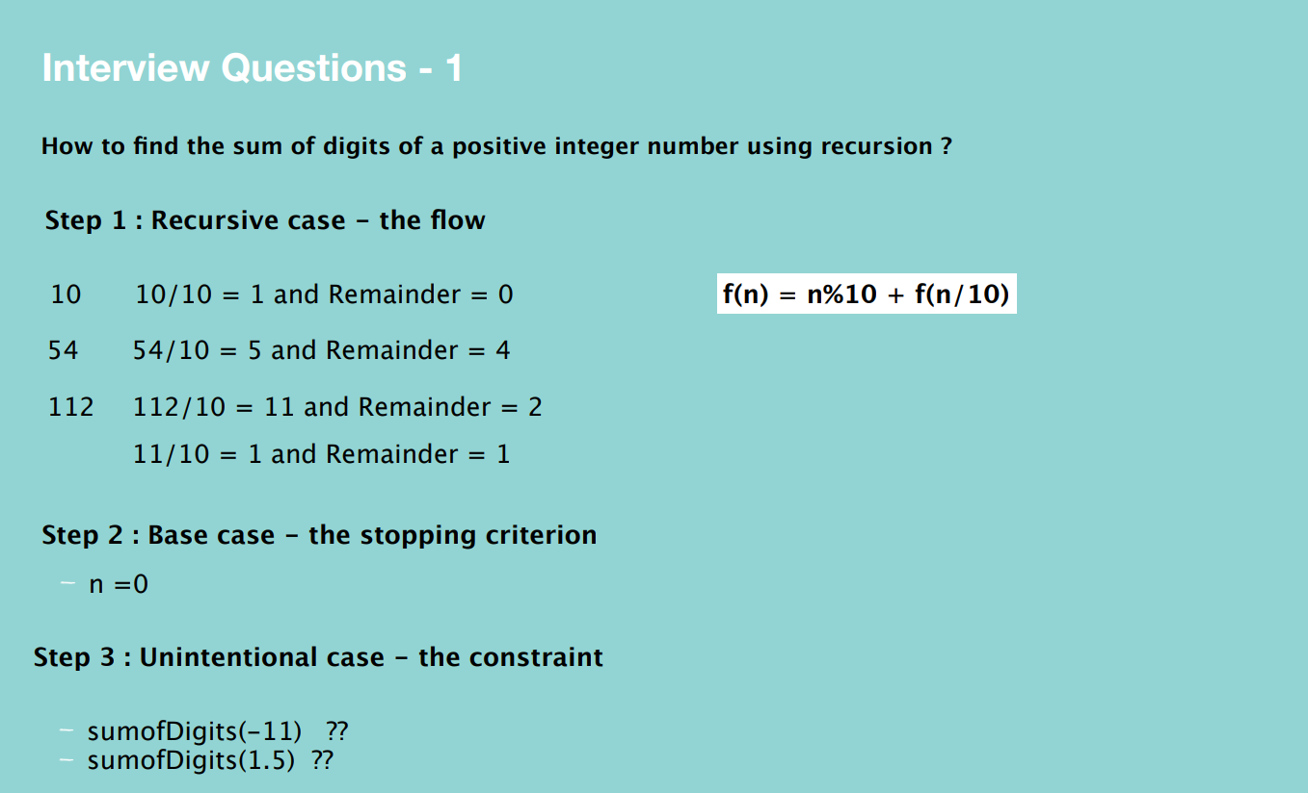

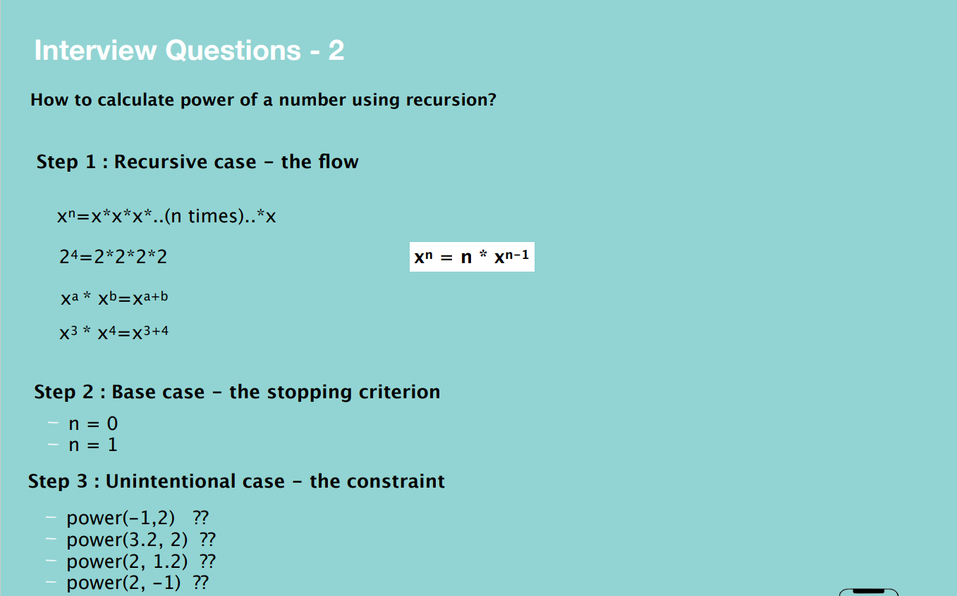

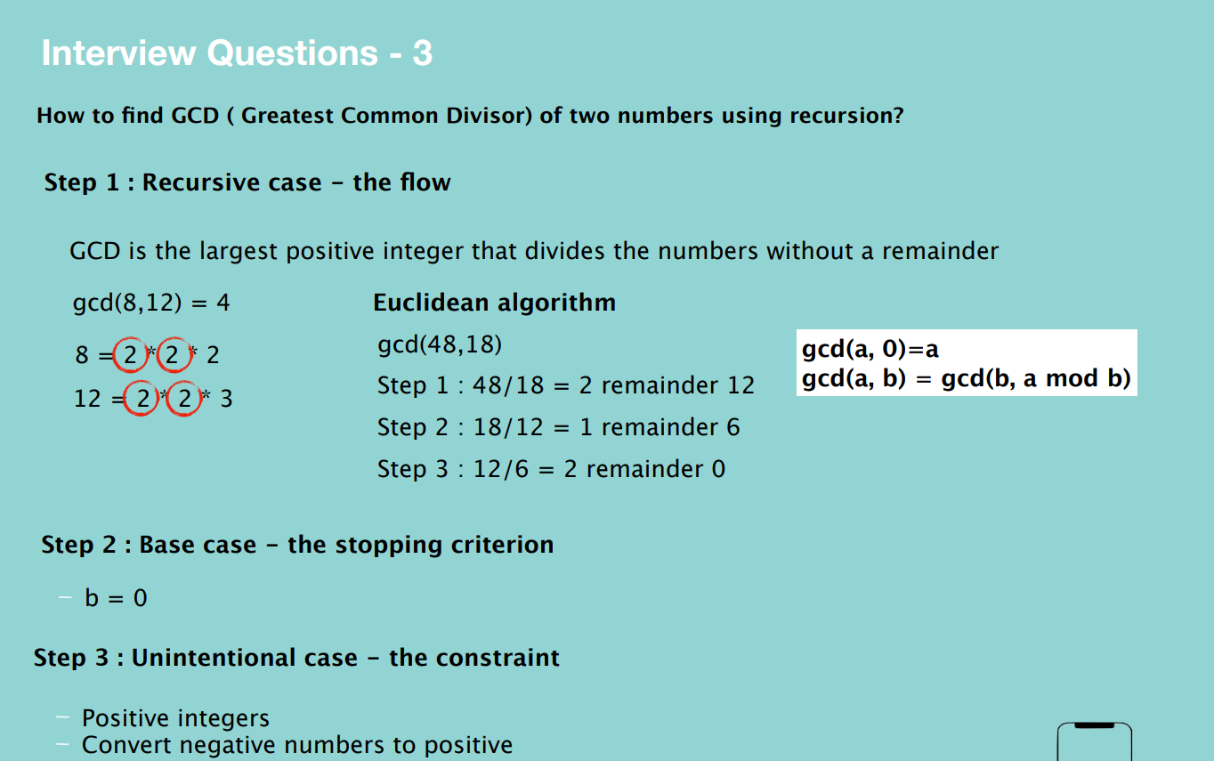

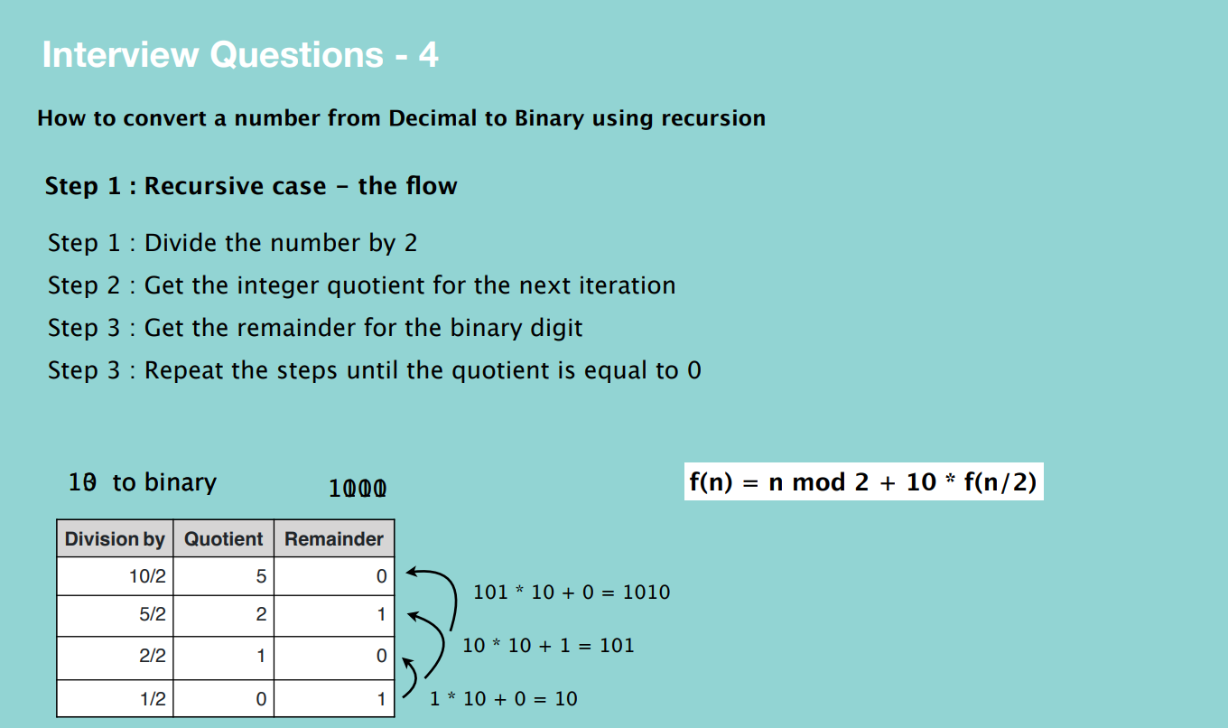

**BIG O**

Big O is the language and metric we use to describe the efficiency of algorithms.

**Time complexity –** shows how the runtime of a function increases as the size of input increases.

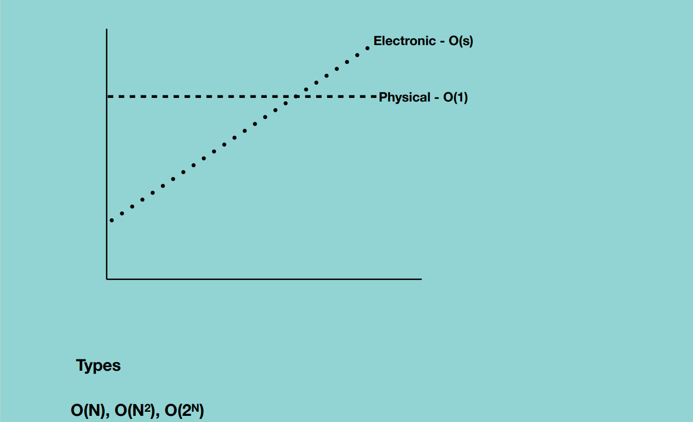

**Big O Notations**

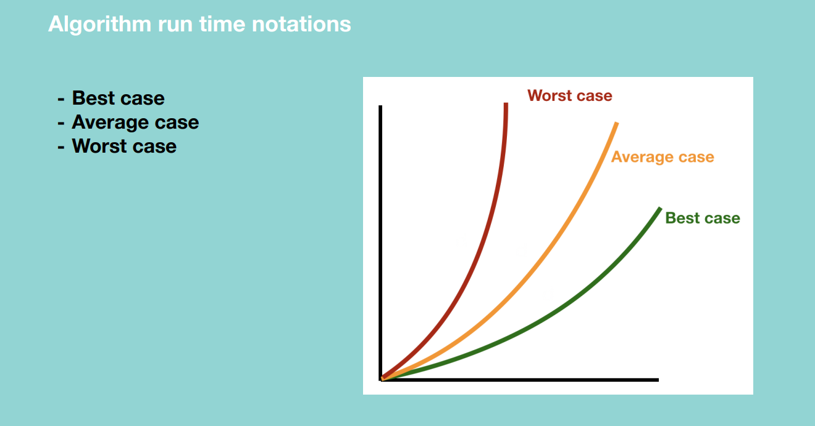

**Quick Sort Algorithm –** Best case, all numbers are equal and we pass through the numbers only once hence O(N).

* + Worst case, pivot is biggest in the array hence O(N^2)
  + Average case – sometimes the pivot number will be very high and sometimes will be very low but will not happen over and over again.

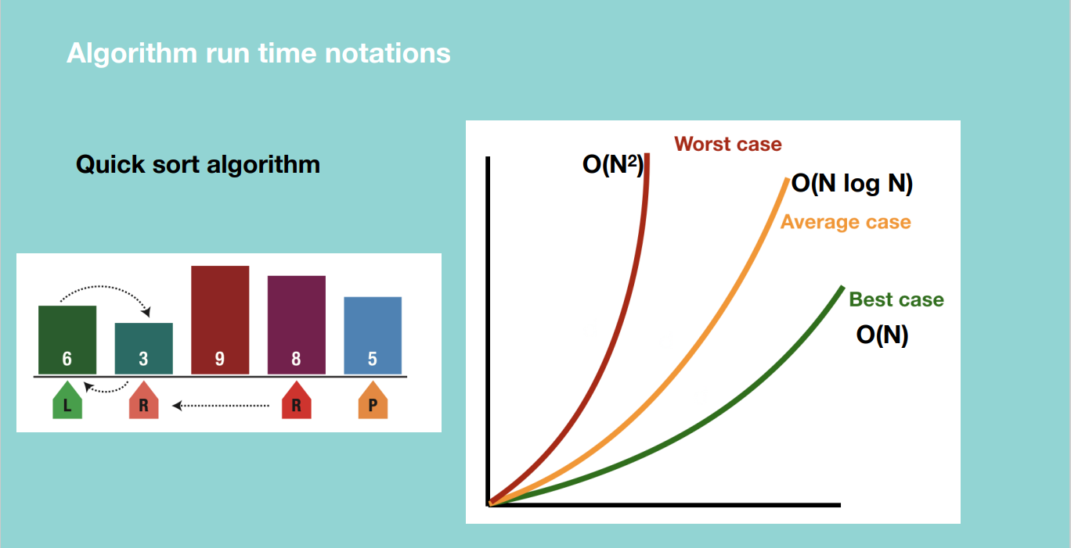

Big O – thinks of the maximum time i.e. a certain operation will never be more than a certain amount of execution time.

Big Omega – thinks of the minimum time i.e. a certain operation will never be less than a certain amount of execution time.

Big Theta – thinks of the average time i.e. if we have an algorithm with max execution time 10 seconds and minimum execution time 1 seconds, the average time will be 5 seconds.

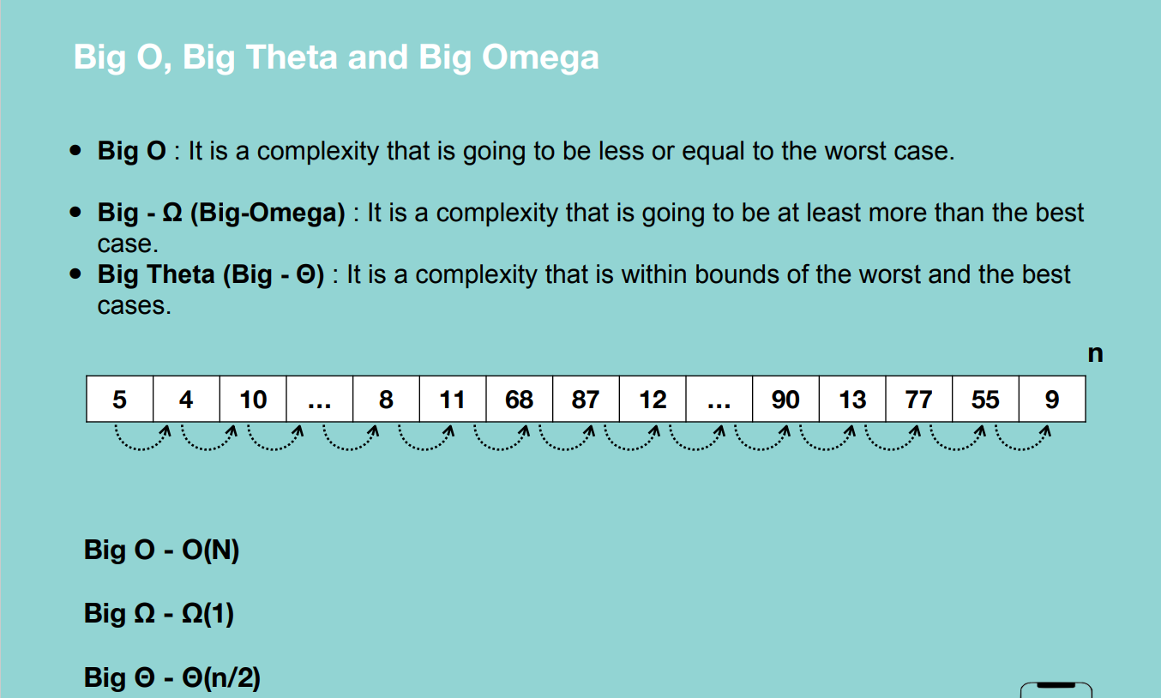

From the figure above, let’s say we take 1ms to move from one element of the array to another.

**Algorithm run time complexities.**

**O(1) –** for any given input, the execution time will not change.

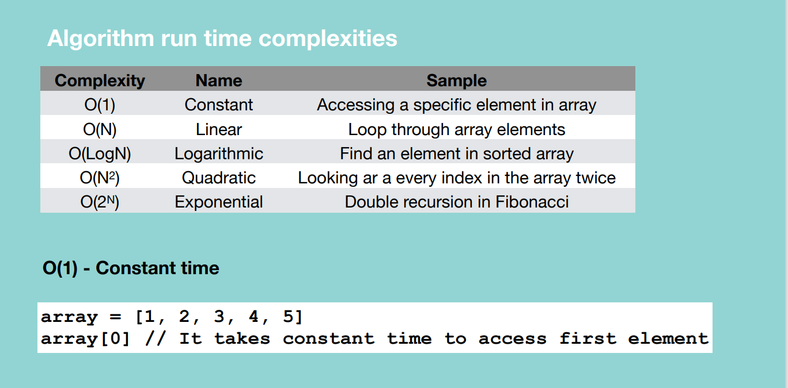

Grabbing a random card in a take takes constant time whatever we grab.

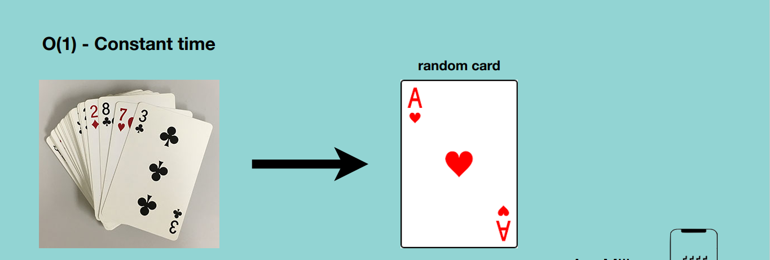

**O(N) – Linear time –** time complexity will grow directly proportional to the size of input data.

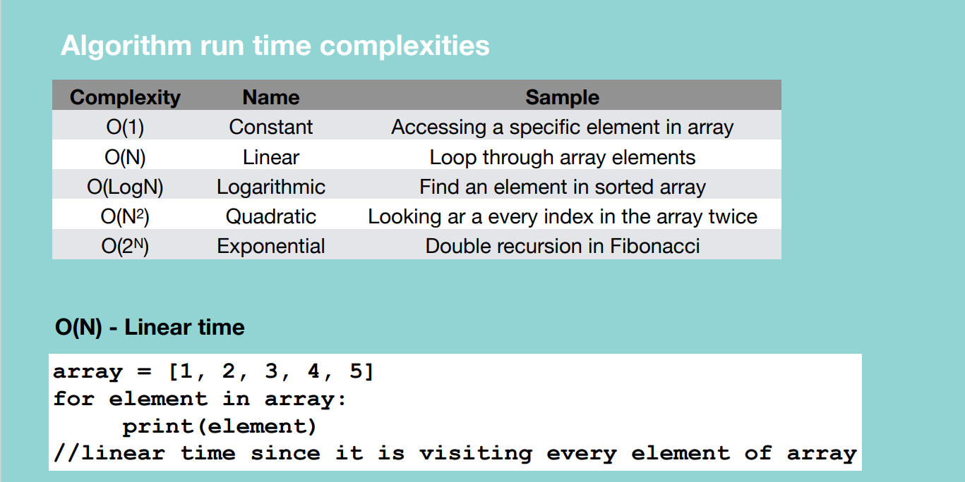

Grabbing a specific card in a take takes constant time whatever we grab.

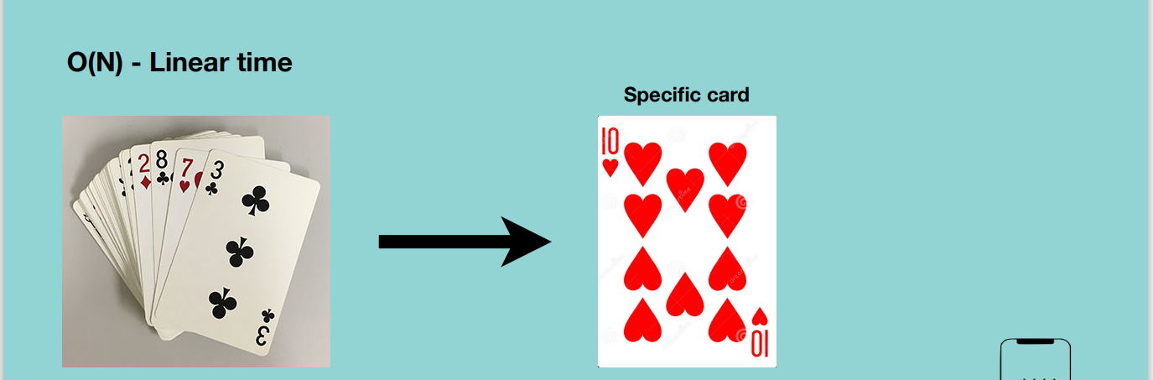

**O(LogN) – Logarithmic –** runs in proportional to the logarithmic of the input size. E.g. if the function doesn’t pass through all the elements in an array

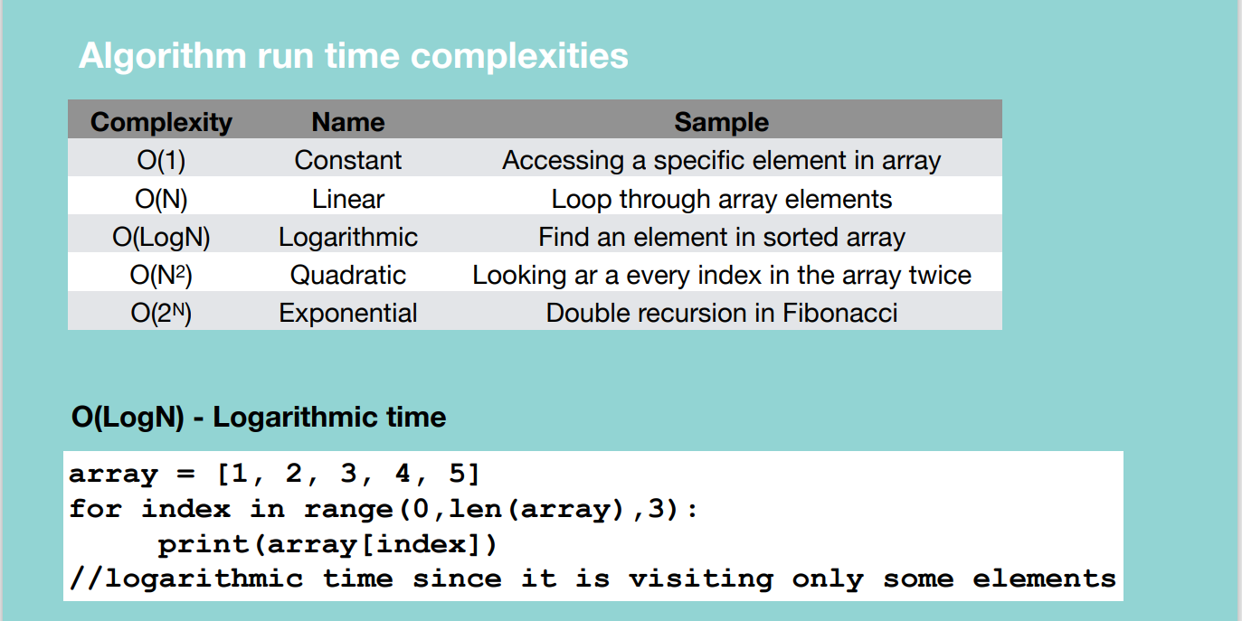

In the example above, we print elements of the array using a step of 3.

Below shows a procedure of trying to find a 10 of hearts in a sorted card deck by continuously dividing the problem space.

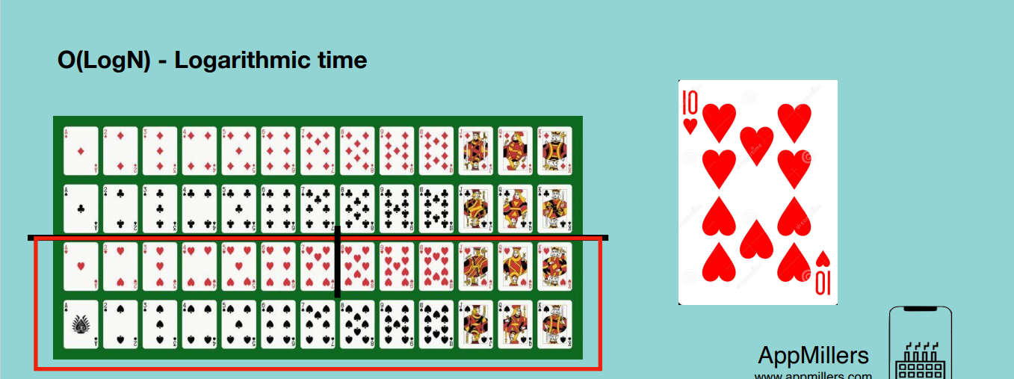

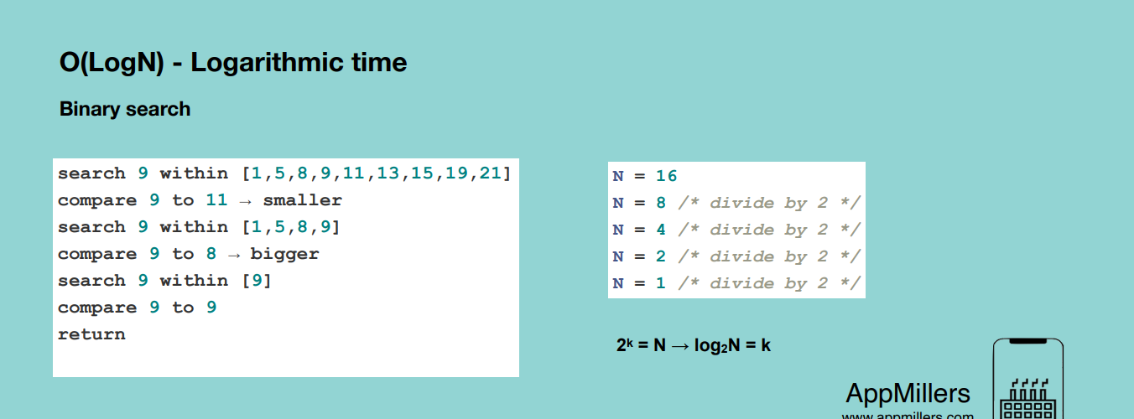

**O(N^2) – Quadratic time** – an algorithm whose performance is directly proportional to the square size of the input data set. It’s like linear algorithm but here the time complexity is increasing quadratically. It occurs whenever we nest our multiple iterations.

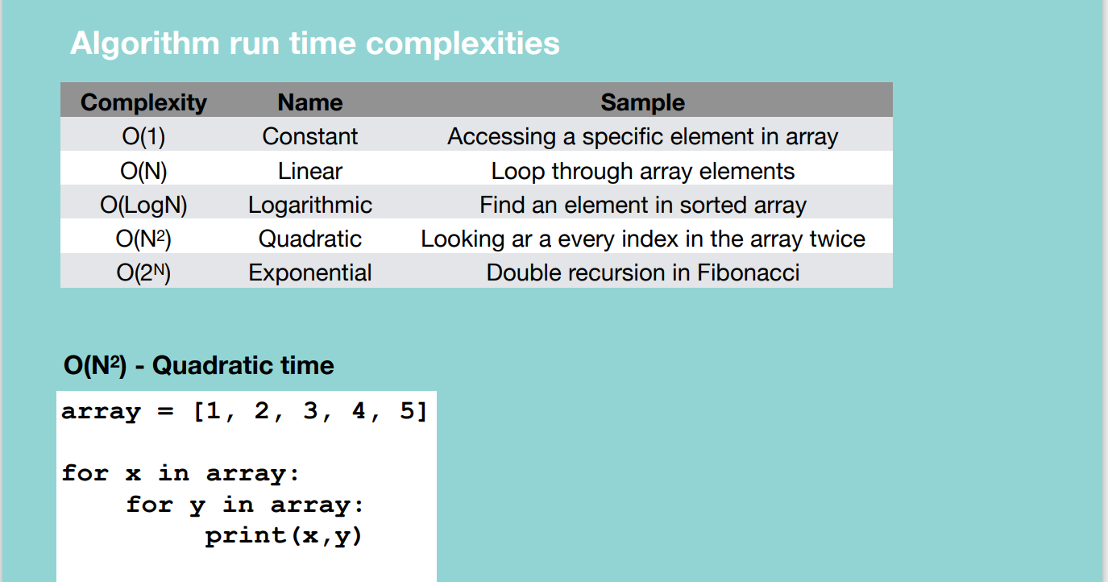

Eg. Revisiting the deck of cards each time we want to pick a card of 3.

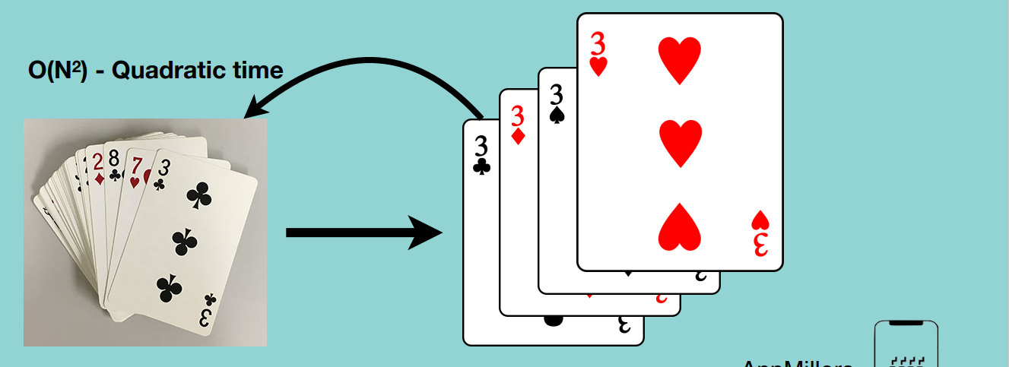

**O(2^N) – Exponential time –** algorithm whose growth doubles with each addition to the input set. Time complexity starts very shallow, rising at an ever increasing rate until the end.

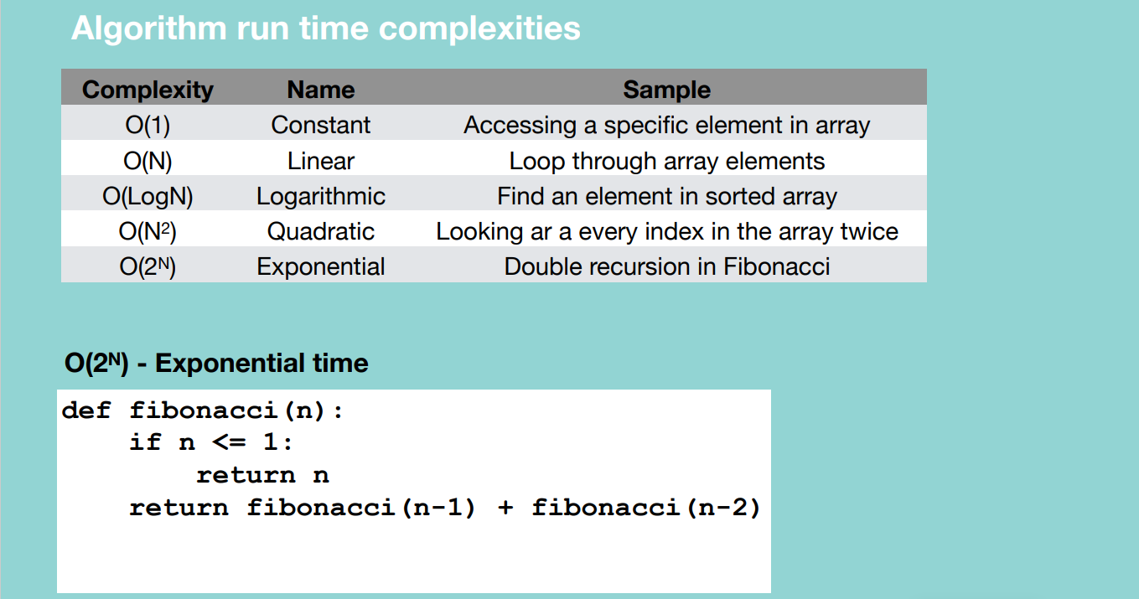

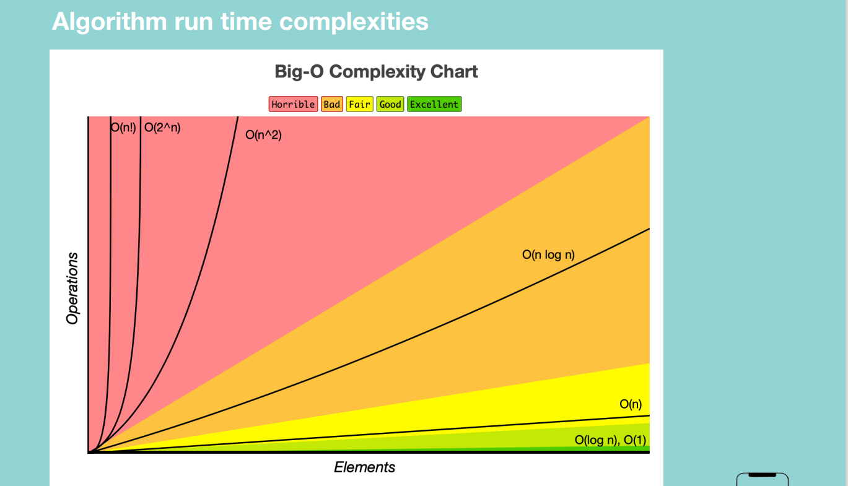

**Space complexity:** measure of the amount of working storage an algorithm needs.

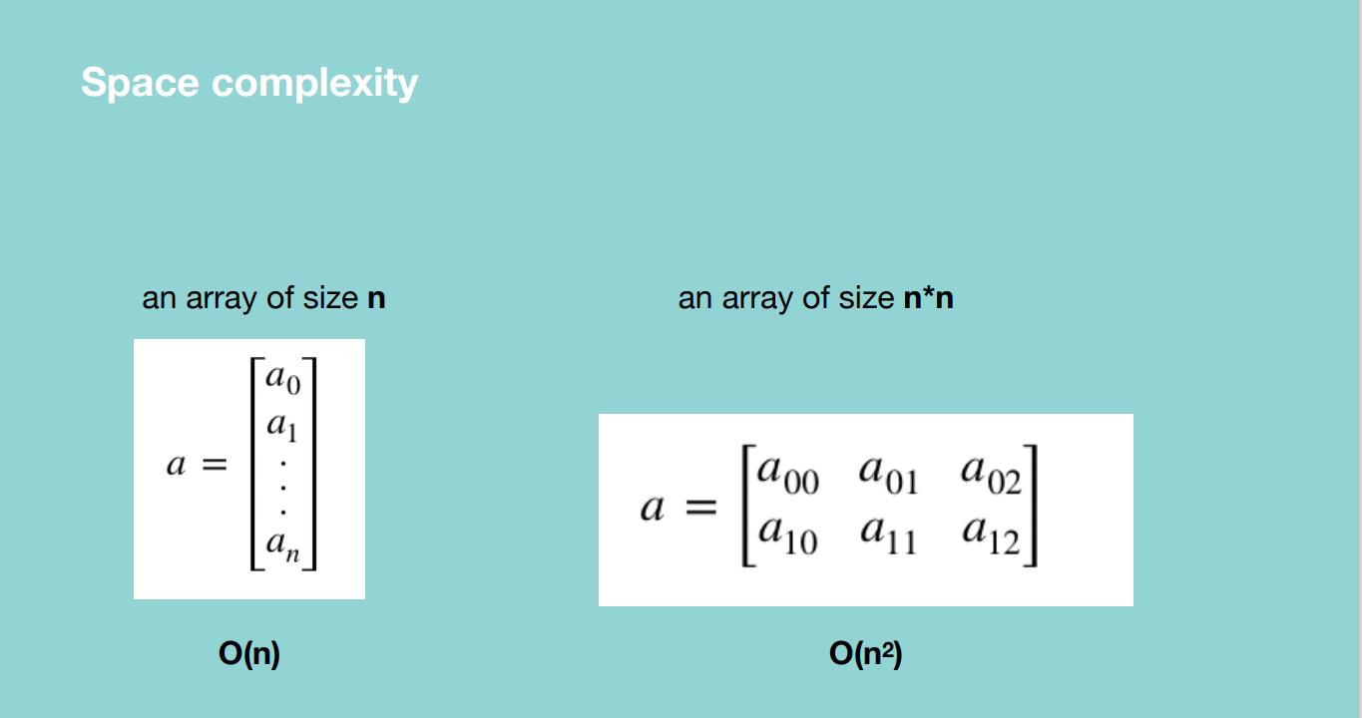

A function which is summing up the number from a given number till zero by calling recursive calls.

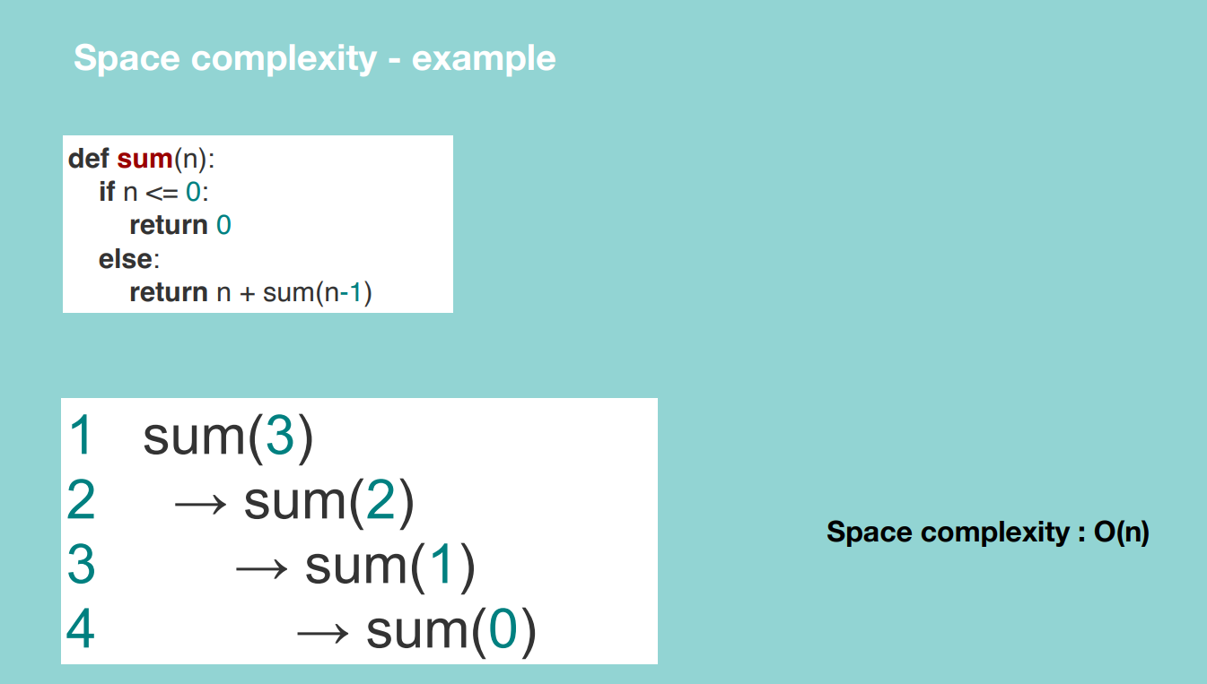

Since the function is not calling itself recursively or adding anything to the call stack.

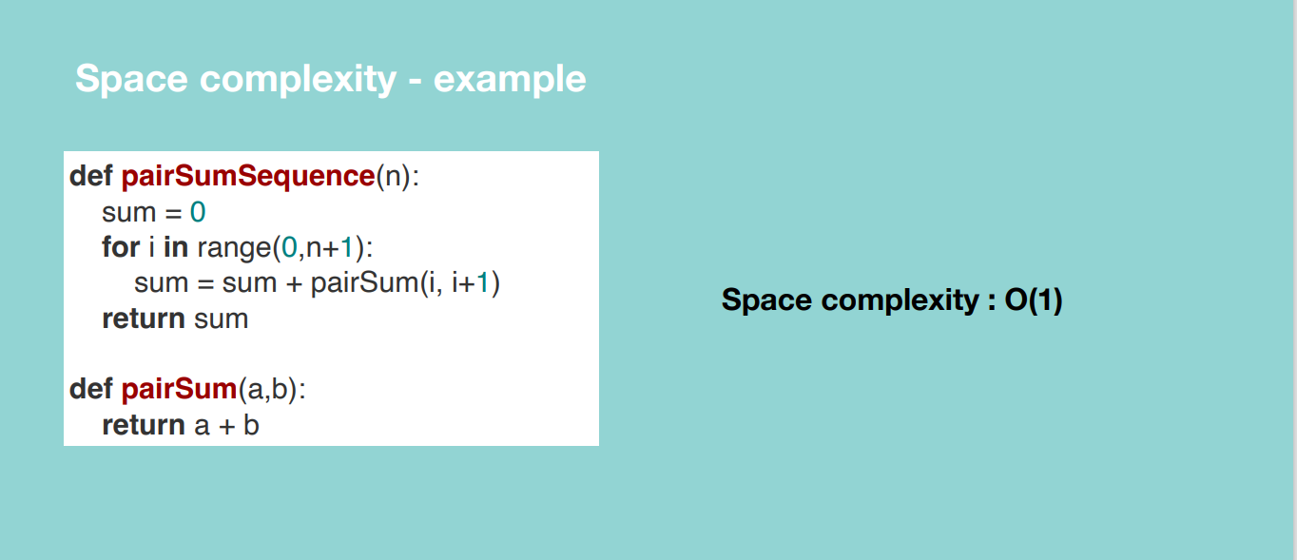

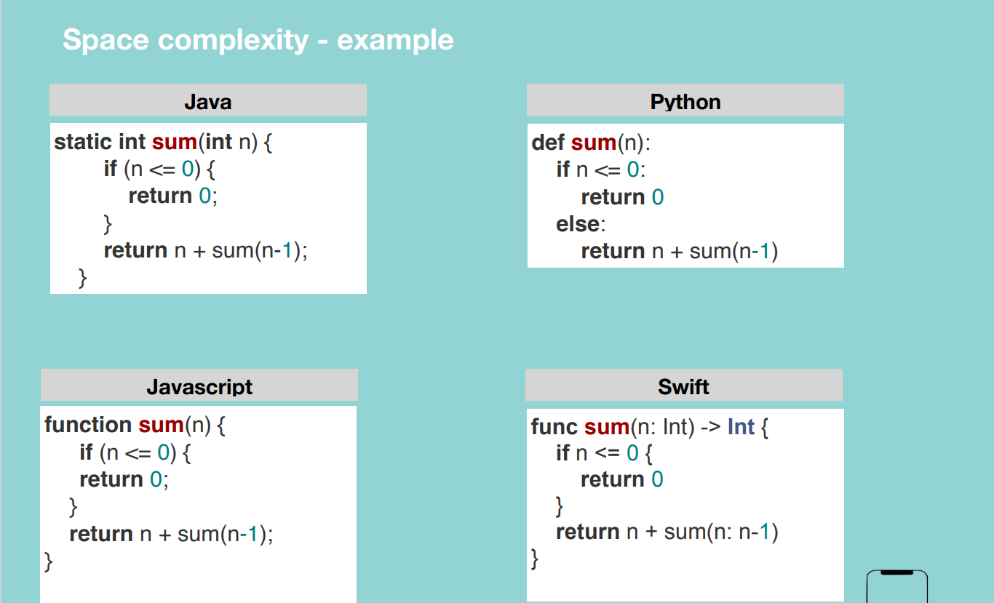

**Drop constants and Non-Dominant Terms**

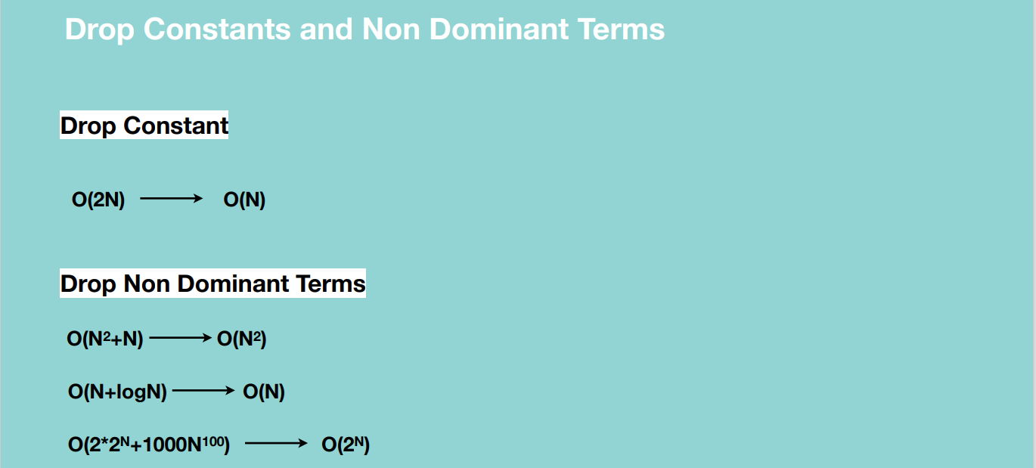

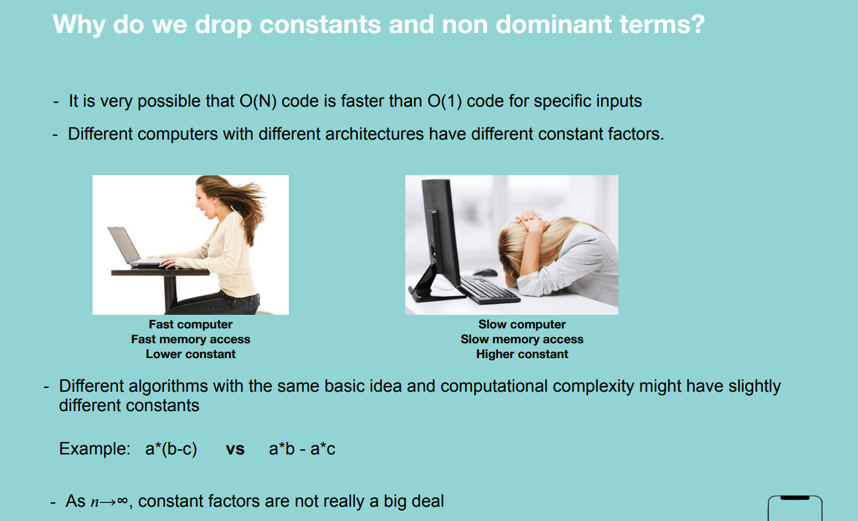

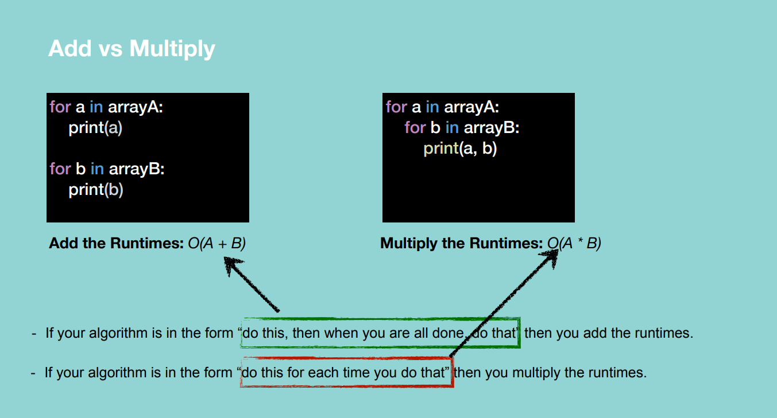

**Note:** the array has a million elements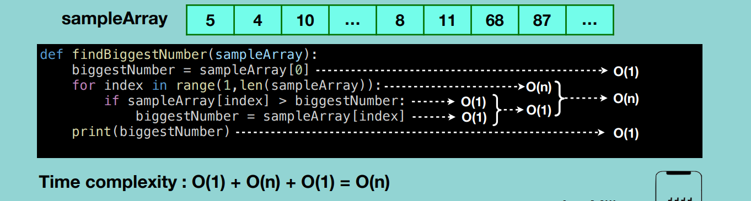

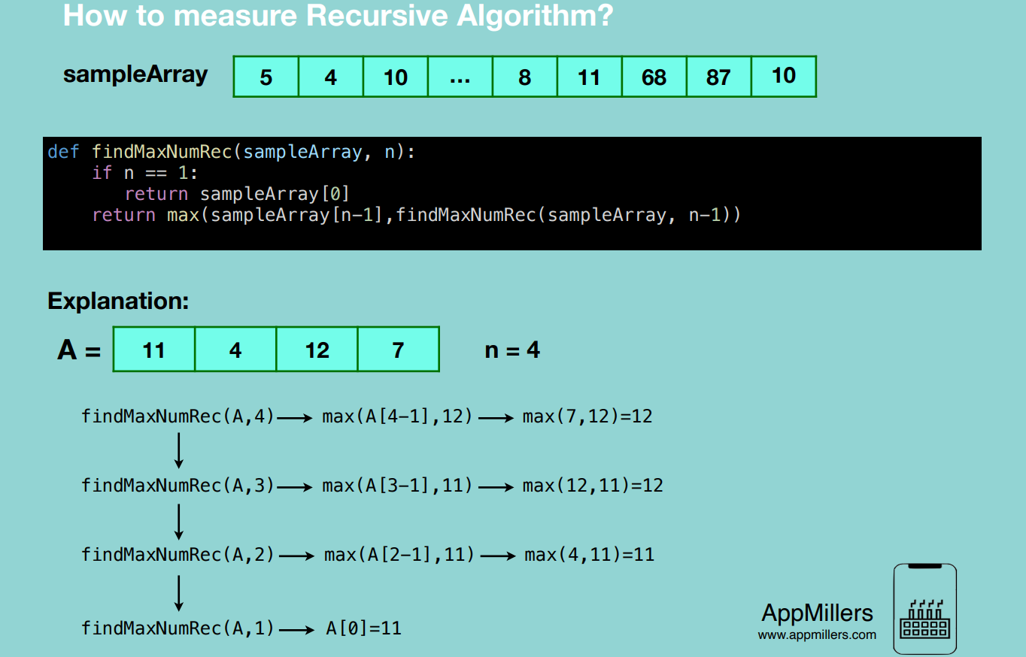

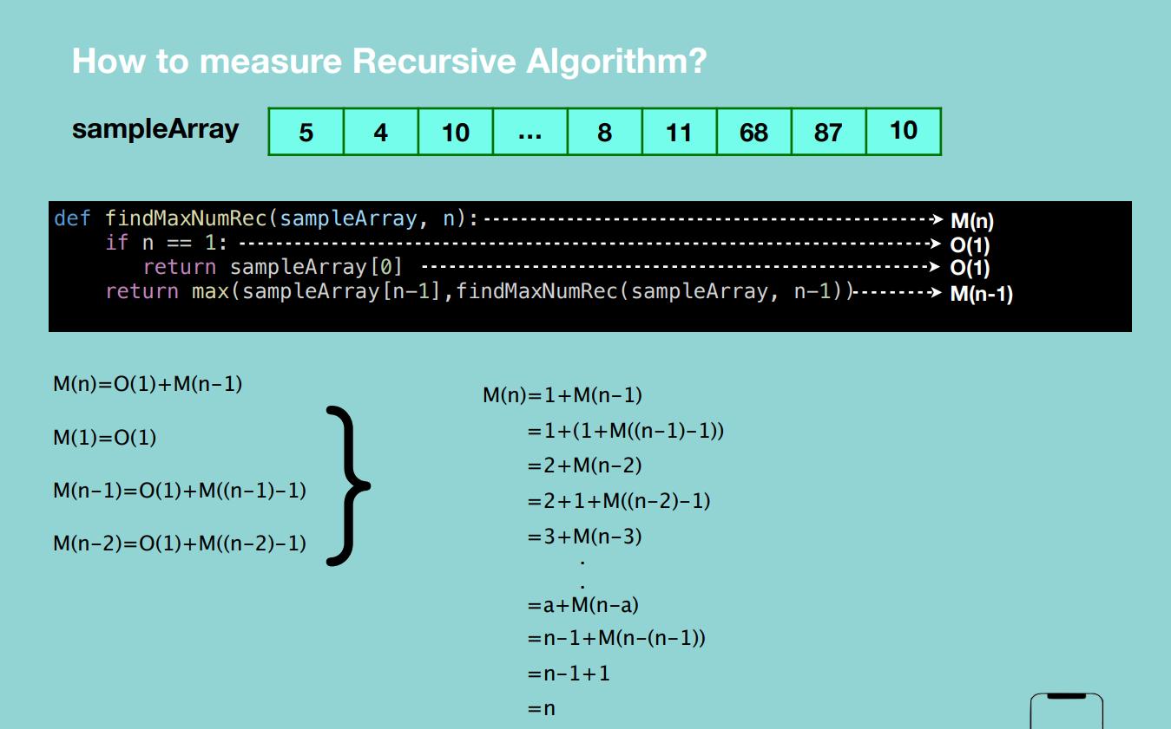

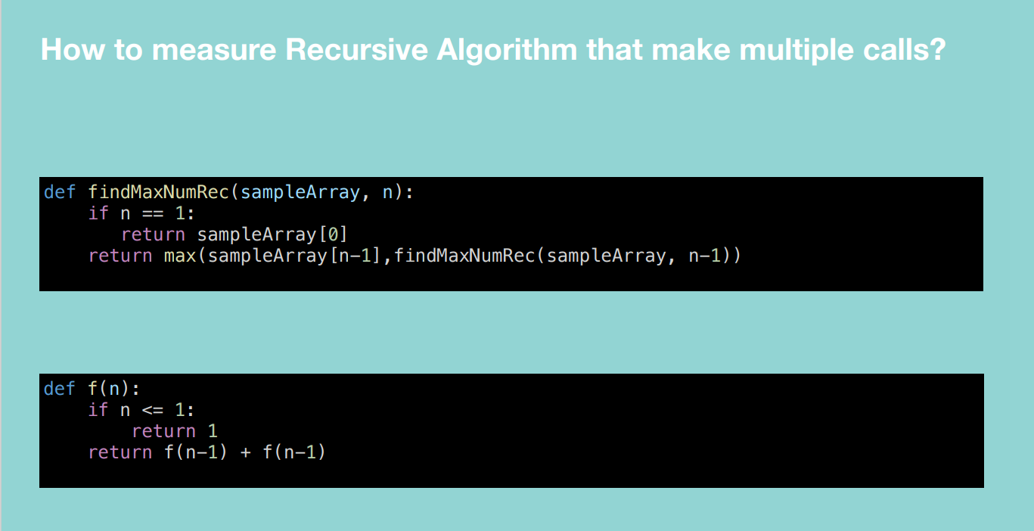

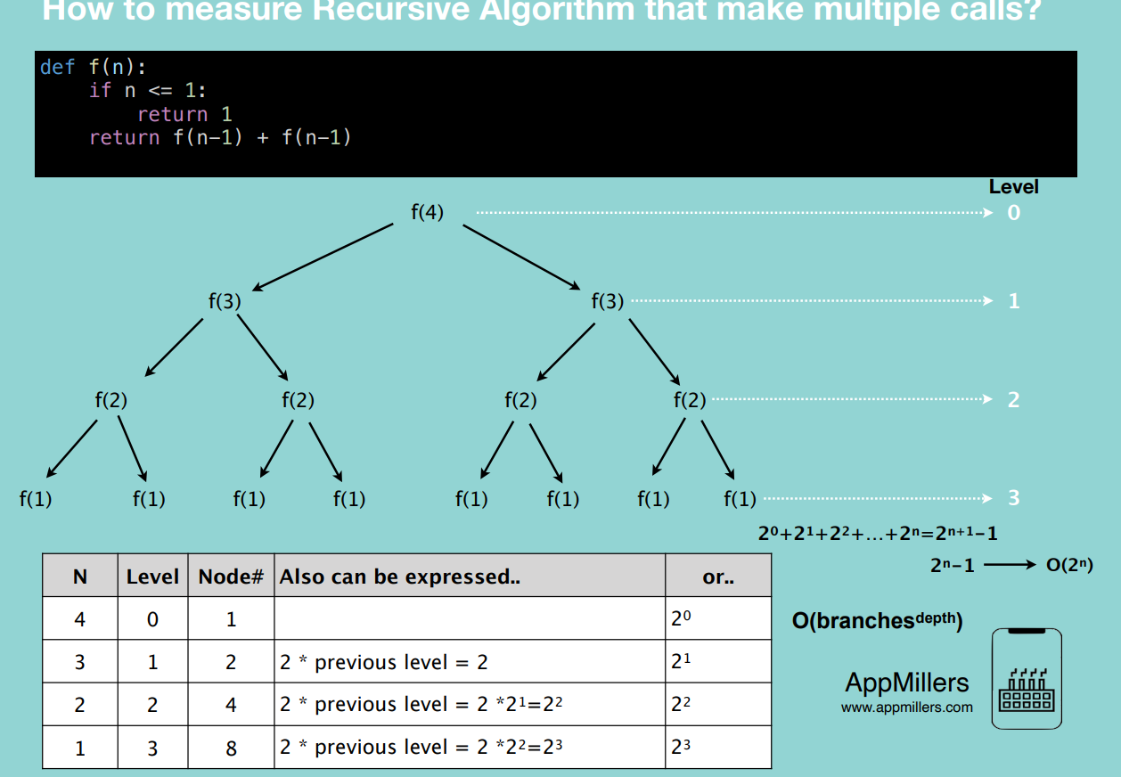

**For a** recursive algorithm with multiple calls, the complexity is **O(branches^depth)** e.g. double recursive calls = O(2^n). triple recursive calls = O(3^n)

**Top 10 Big O interview Questions**

**Found in Cracking the coding interview**

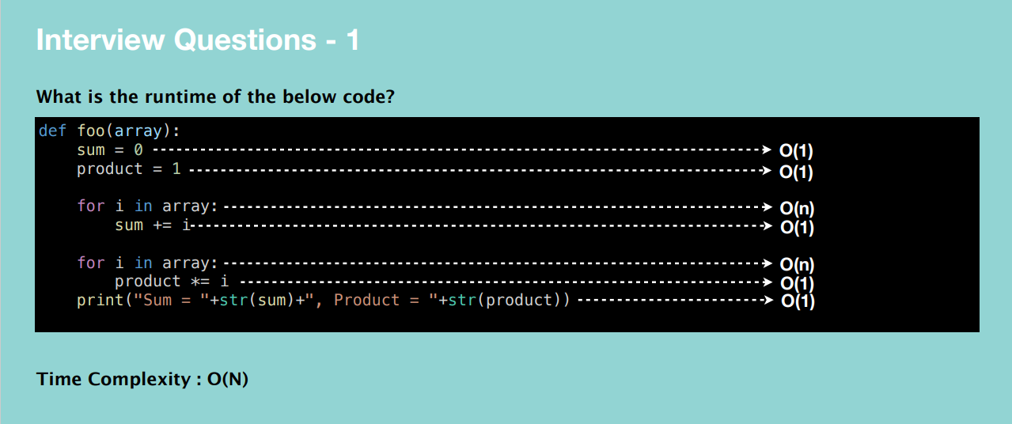

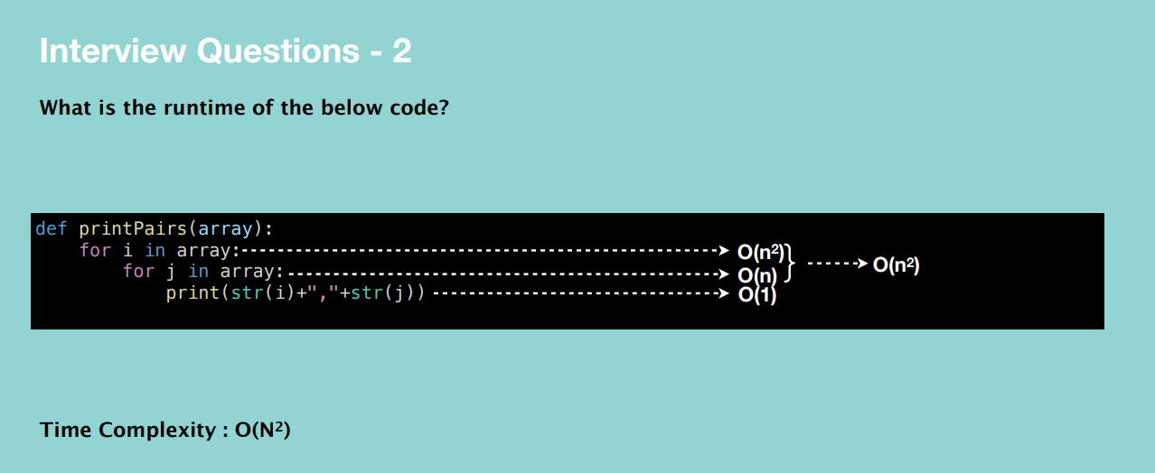

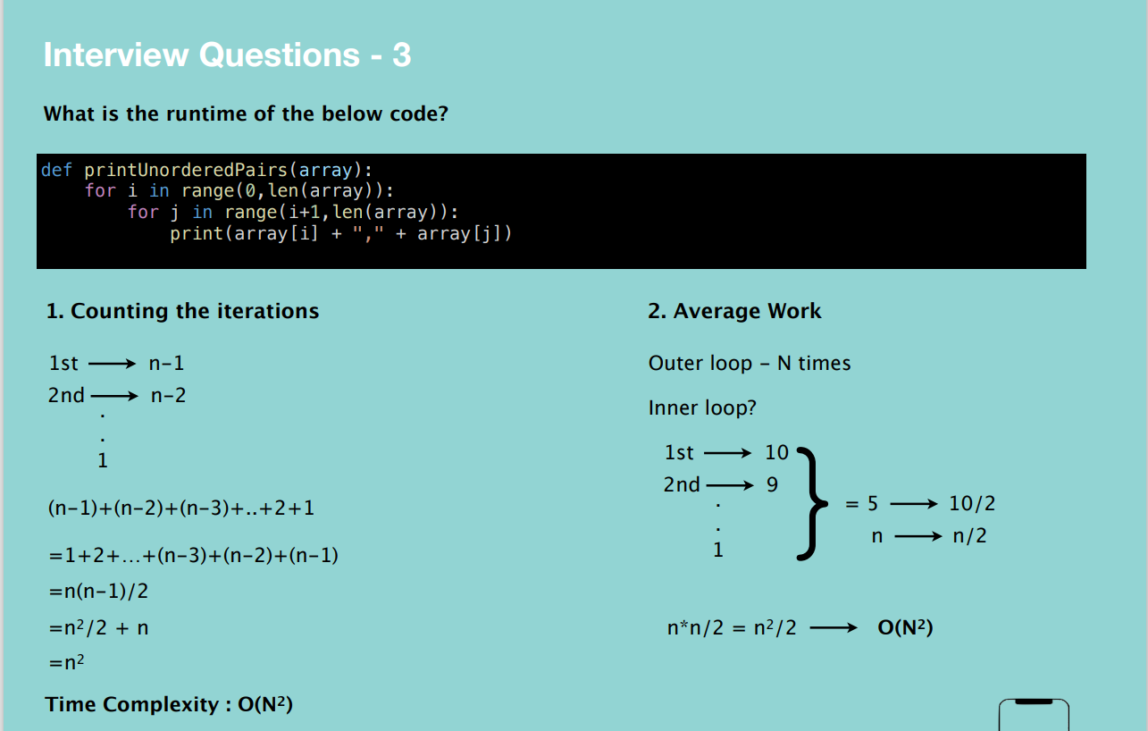

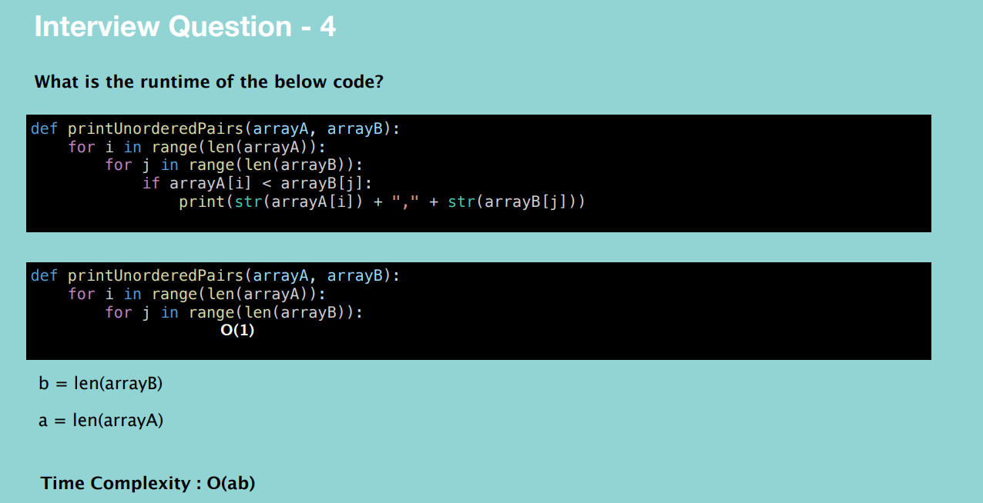

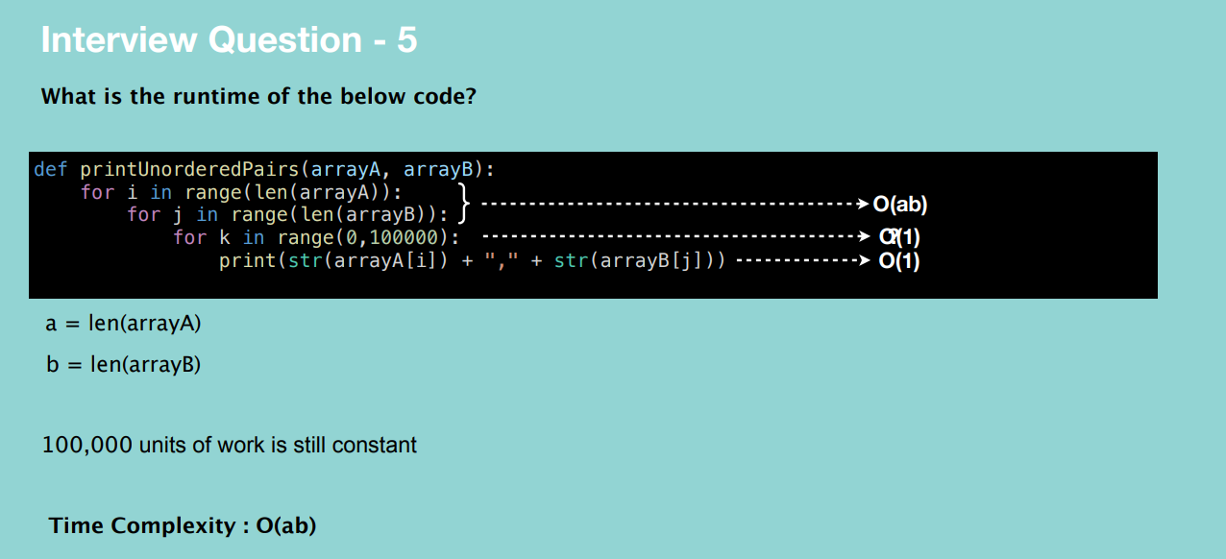

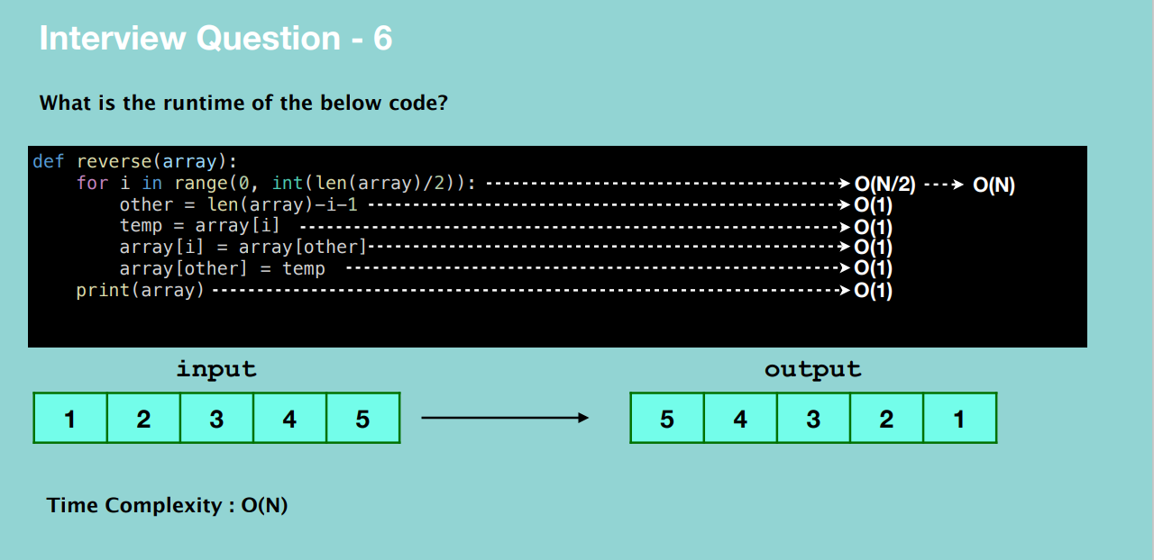

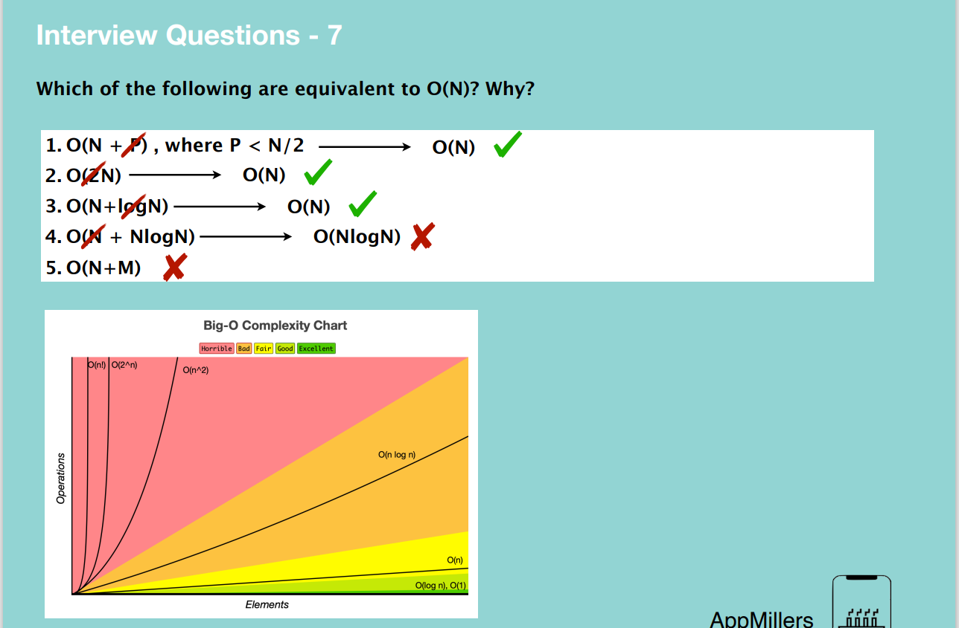

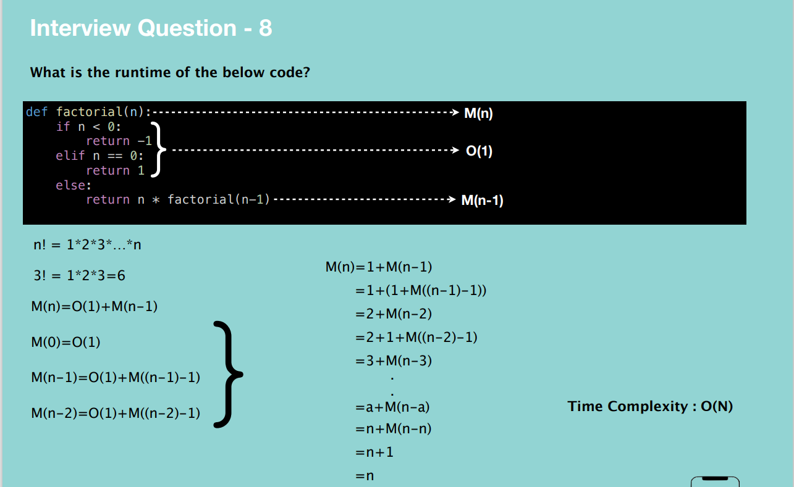

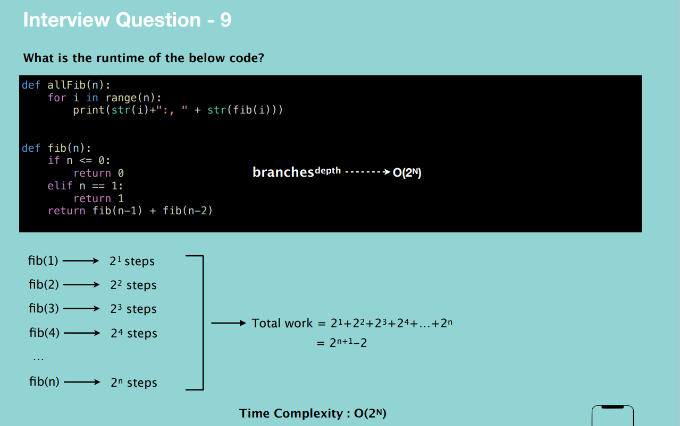

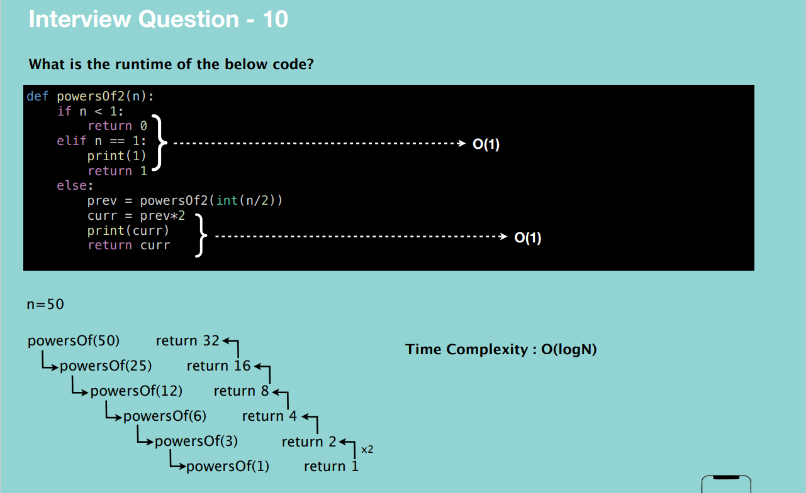

**Arrays – simple collection of objects or things (most used data structure) OR a data structure consisting of a collection of elements, each identified by at least one array index or key.**

Each item is identified uniquely based on their location.

The size of the array is predefined and cannot be changed.

All items in this array are next to each other. i.e. are located in a contiguous location in memory.

An array can store data of a specified type.

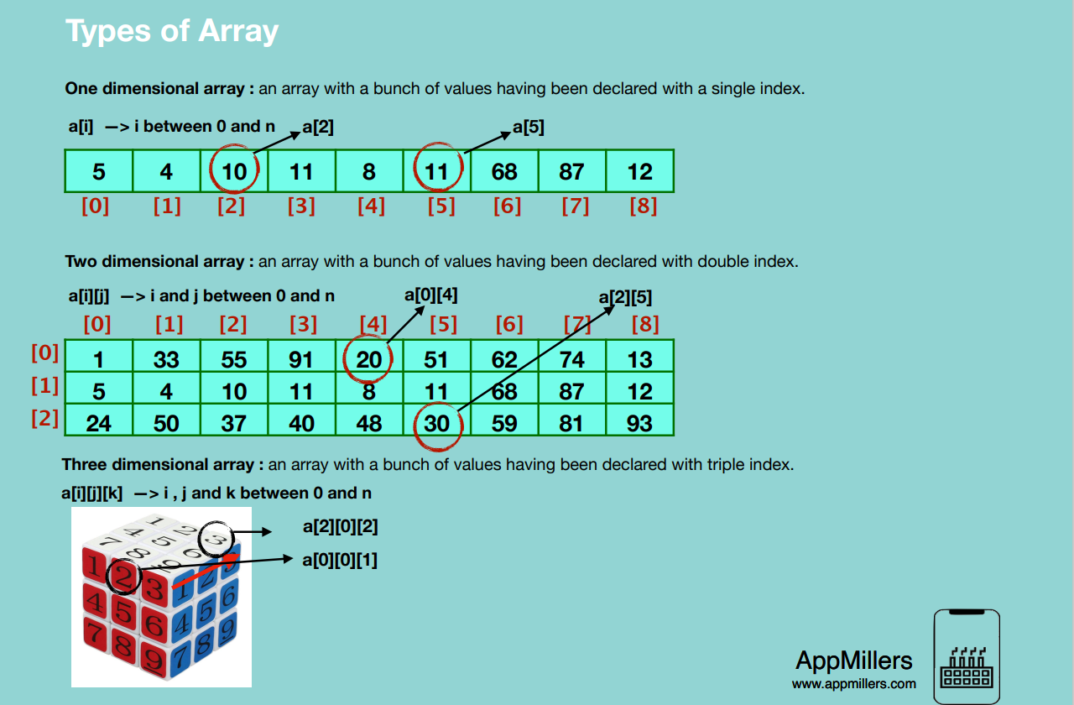

When we create an array, we”

* Assign it to a variable
* Define the type of elements that it will store
* Define its size (the maximum numbers of elements) **Note: not applicable to some programming languages which use dynamic arrays, they are easy to use but can cause performance issues.**

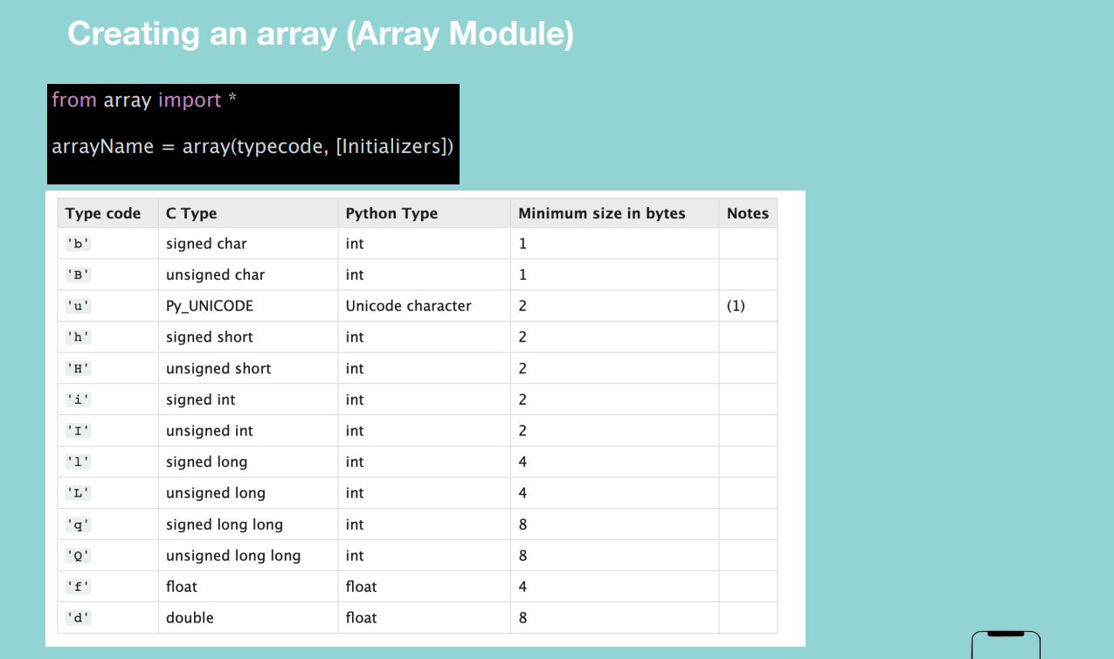

**Array Insertion**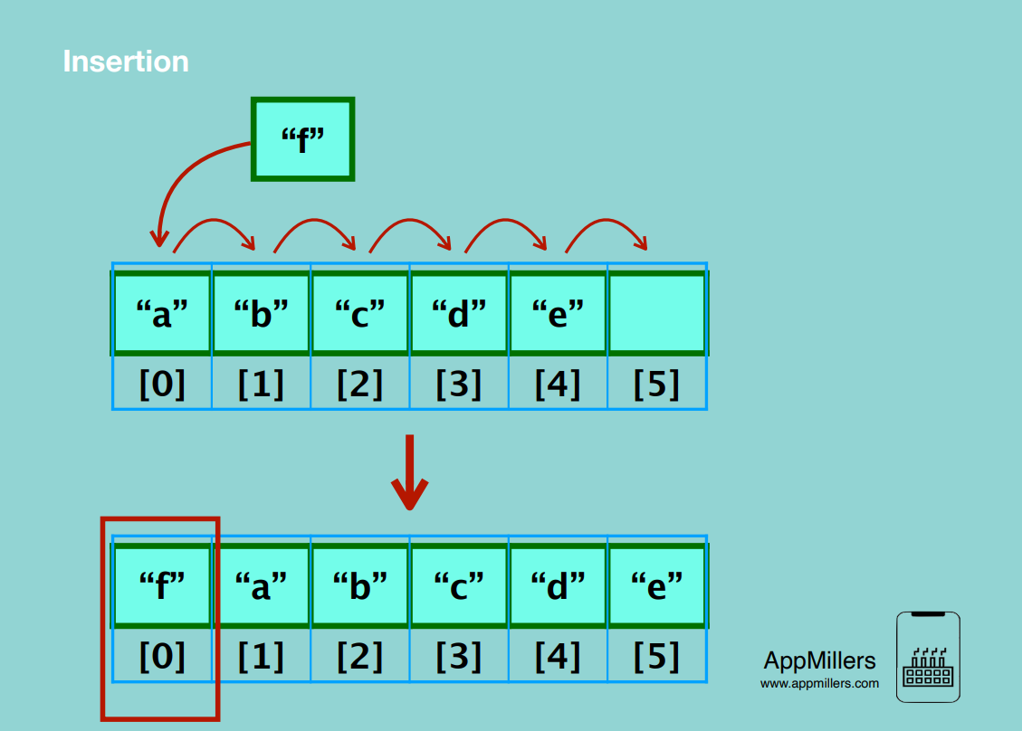

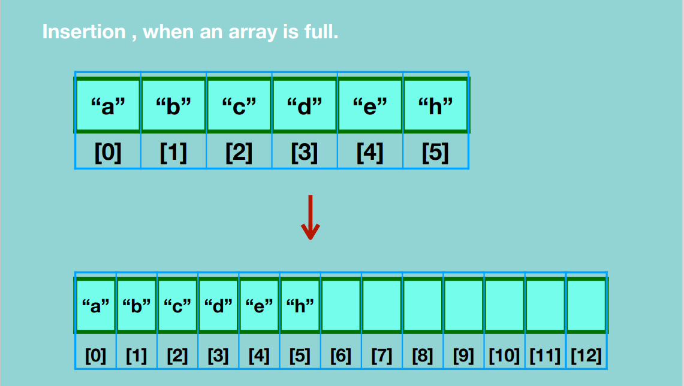

**Array Traversal**

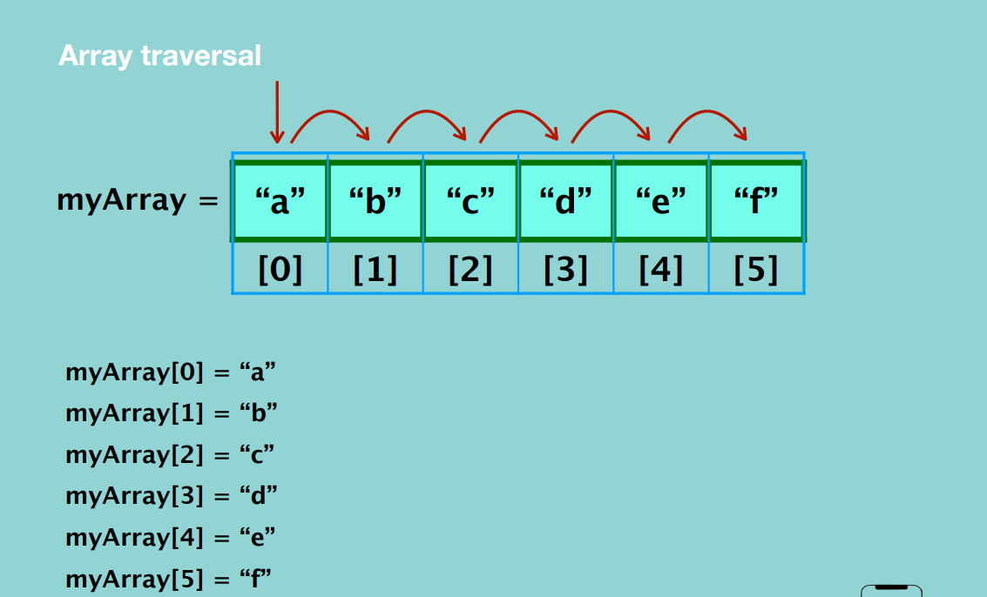

**Array accessing <<arrayName>>[index]**

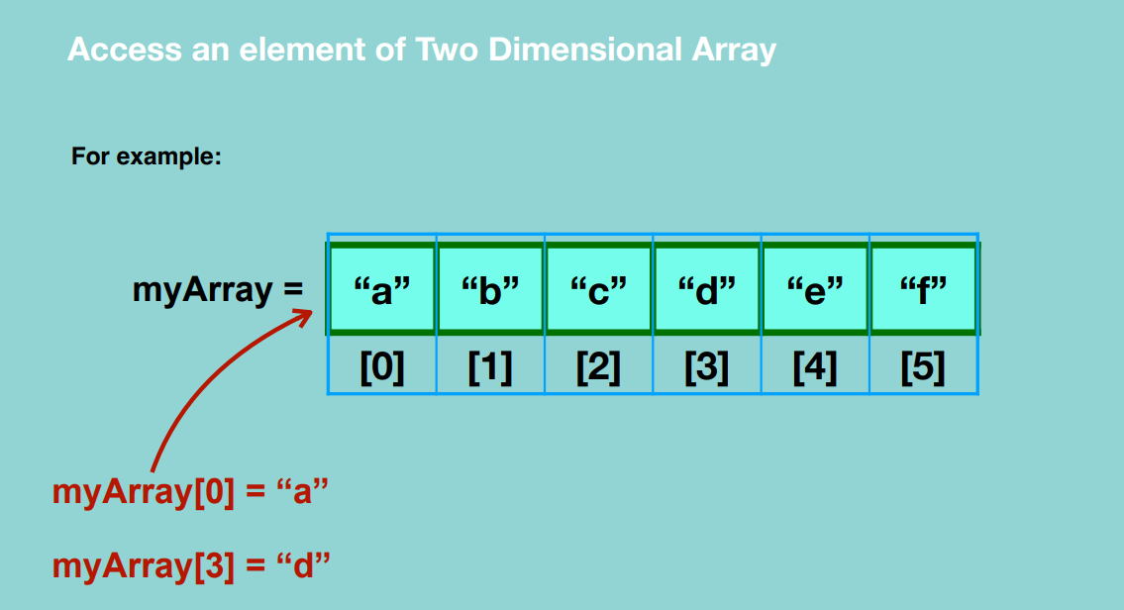

**Deleting element in the array**

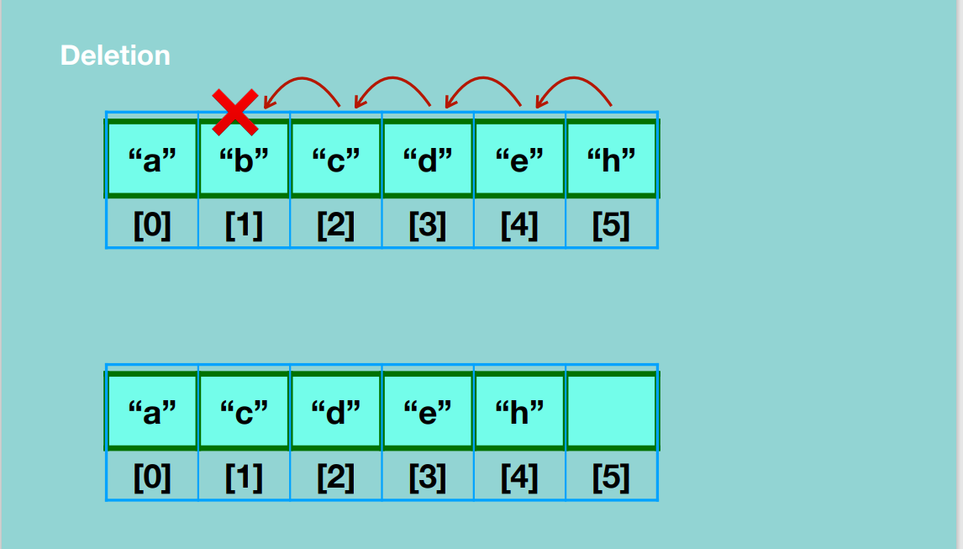

**Time and Space complexity in One Dimensional Arrays**

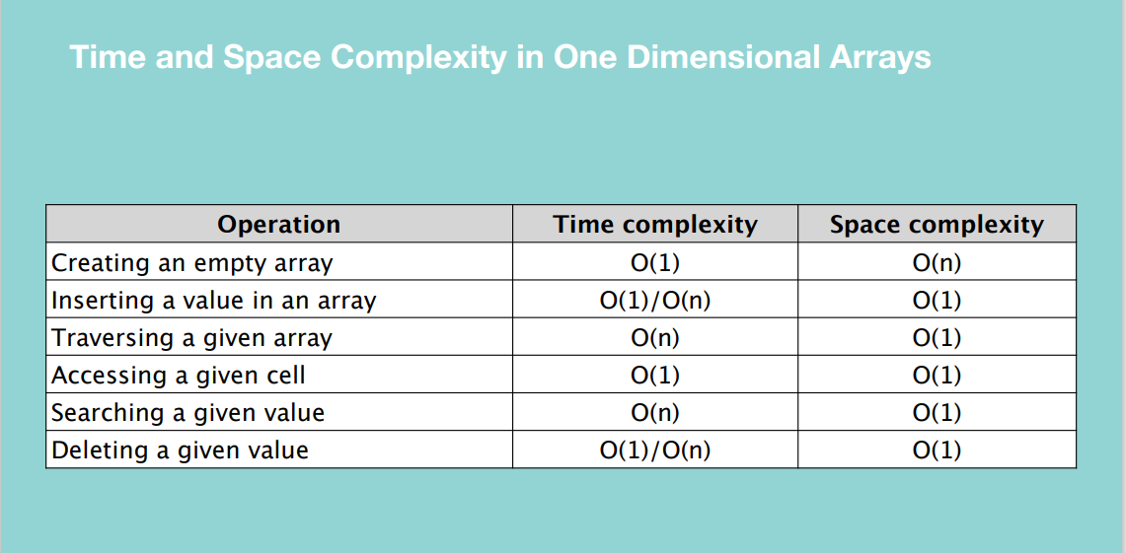

**Hence arrays are one of the most efficient DS when you need to easily access a value.**

**Two Dimensional Arrays**

**Insertion**

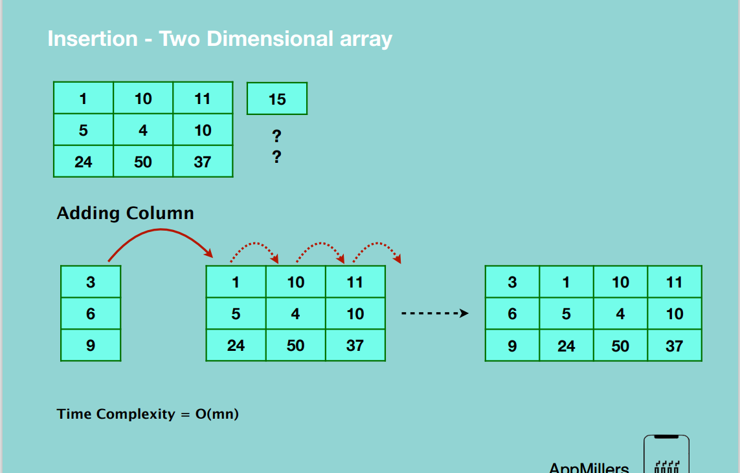

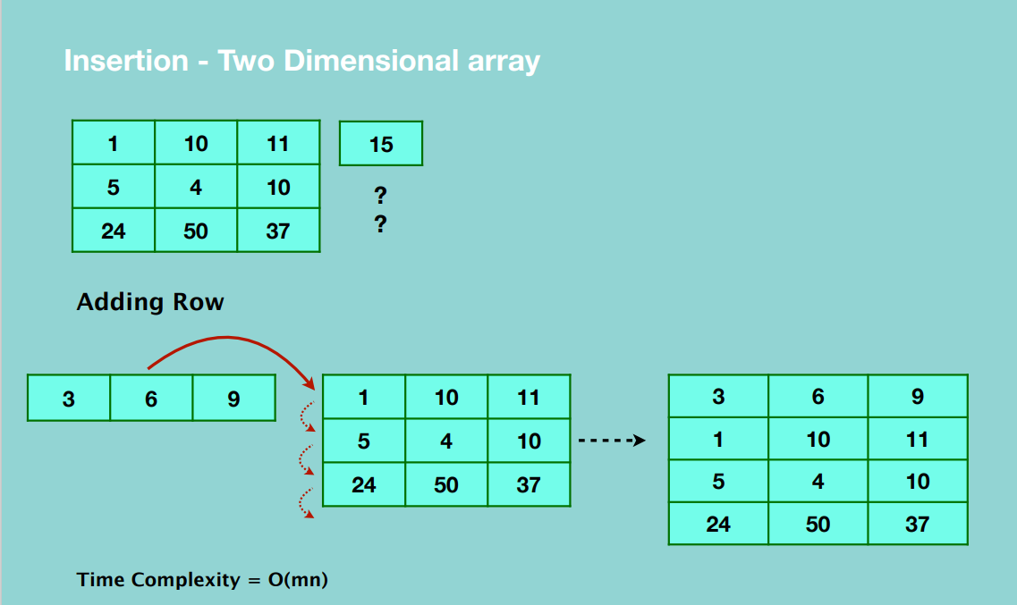

**Accessing elements in 2D array**

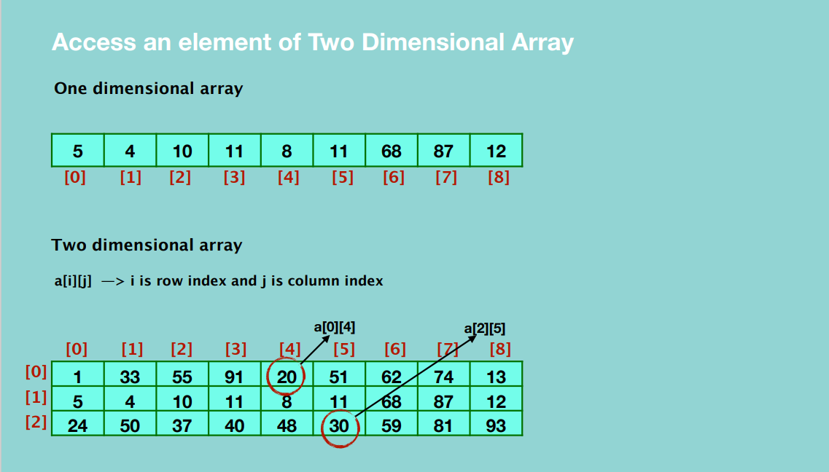

**Deletion**

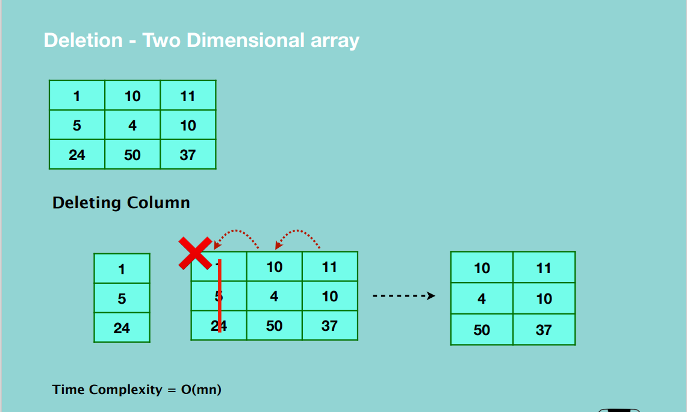

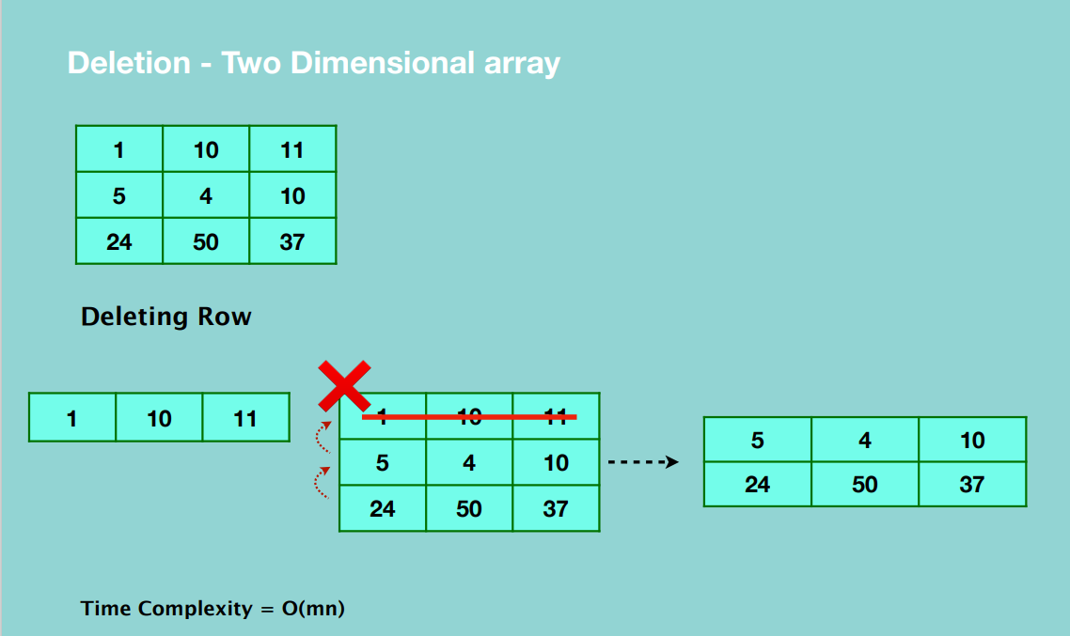

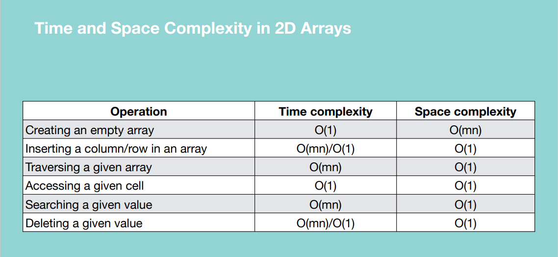

**When to use Arrays**

* To store multiple variables of the same data type
* Random access

**When to avoid**

* Same data type elements – specific to some languages
* Reserved memory

**Python Lists –** built in data structures

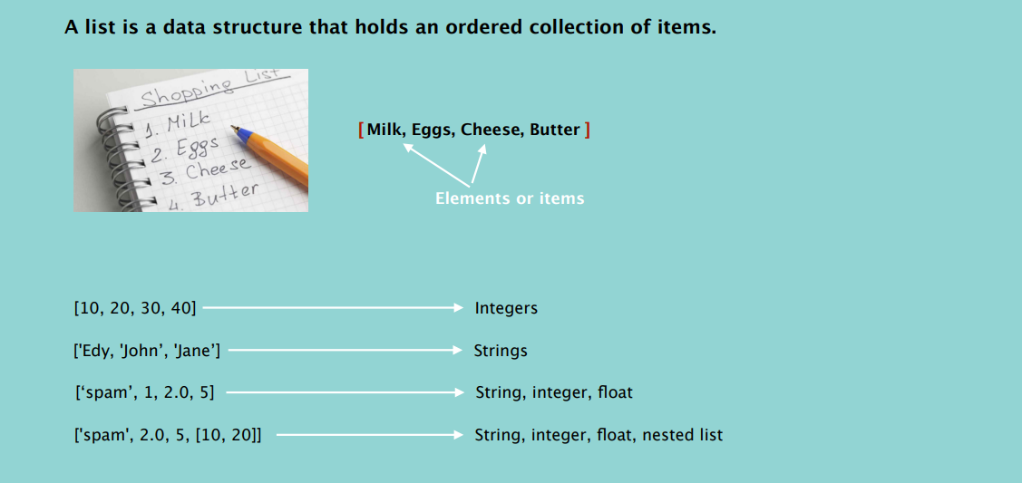

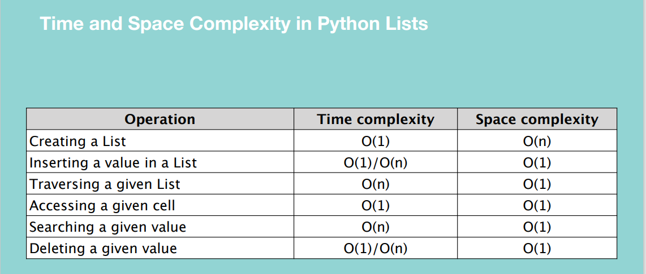

**Dictionary**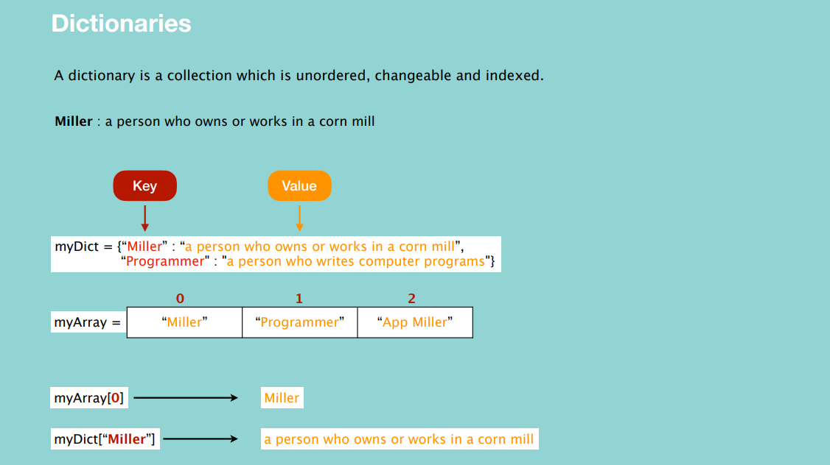

**NOTE:** Python dictionaries are implemented using hash tables.

The goal of the hash function is to distribute the index evenly in the array.

A good function minimizes the number of collisions.

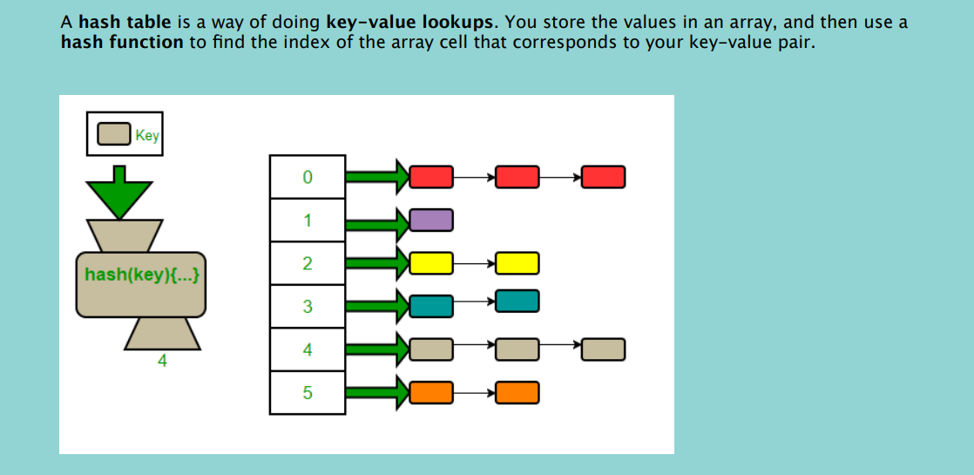

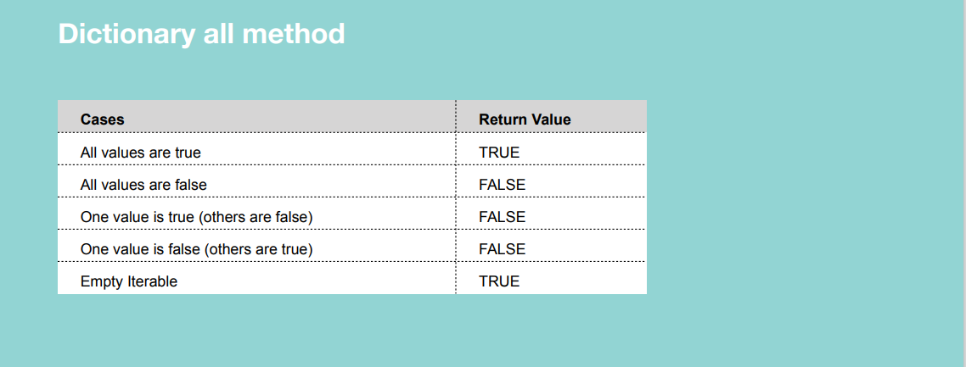

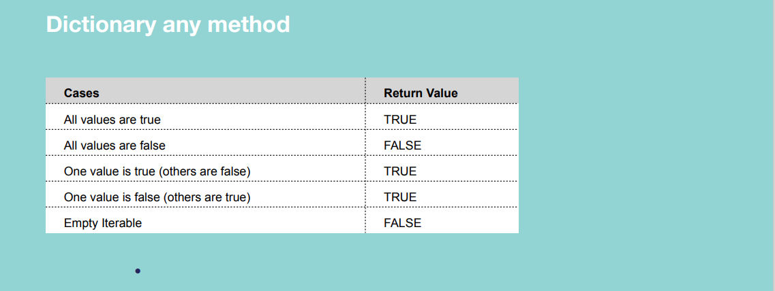

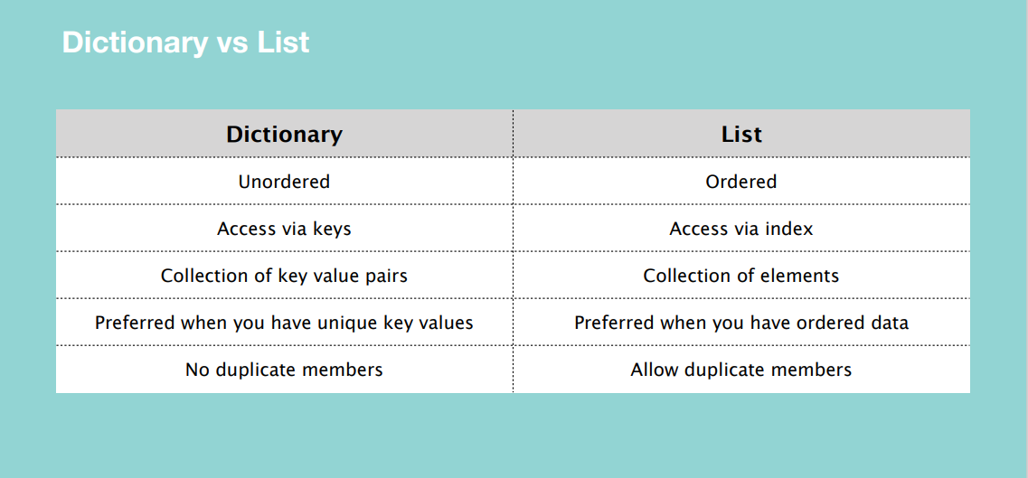

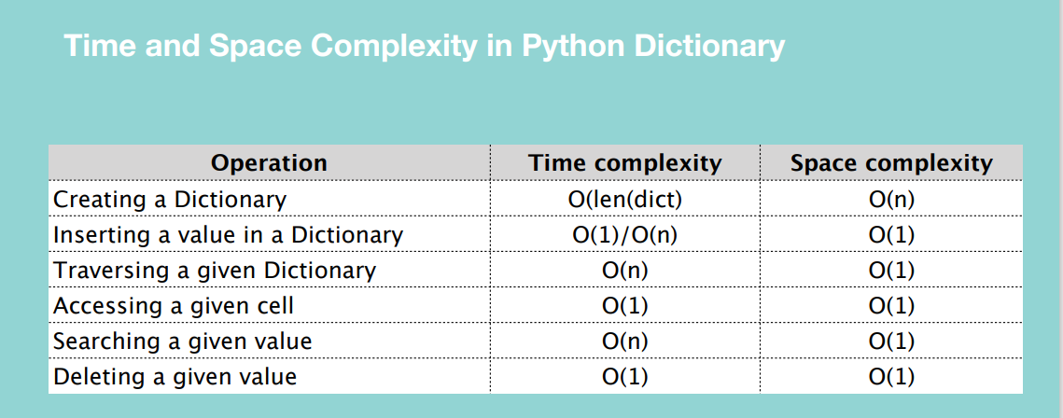

Creating a dictionary depends on the length of the dictionary because the hashfunction has to be executed to determine the index.

Searching using linear search is O(n) while with in operator it’s O(1) because it uses a hash function.

**TUPLE**

A tuple is an immutable sequence of Python objects.

Tuples are also comparable and hashable i.e. it has a value that remains the same during its live time.

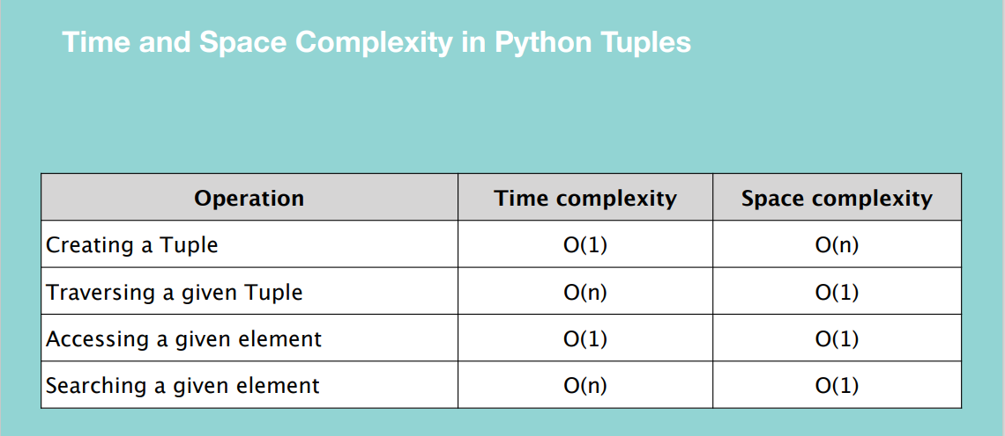

**LINKED LIST**

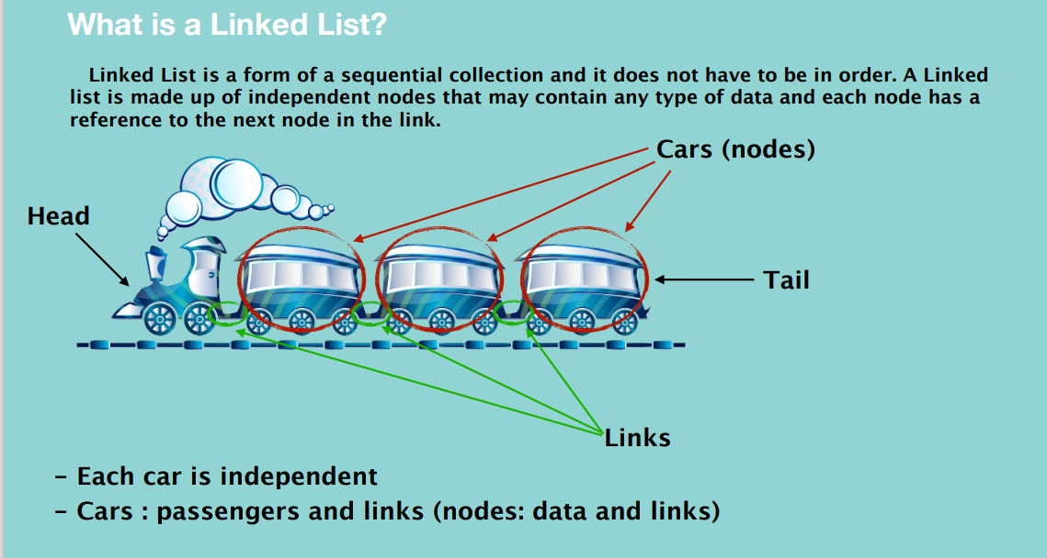

**NOTE:** The nodes of a linked list are not contiguous.

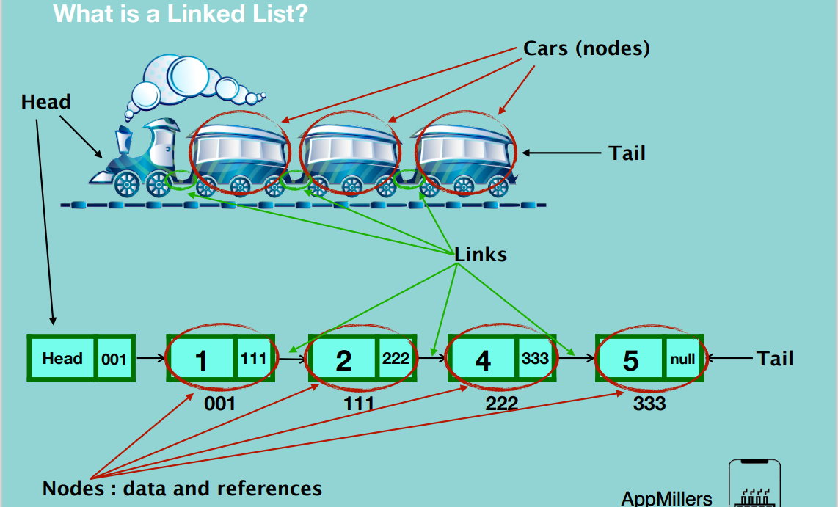

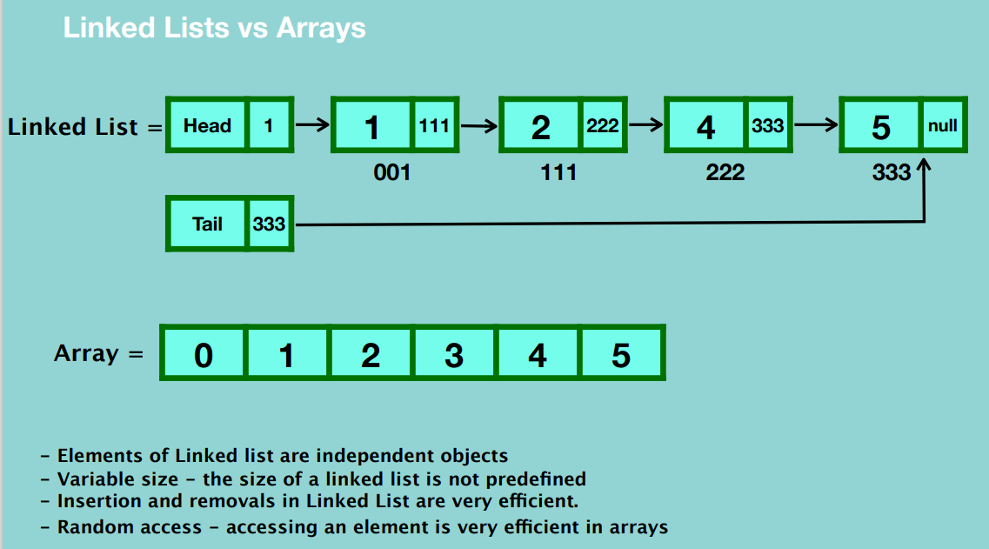

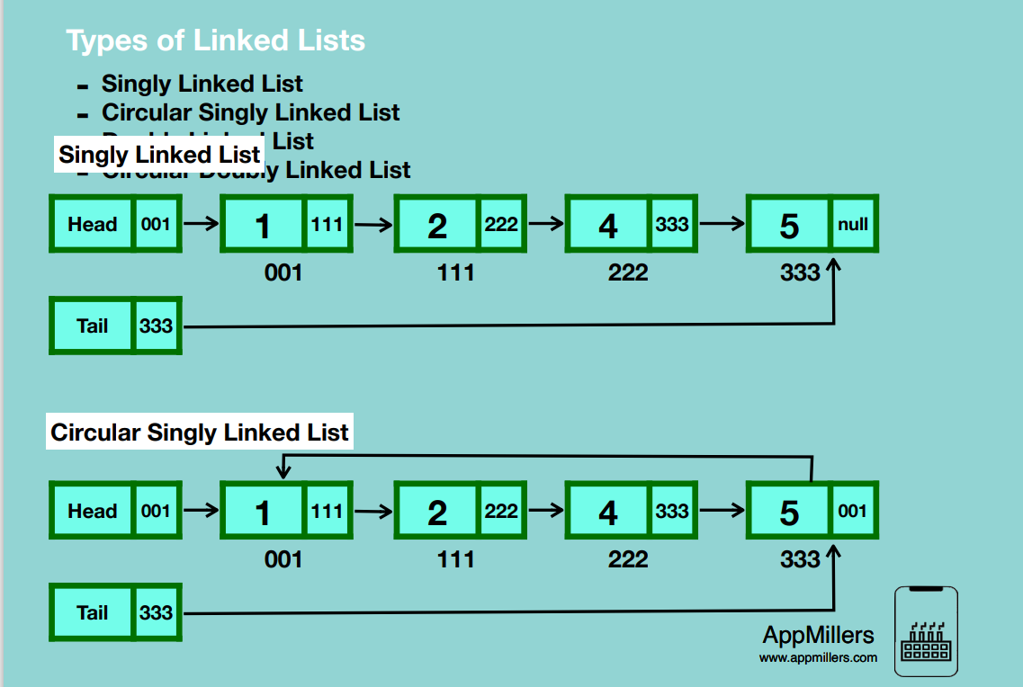

In Circular singly linked list, the last node stores a reference to the first node.

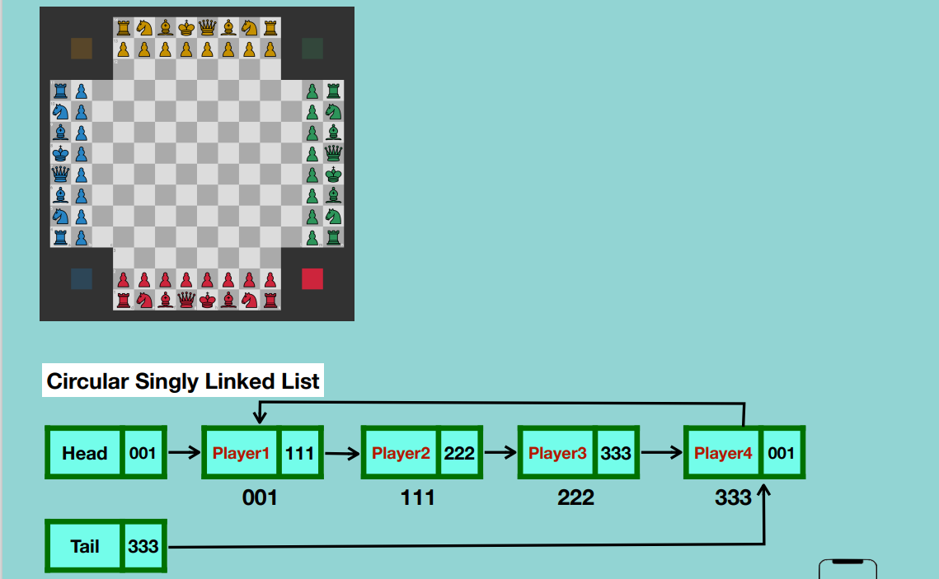

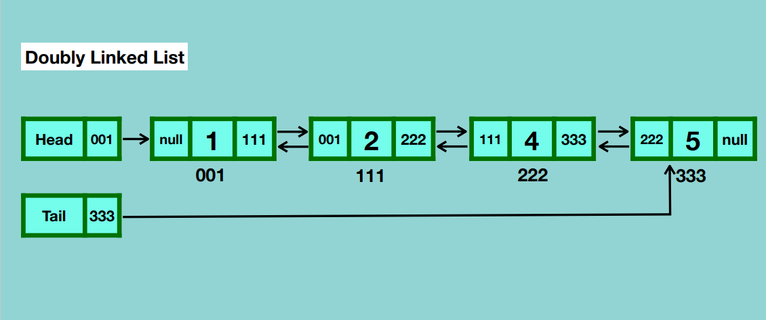

Each node has two references, one the next node and one to the previous node. It provides us flexibility of traversing in both directions.

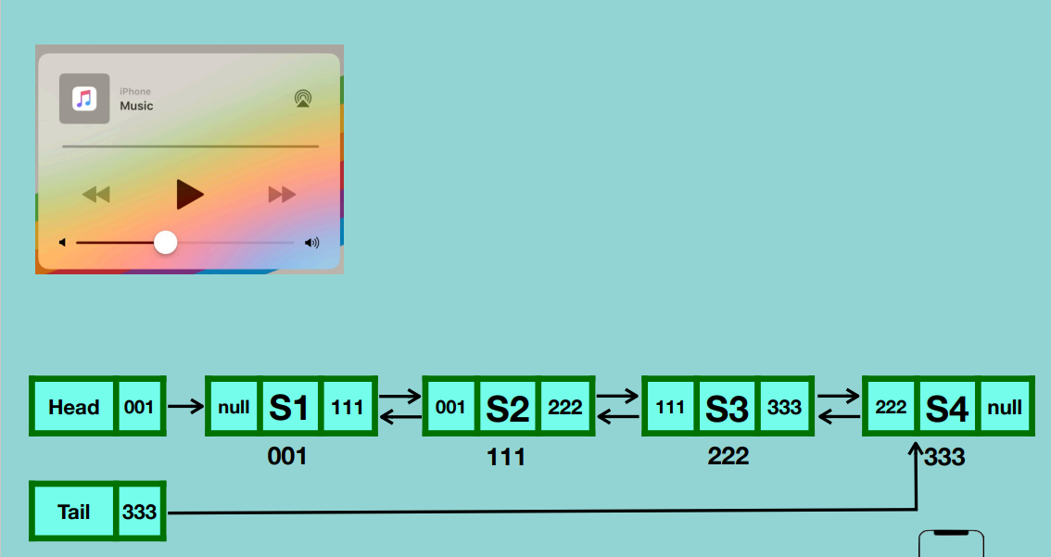

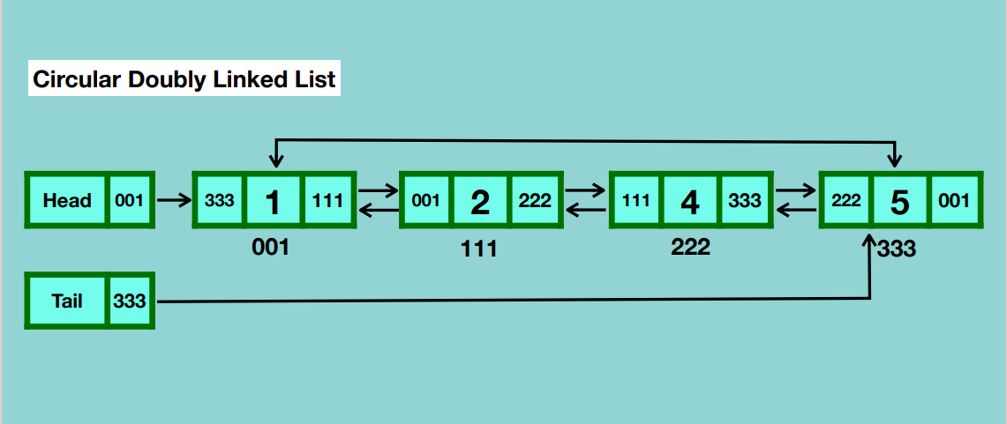

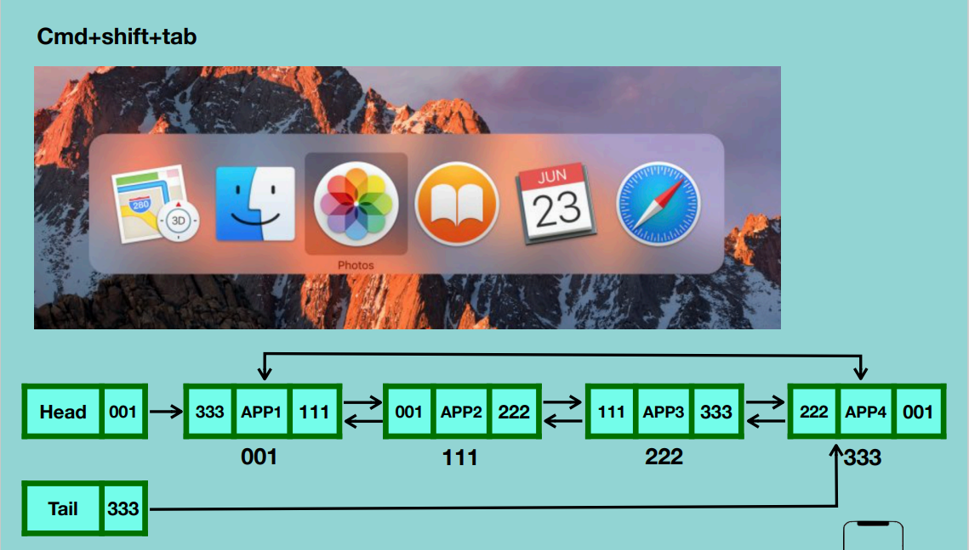

Looping through a list infinitely both forwards and backwards.

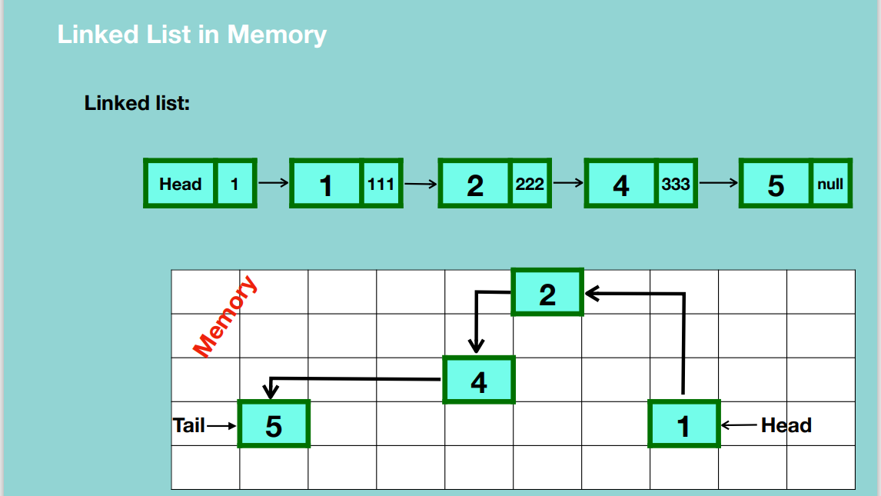

**Creation of a Singly Linked List**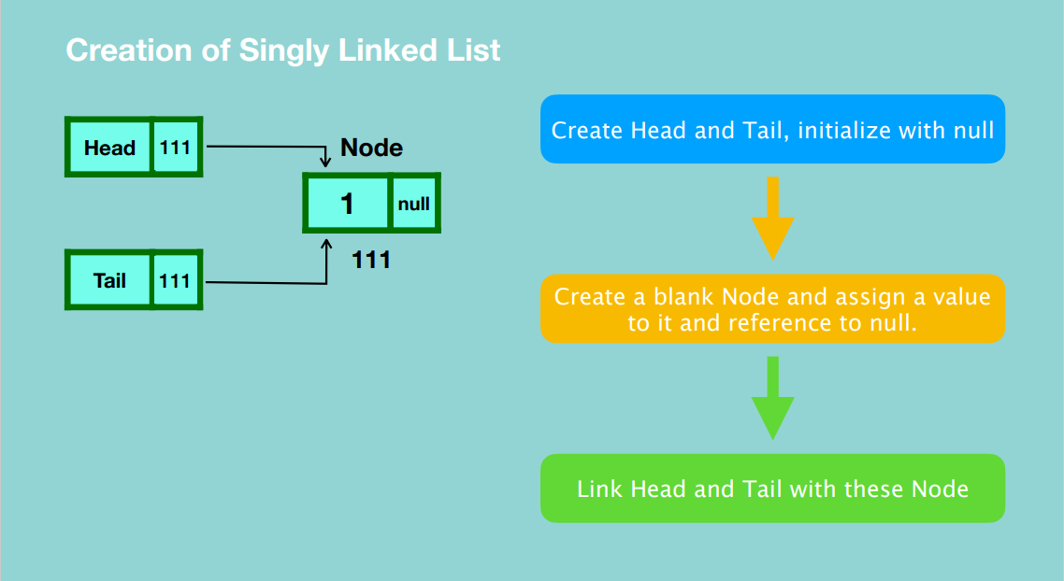

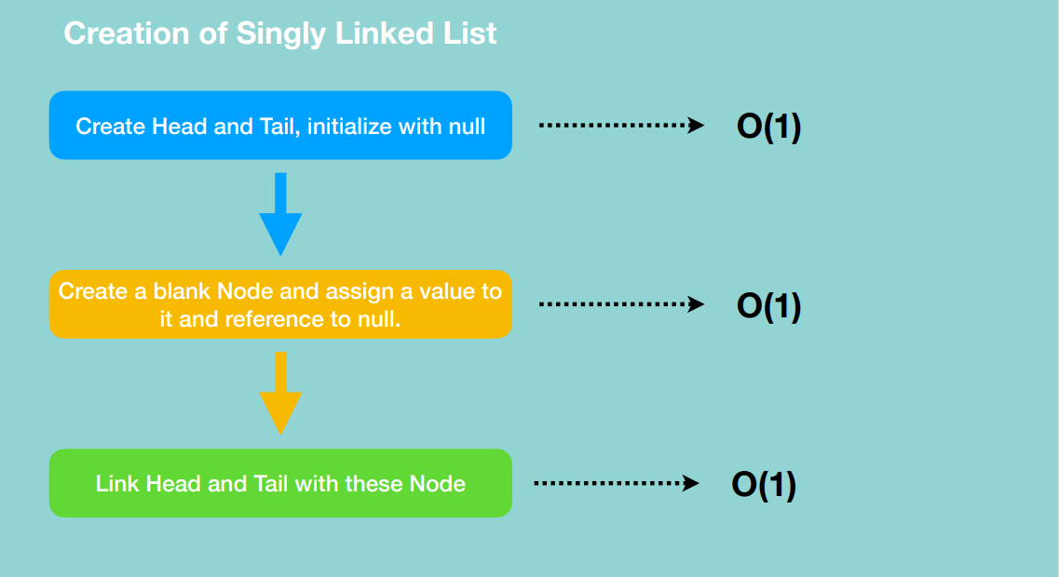

**INSERTION**

1. At the beginning of the linked list.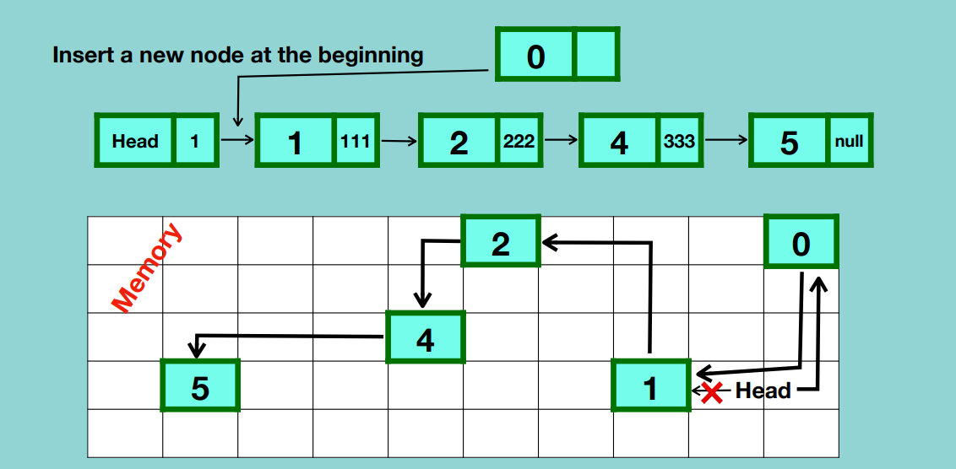

* Allocate random memory for the new node.
* Point the new node to the location of the first node.
* Point the head to the location of the new node and connection between the head and the previously first node will be broken.

2. After a node in the middle of linked list

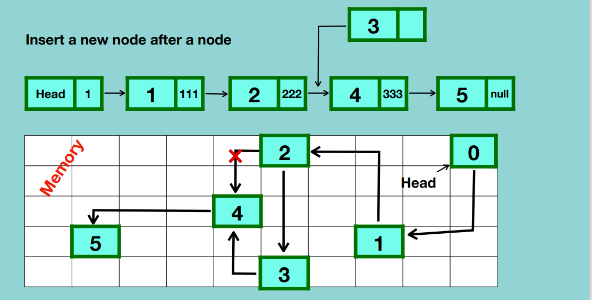

* Traverse from the head to the node after which the new node will be added i.e. 2.
* Allocate a random memory location for the new node.
* Point the new node to the next node of the node after which it’s going to be inserted.
* Point the current node i.e. 2 to the new node and the connection with the previous node will be broken.

1. At the end of the linked list.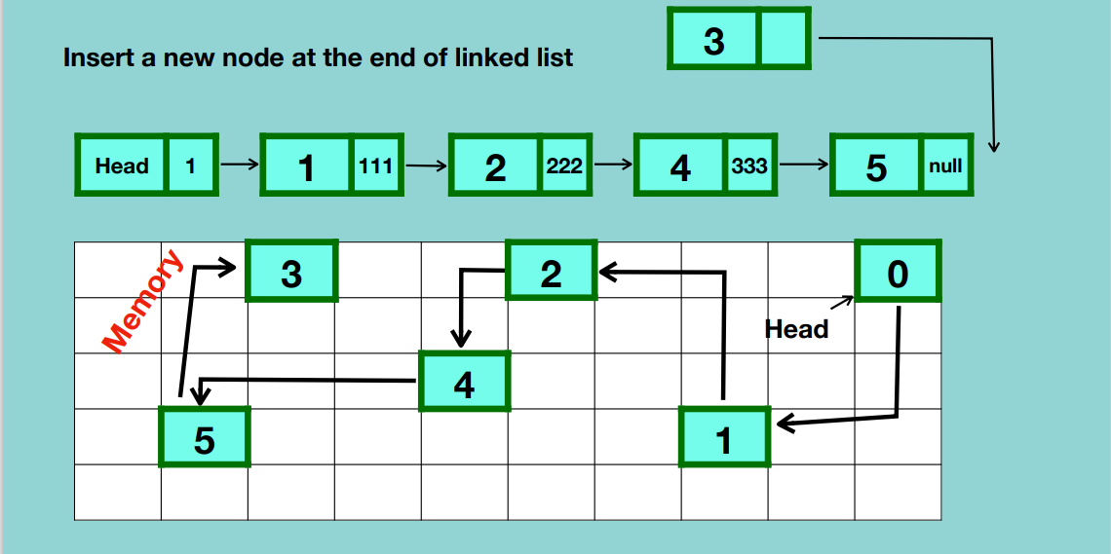

* Traverse from the first element to the last node.
* Allocate a random memory for the new node.
* Update the reference of the last node to point to the new node.
* Make the tail point to the new node.

Adding an element at the beginning of the linked list is very efficient because there is no updating of linking nor is there traversing while adding at the end of the linked list needs you to traverse the entire linked list and change the linking.

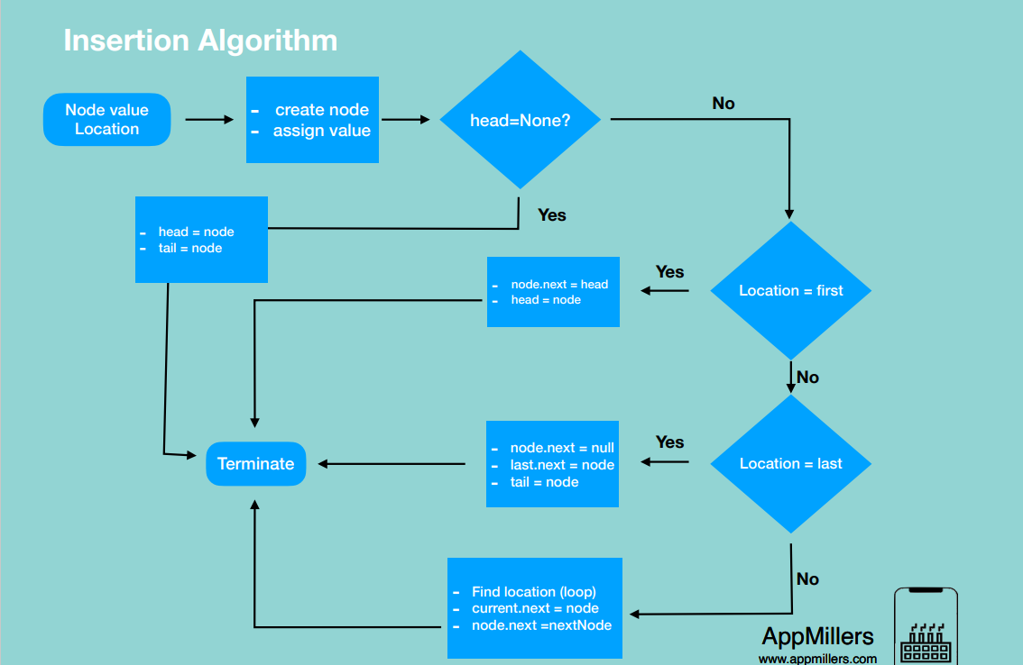

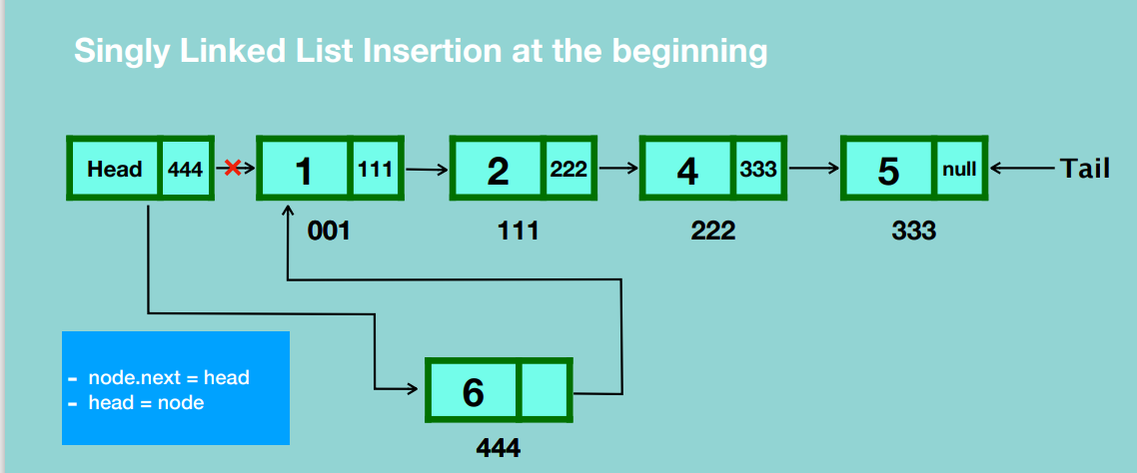

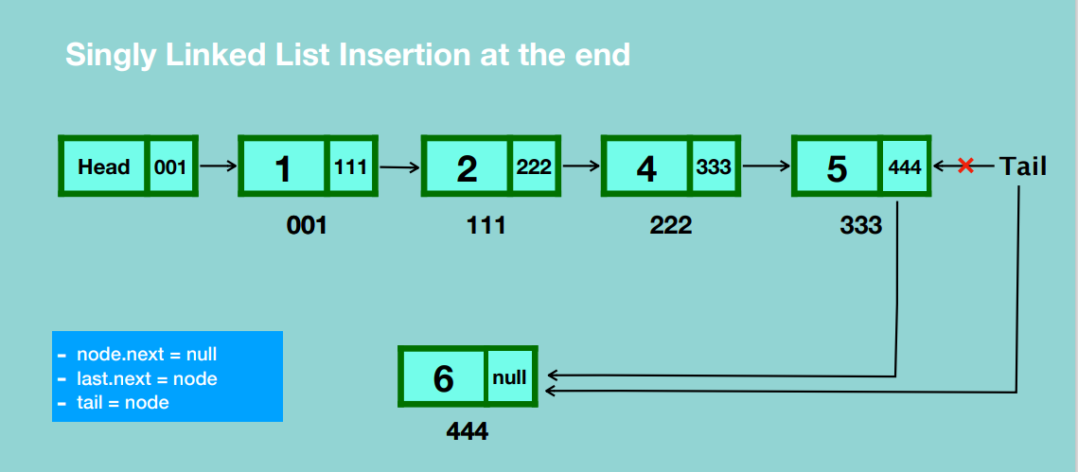

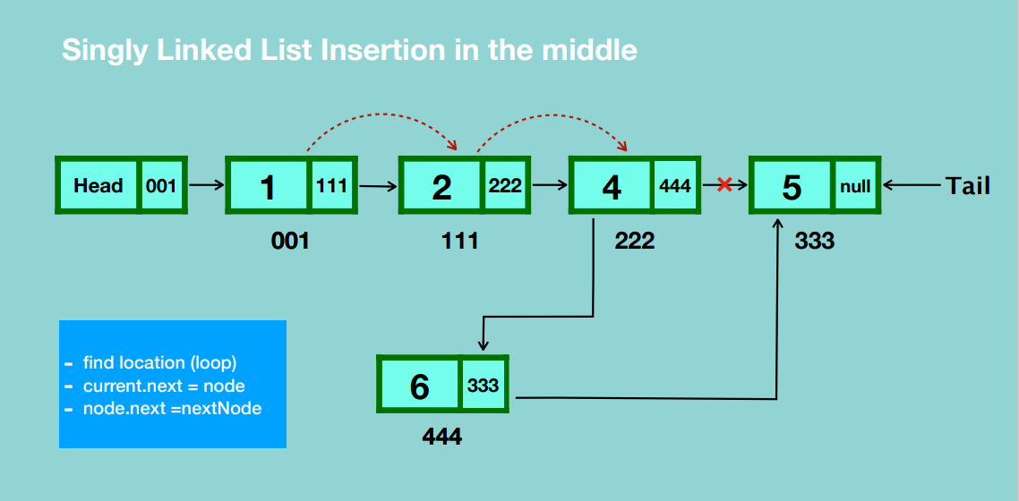

**TRAVERSAL**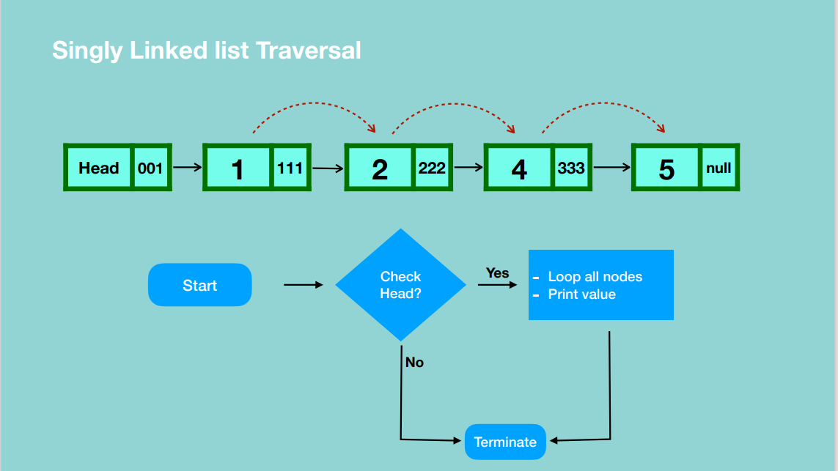

**SEARCH**

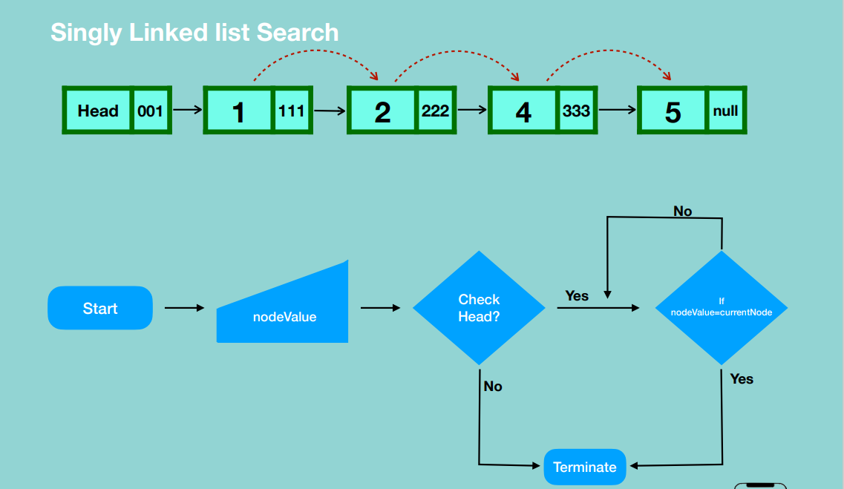

**DELETION**

1. Deleting the first node

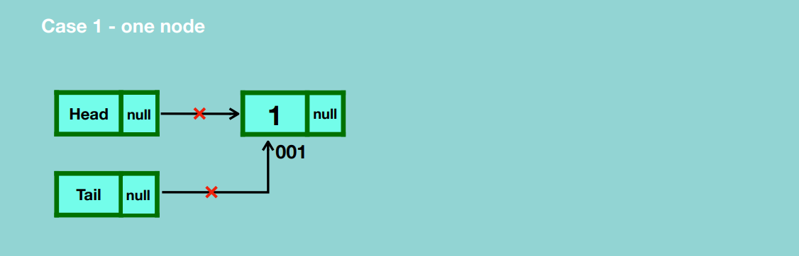

* Update head and tail references to null.
* Garbage collection deletes the node.

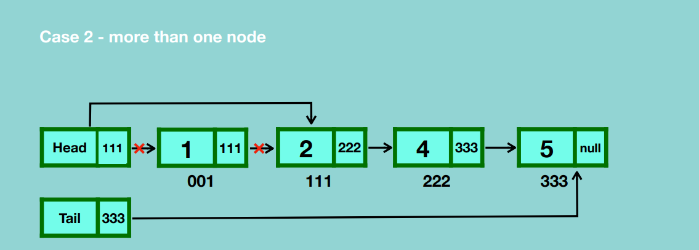

* Update the head reference to the second node which breaks the connection the the first node.
* Update the first node reference to null.
* Garbage collection takes place.

1. Deleting any given node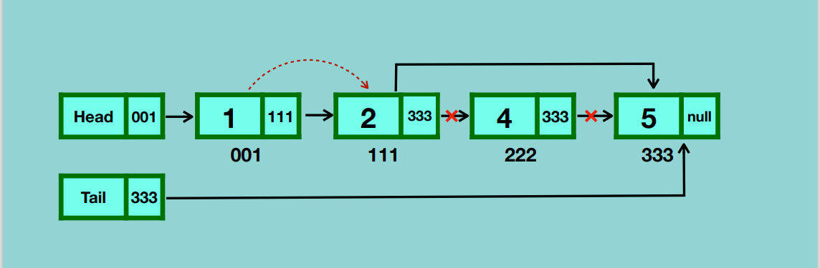

* Traverse to the node that is before the node that you want to delete.
* Update the reference of the current node to that of the node after the one you want to delete.
* Update the reference of the node you want to delete to null.
* Garbage collection takes place.

1. Deleting the last node

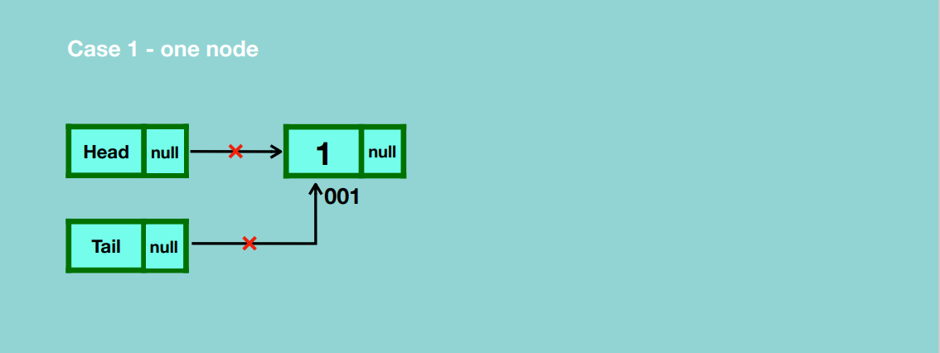

* Update the reference of head and tail to null.
* Garbage collection takes place.

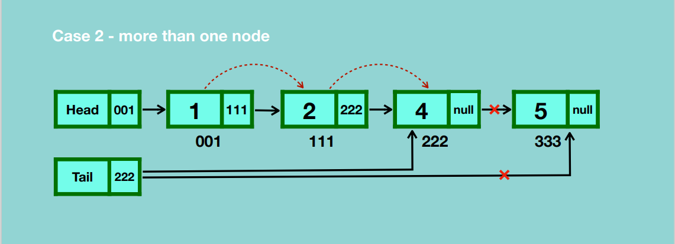

* Traverse to the node before the last node.
* Update the reference of the node before the last node to null.
* Update the reference of the tail to the node before the last node.
* Garbage collection takes place.

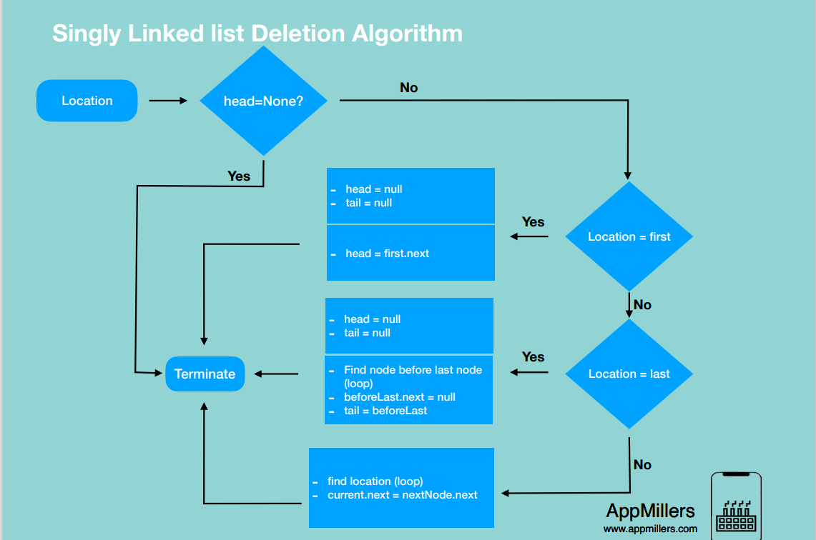

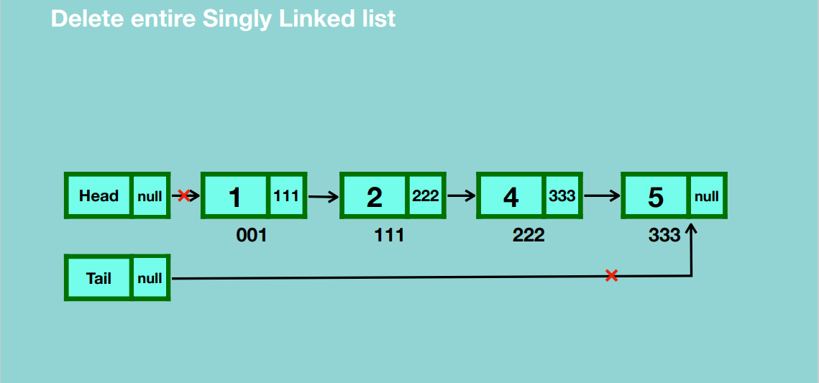

* Disconnect head and tail references from the first and last node of the linked list.
* Garbage collection will handle removal of all the nodes.

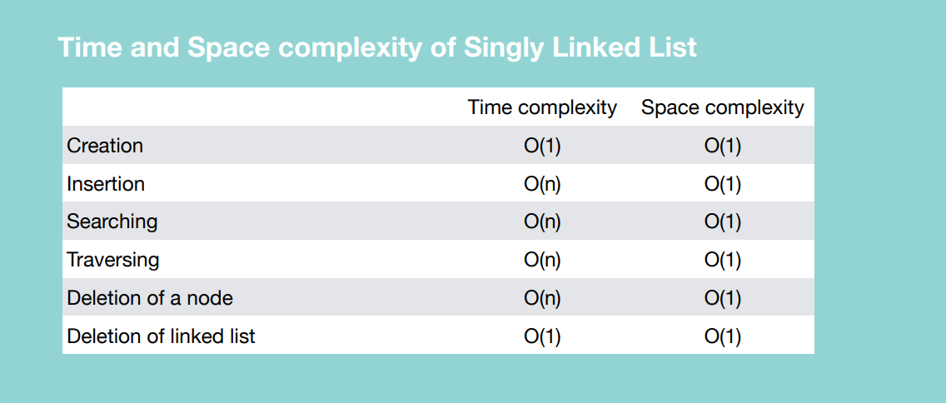

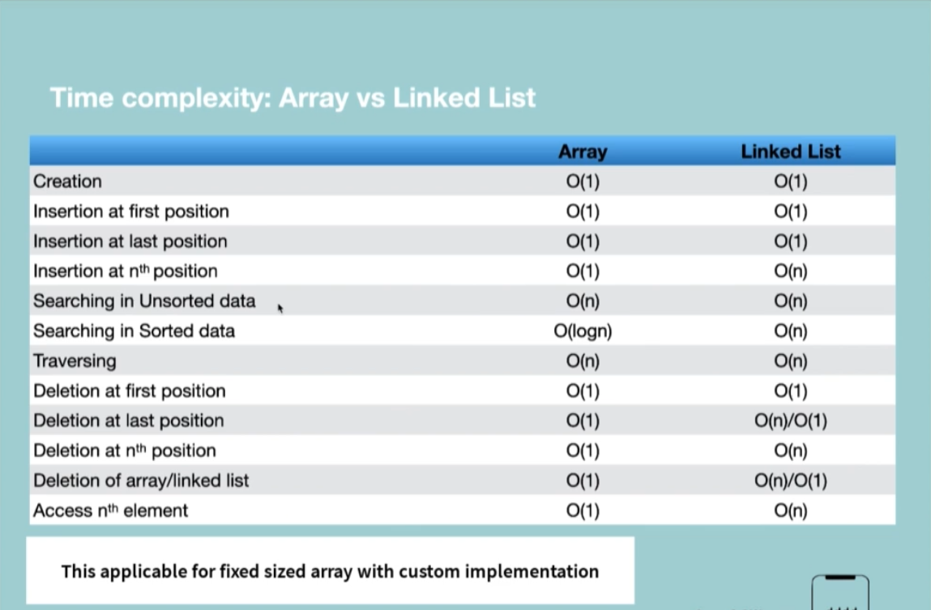

**CIRCULAR SINGLY LINKED LIST**

Last node points to the first node.

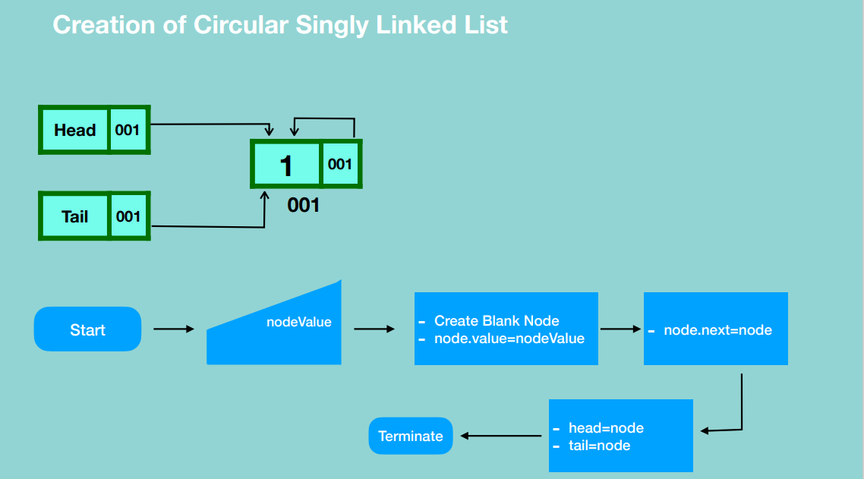

* Here the first node references itself after creation.
* The head and tail reference the first node.

**INSERTION**

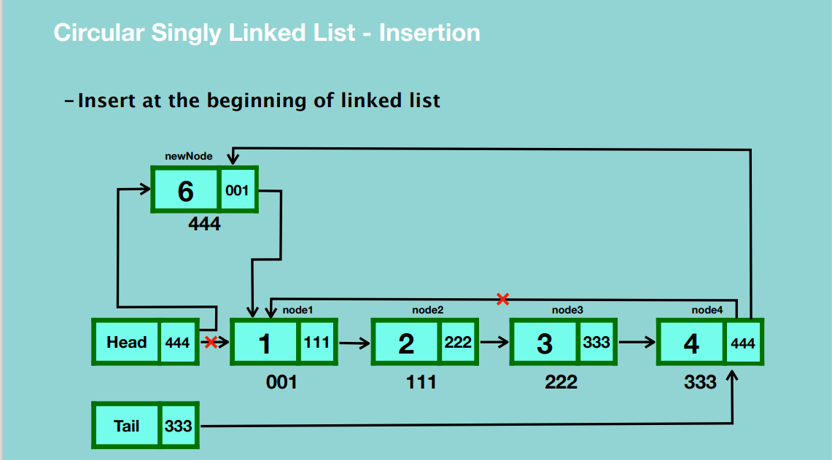

* Create a blank node and assign a value to it.
* Update the reference of the new node to the first node.
* Update the reference of the head to the new node.
* Update the last node’s reference to the new node.

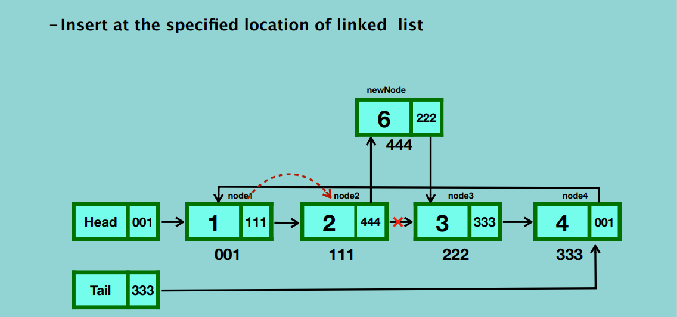

* Create a new node and assign a value to it.
* Traverse from the first node to the node after which you’re going to insert the new node.
* Update the reference of the new node to the node that the current node is pointing to.
* Update the reference of the current node to the new node.

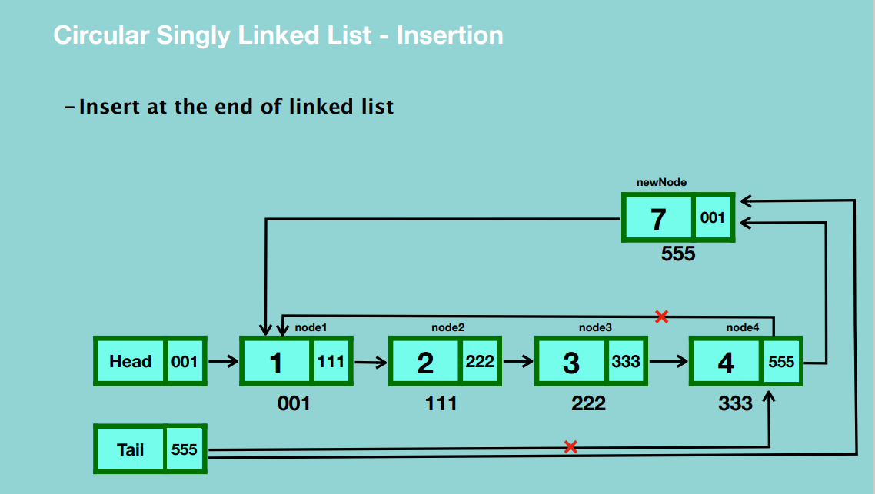

* Update the reference of the last node to the new node’s location.
* Update the reference of the tail to the new node.
* Update the reference of the new last node to the first node.

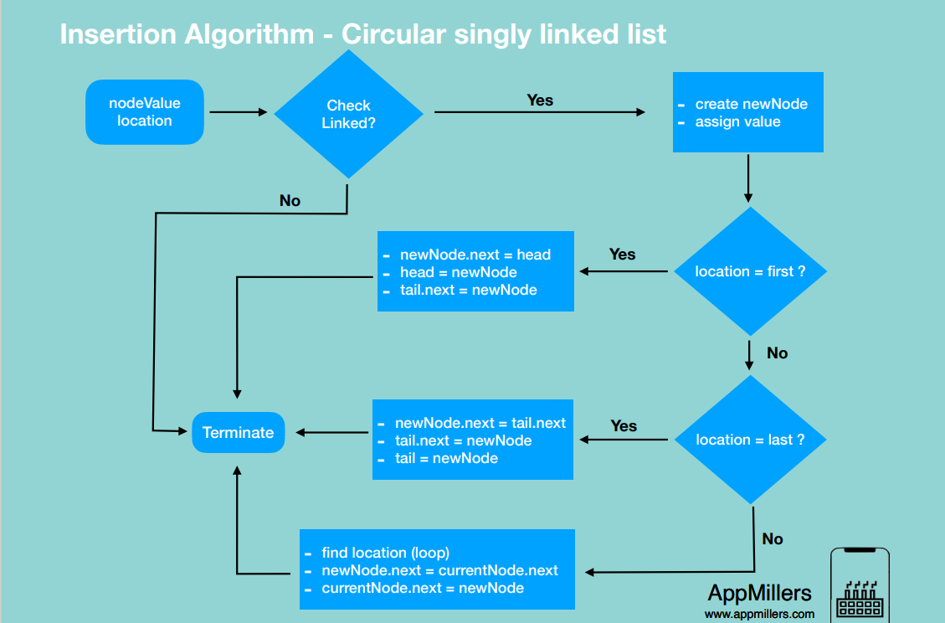

**SEARCHING**

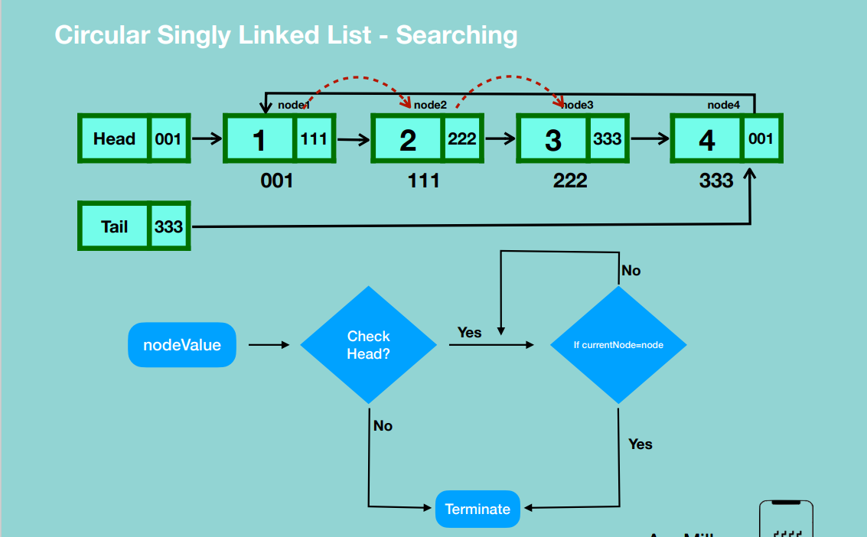

**DELETION**

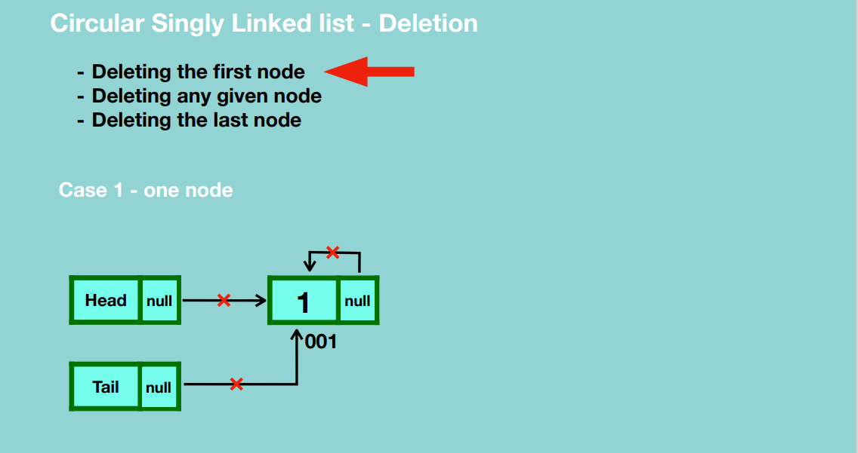

* Update all references that point to the node to null. i.e. update reference of head to null, reference of tail to null and reference of the node itself to null.
* Garbage collection takes place.

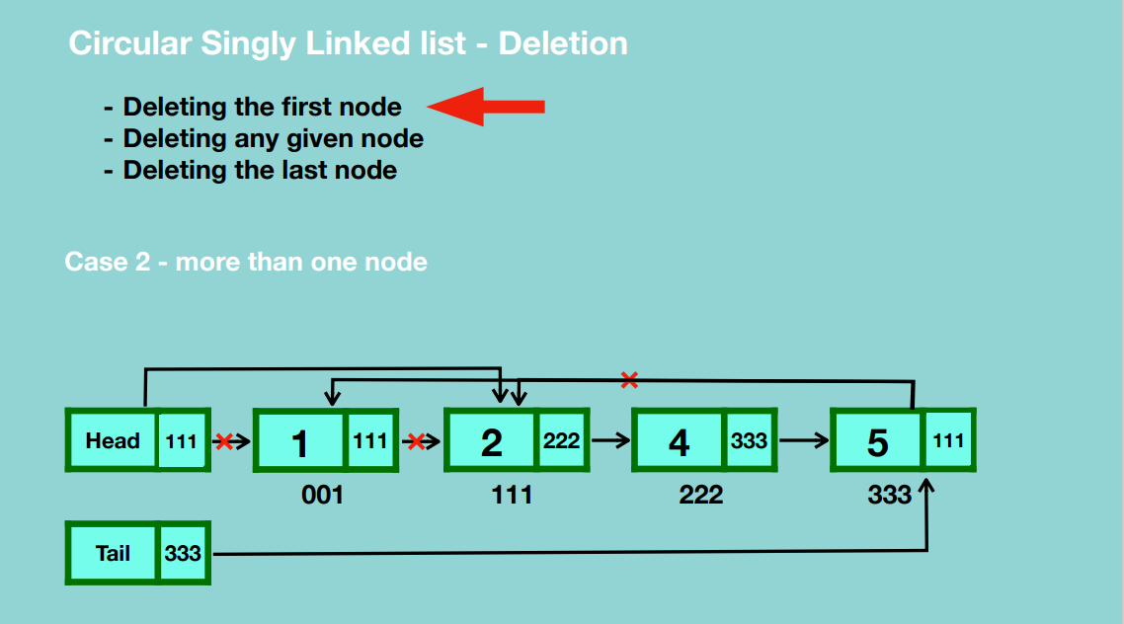

* Update reference of the head node to the second node.
* Update the reference of the last node to the second node.
* Garbage collection takes place.

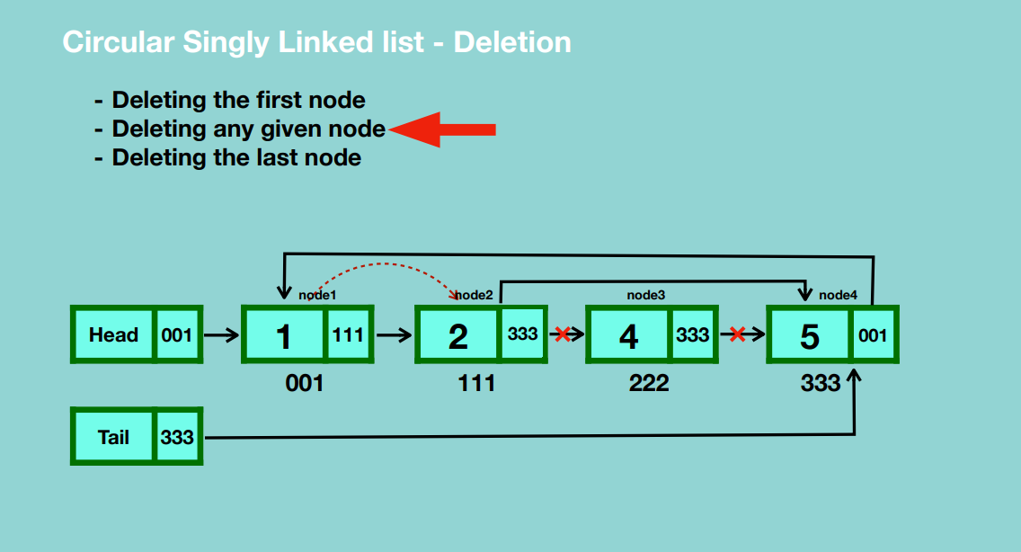

* Traverse from head node to the node before the one we want to delete.
* Update the current node’s reference to the one after the node we want to delete.
* Update the reference of the node we want to delete to null.
* Garbage collection takes place.

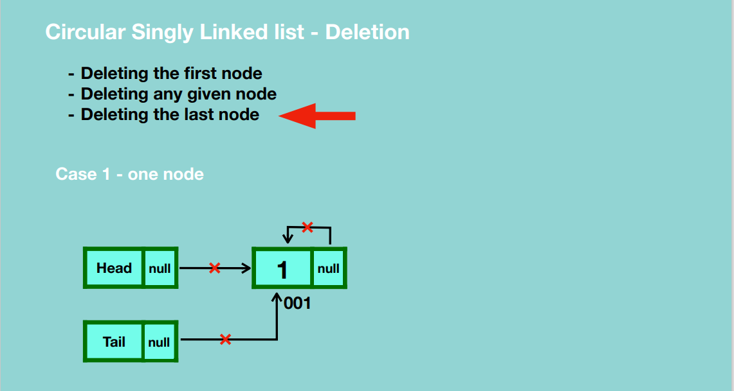

* Update head and tail references to null.
* Update the node’s reference to null.
* Garbage collection takes place.

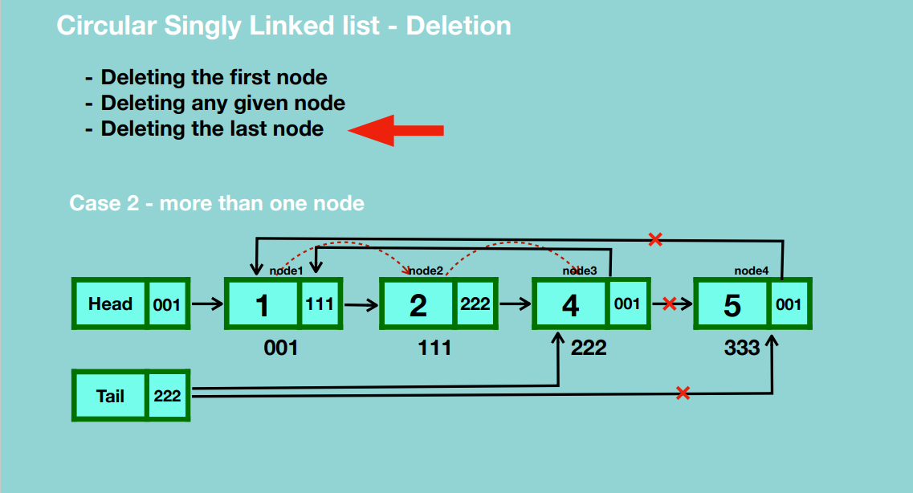

* Traverse till we reach the node before the last node.
* Update the reference of the current node to point to the first node.
* Update the reference of the node to be deleted to null.
* Update the tail reference to point to the current node.
* Garbage collection takes place.

**Delete entire linked list**

* Set head reference to null.
* Set reference of last node to null.
* Set tail reference to null.

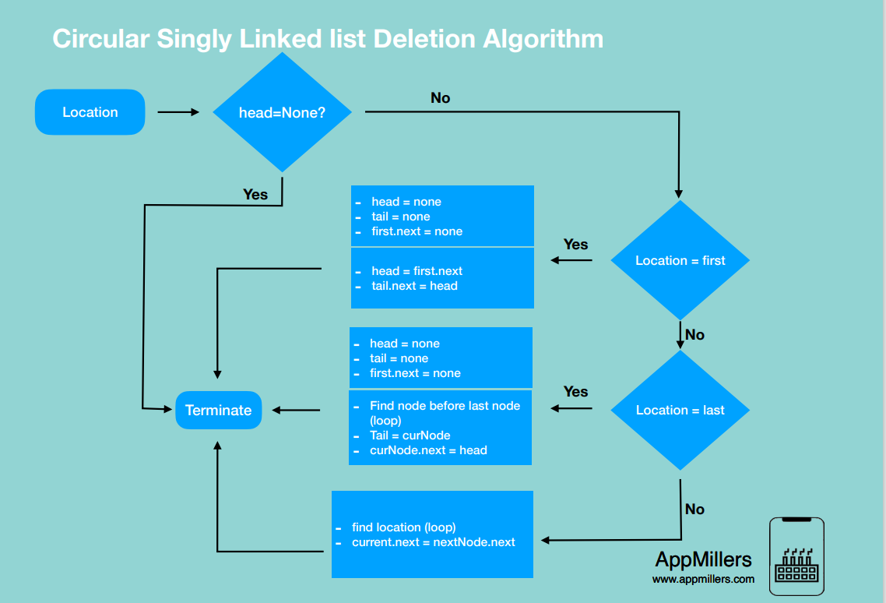

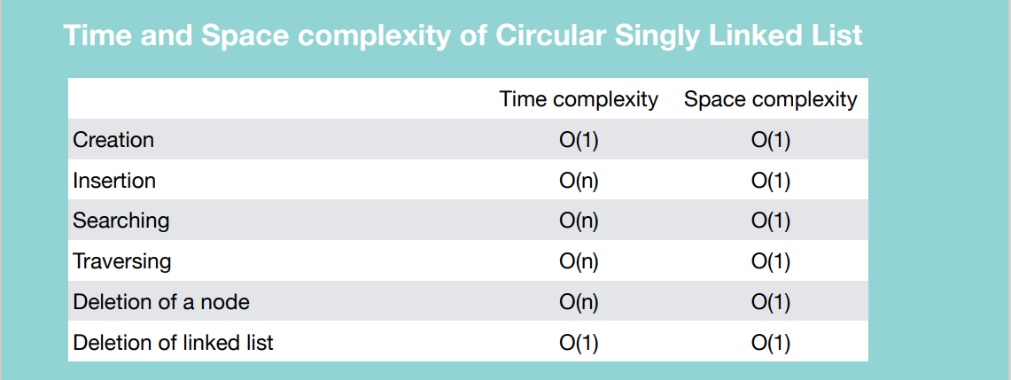

**DOUBLY LINKED LIST**

Each node contains two references, that references previously and forwards.

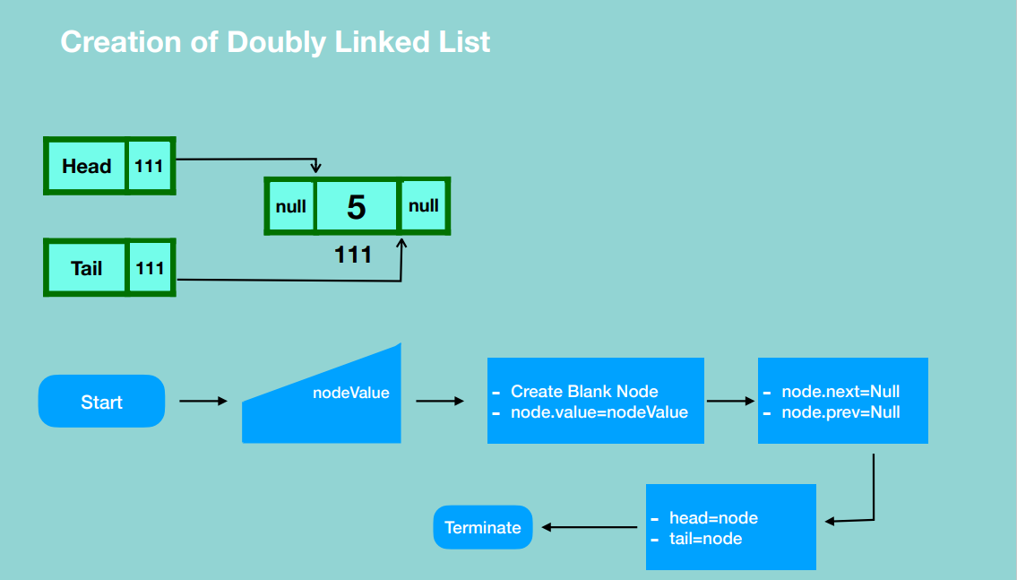

* Create head and tail references, then create a blank node and assign it a value giving it a previous and forward references to null.
* Update the head and tail references to point to the new node.

**INSERTION**

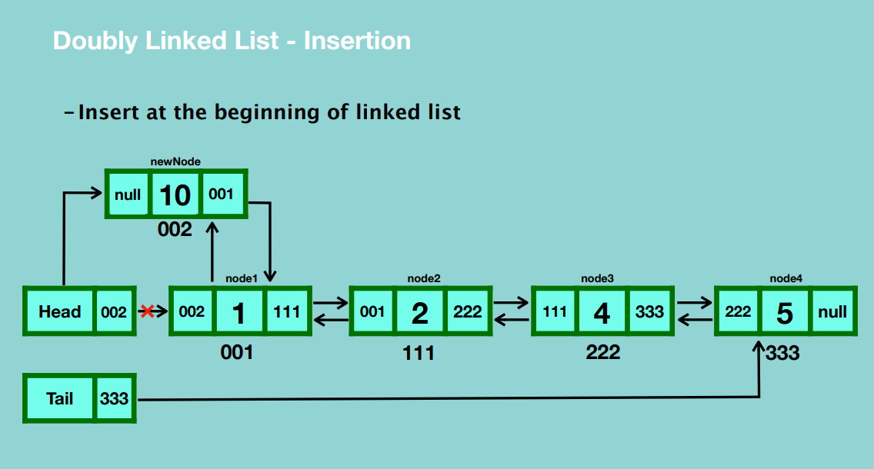

* Create a blank node in memory and assign it a value.
* Set the node’s previous reference to null.
* Set the new node’s next reference to the first node.
* Update the previous reference of the first node the location of the new node.
* Update the reference of the head to the location of the new node.

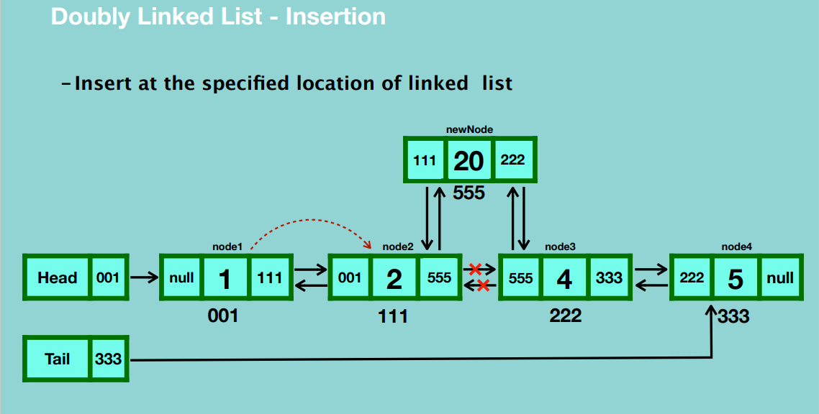

* Create a blank node and assign it a value.
* Traverse through the doubly linked list until we reach the node which is before the node we want to insert before.
* Update the new node’s next reference to the current node’s next reference.
* Update the previous reference of the new node to the location of the current node.
* Update the next reference of the current node to the location of the new node.
* Update the previous reference of the current node’s next reference to point to the new node.

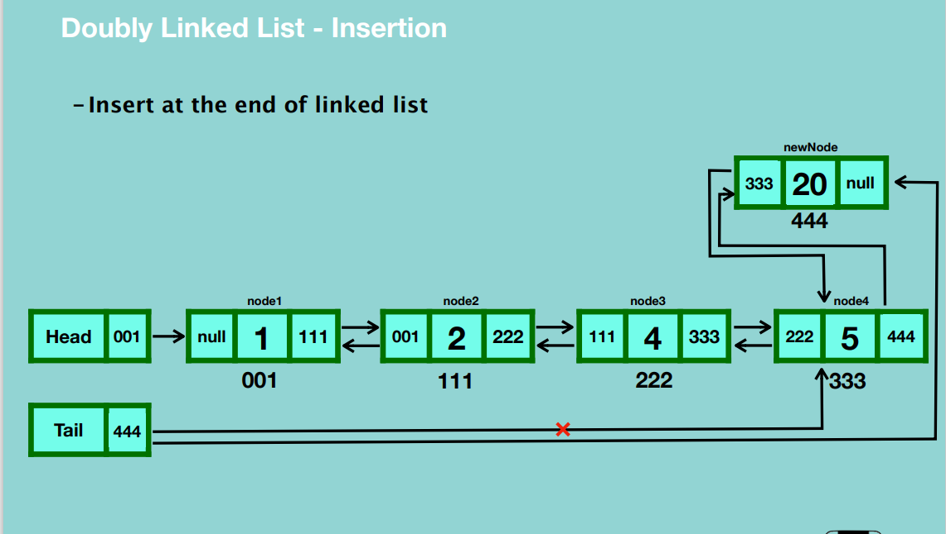

* Create a blank node and assign it a value.
* Update the next reference of the new node to null.
* Update the previous reference of the new node to the last node.
* Update the next reference of the last node to point to the new node.
* Update the reference of the tail to the new node.

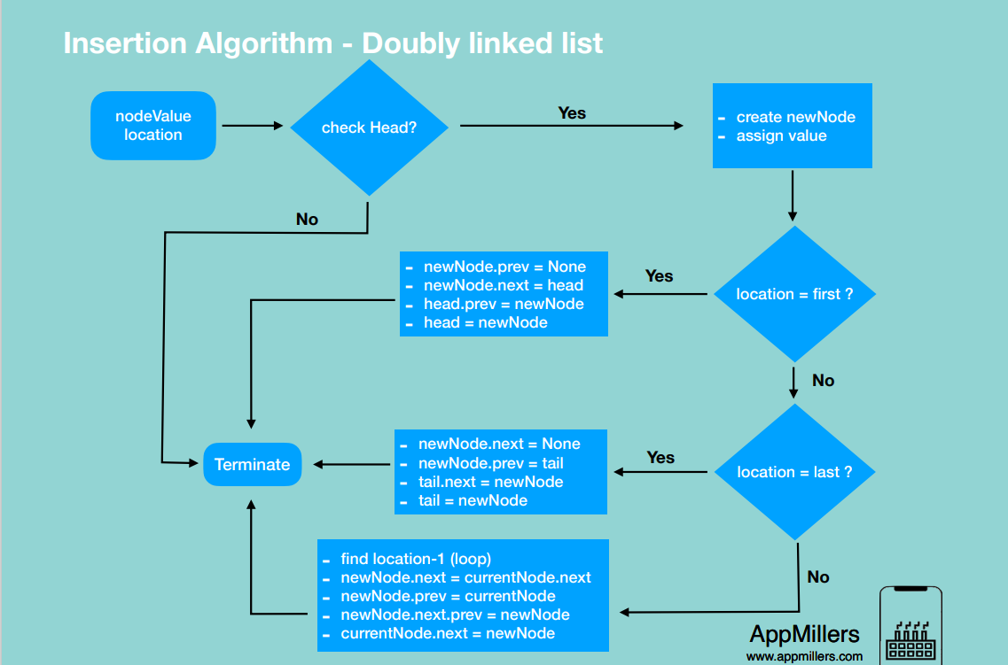

**DELETE**

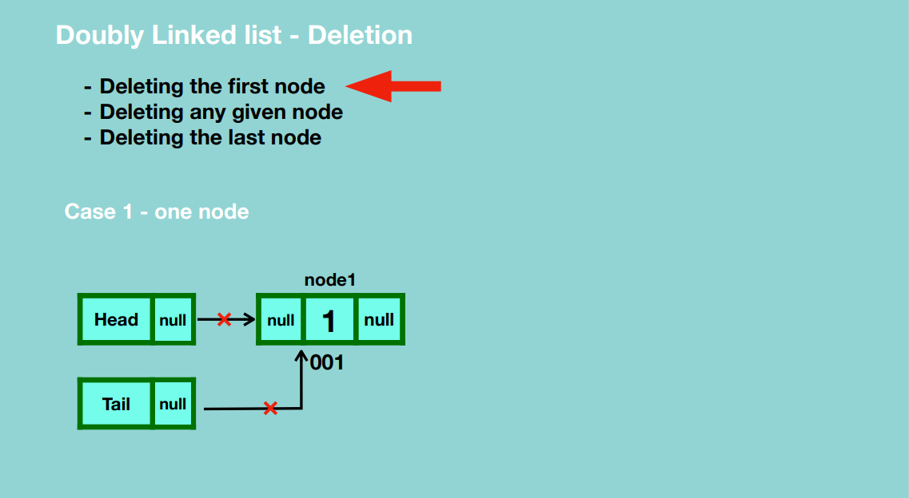

* Update the head and tail reference to null.
* Garbage collection takes place.

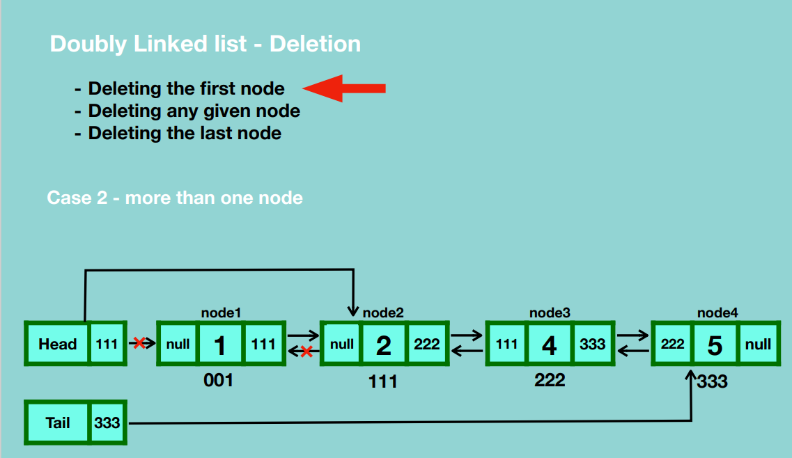

* Update head reference to point to the second node.
* Update the previous reference of the second node to null.
* Garbage collection takes place.

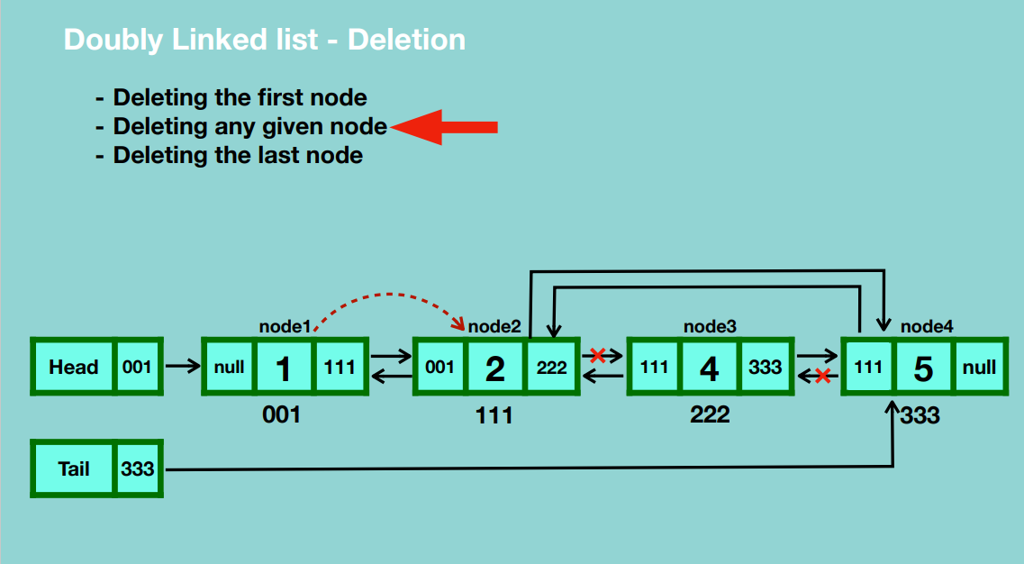

* Traverse from the first node up to the node before the one you’re deleting.
* Update the reference of the current node to the next reference of the node you’re planning to delete.
* Update the previous reference of the next node after the one we’re deleting to the current node.
* Garbage collection.

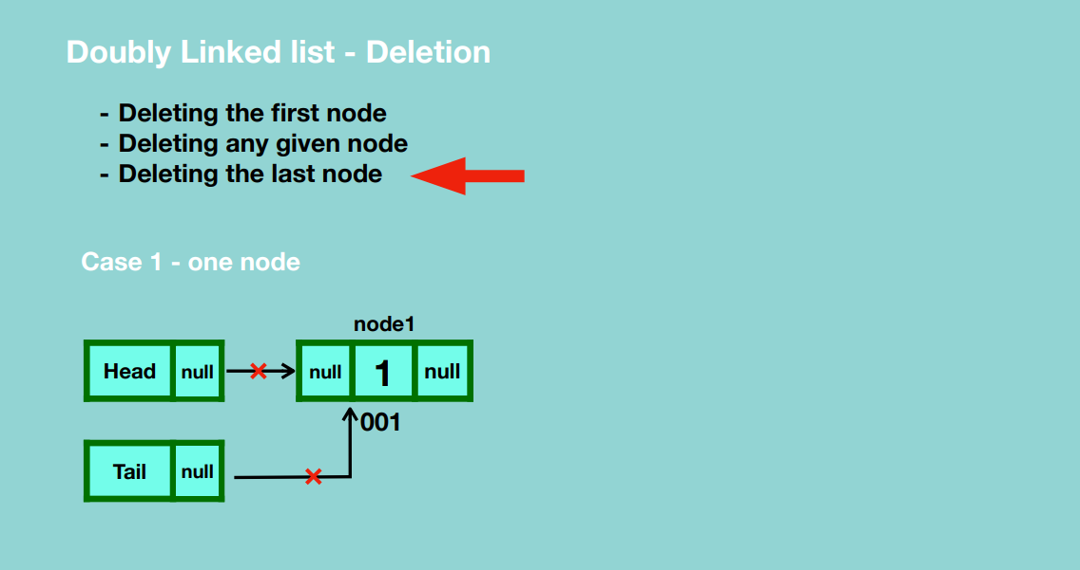

* Update the head and tail reference to null.
* Garbage collection.

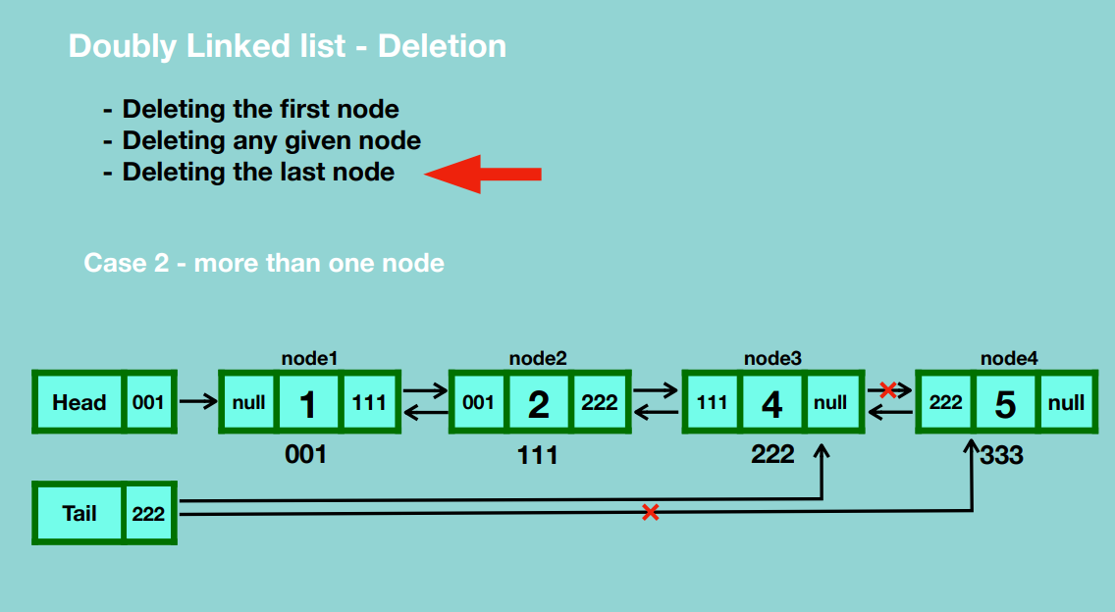

* Update the tail reference to point to the node before the last node.
* Update the next reference of the node before the last node to null.
* Garbage collection when no node points to that particular node.

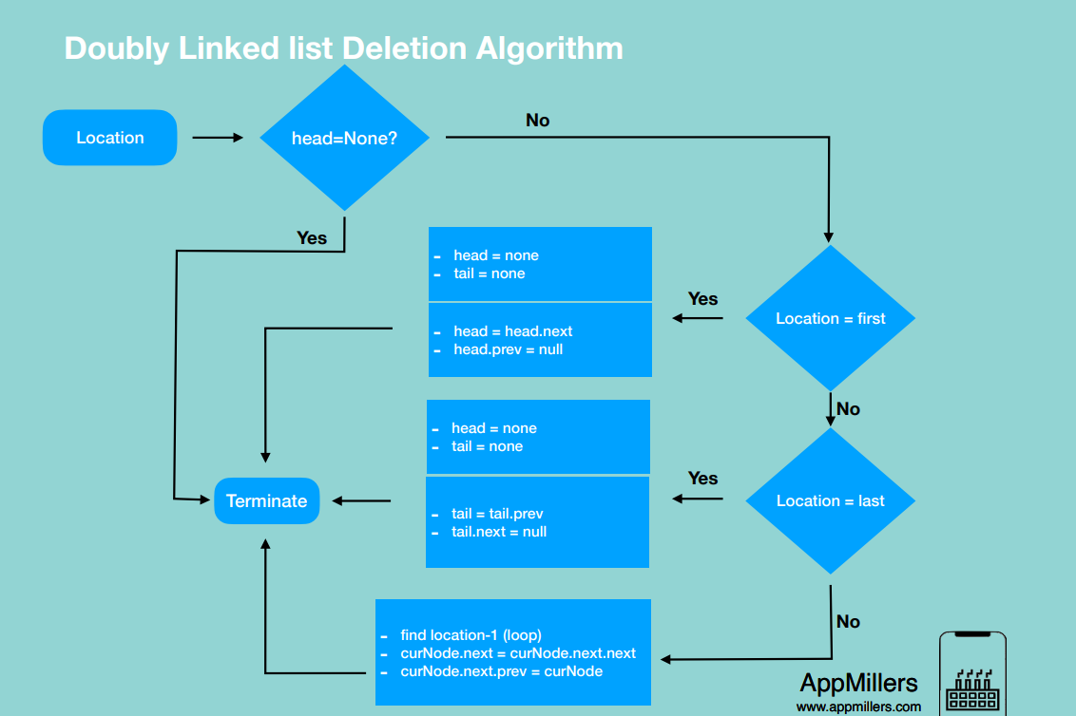

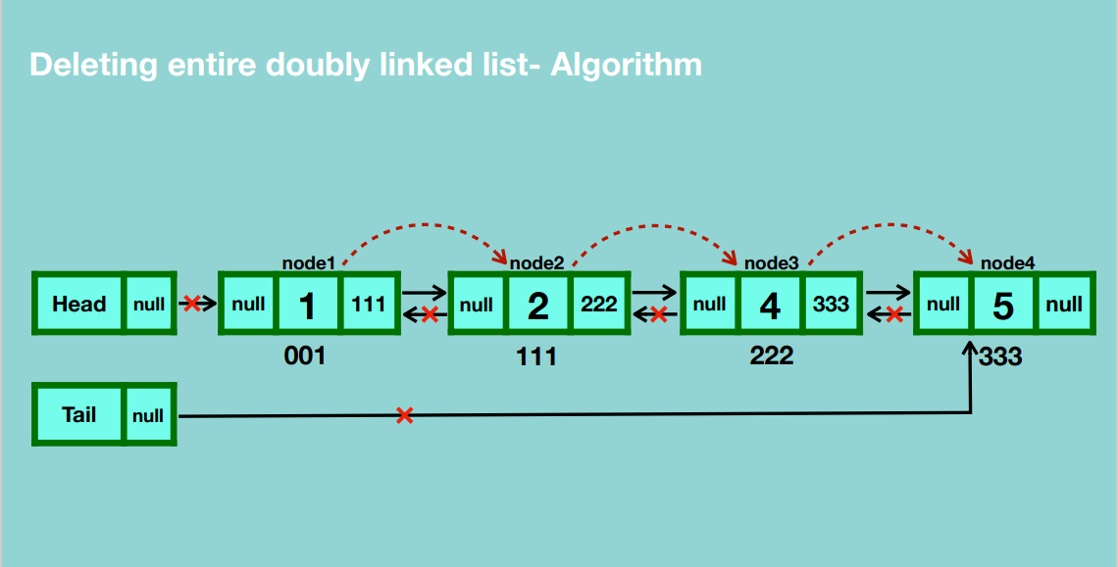

* Traverse through the linked list and update the nodes’ previous references to null.
* Set the head reference to null.
* Set tail reference to null.
* Garbage collection.

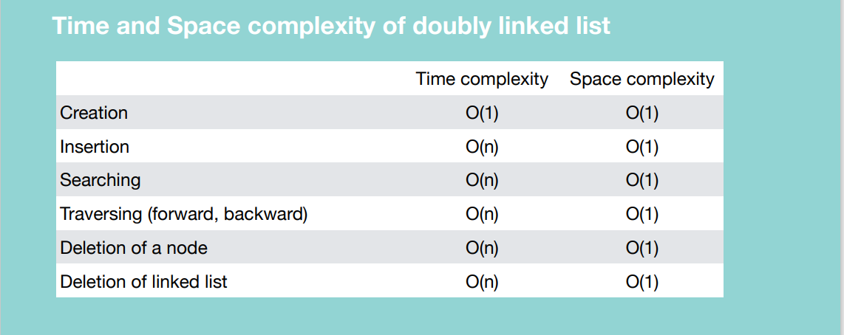

**CIRCULAR DOUBLY LINKED LIST**

**CREATION**

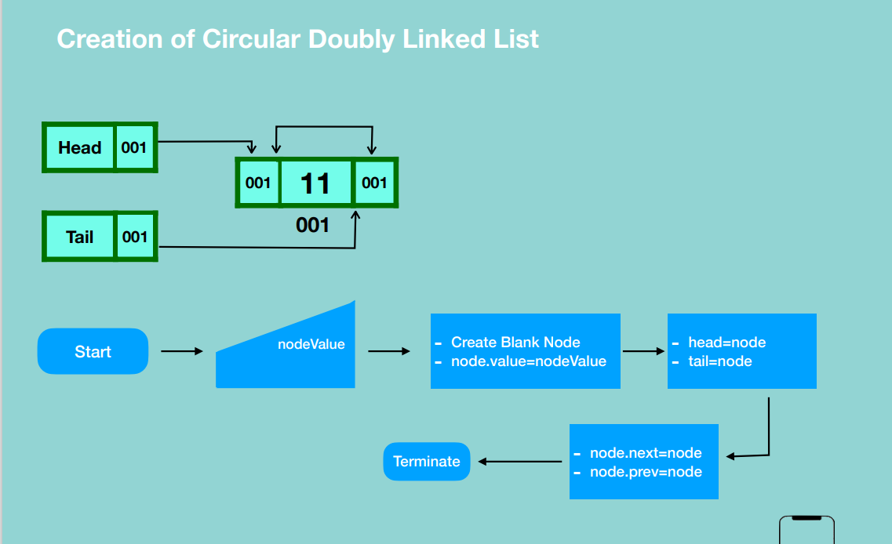

* Create a blank node and give it a value.
* Update the head’s reference to the location of the new node.
* Update the tail’s reference to the location of the new node.
* Update the new node’s previous and next references to itself.

**INSERTION**

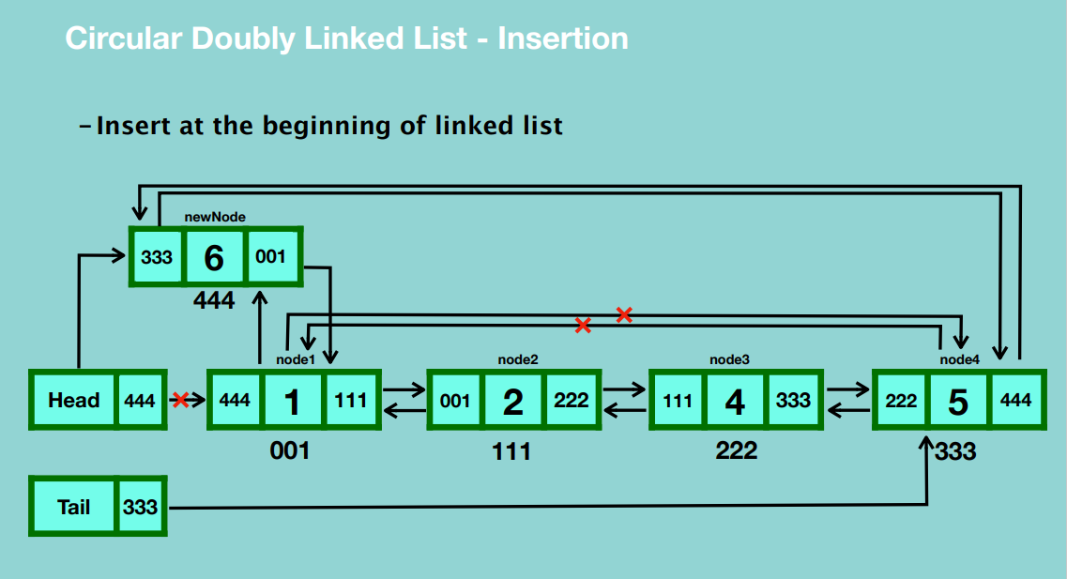

* Create a blank node and assign it a value.
* Update the next reference of the new node to the location of the first node.
* Update the previous reference of the new node to the last node.
* Update the last node’s next reference to the new node’s location.
* Update the first node’s previous location to the new node’s location.
* Update the head’s reference to point to the new node.

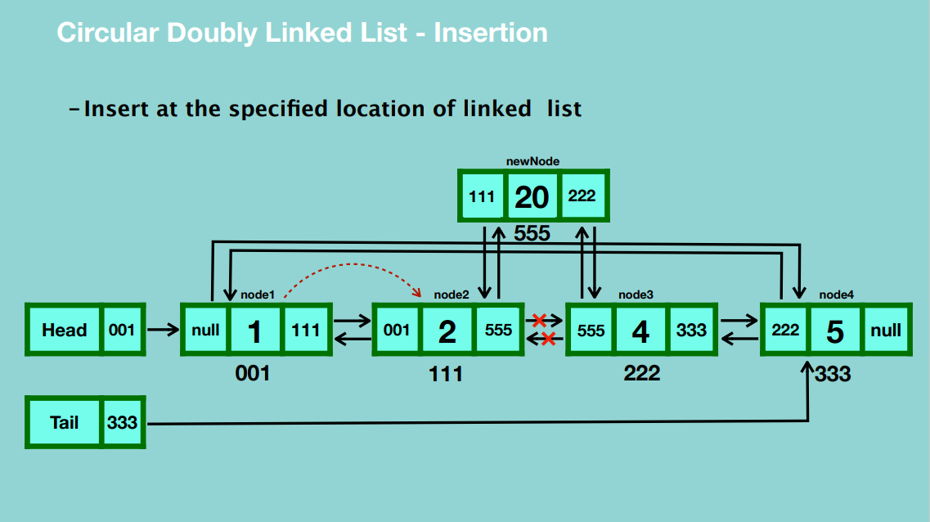

* Create a blank node and assign a value to it.
* Traverse to the node before the position you want to insert the new node.
* Update the new node’s next reference to the location of the node after the current node.
* Update the previous reference of the new node to the current node.
* Update the current node’s next reference to the location of the new node.
* Update the previous reference of the node after the current node to point to the location of the new node.

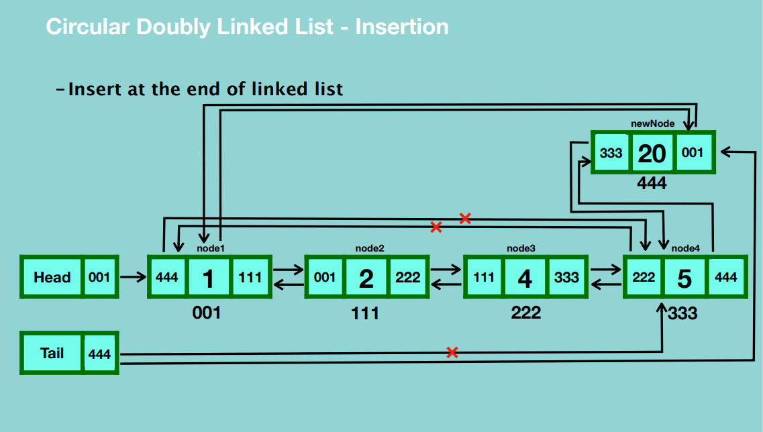

* Create a blank node and assign a value to it.
* Update the next reference of the new node to point to the first node.
* Update the previous reference of the new node to the location of the last node.
* Update the next reference of the last node to the location of the new node.
* Update the tail reference to point to the new node.
* Update the previous reference of the first node to the new node.

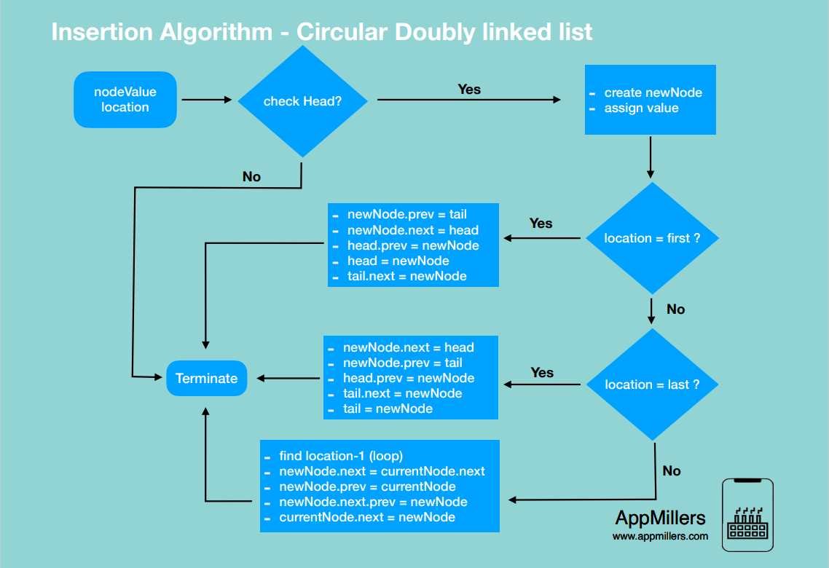

**DELETION**

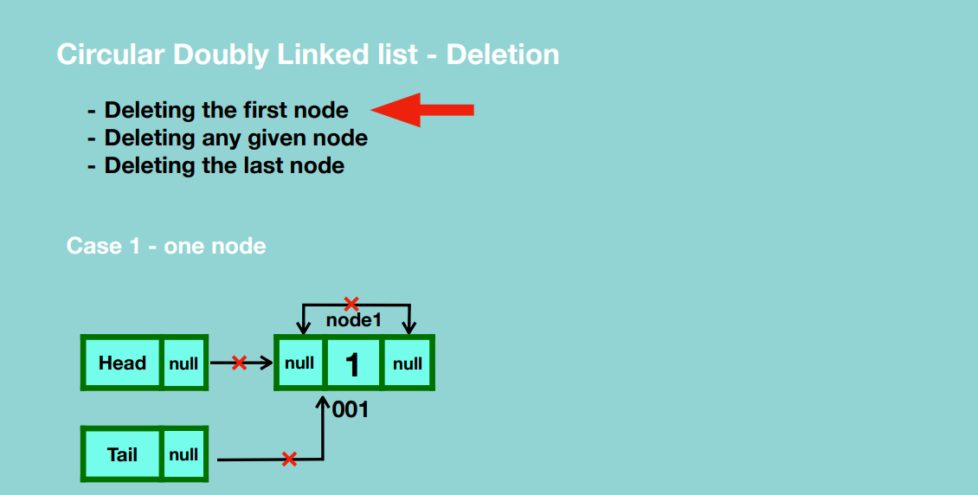

* Update the previous and next references of the node to null.
* Update the head and tail references to null.
* Garbage collection takes place.

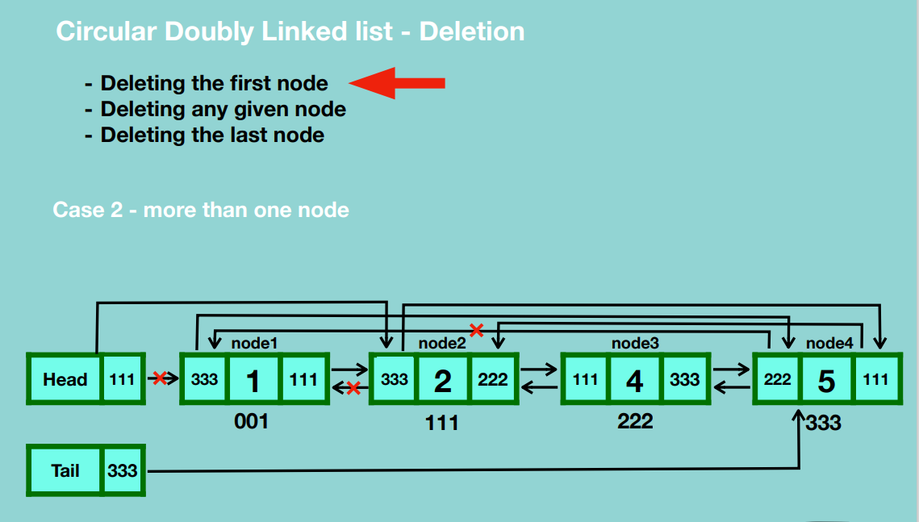

* Update the last node’s next reference to the second node.
* Update the head’s reference to point to the second node.
* Update the second node’s previous reference to the last node.
* Garbage collection takes place.

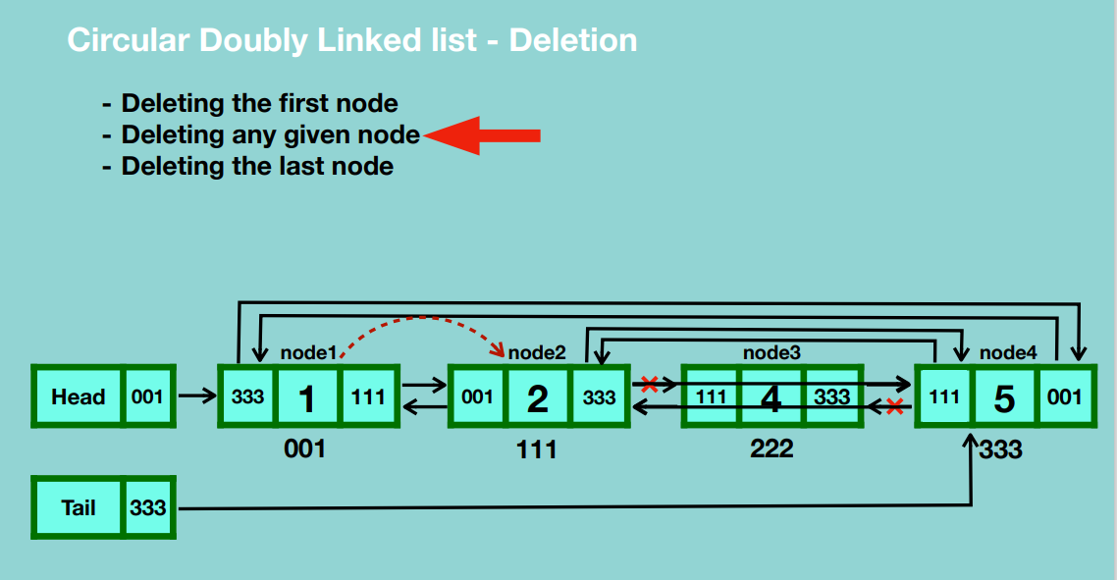

* Traverse to the node before the one you want to delete.
* Update the current node’s next reference to the node after the one you want to delete.
* Update the previous reference of the node after the one you want to delete to the current node.
* Garbage collection takes place.

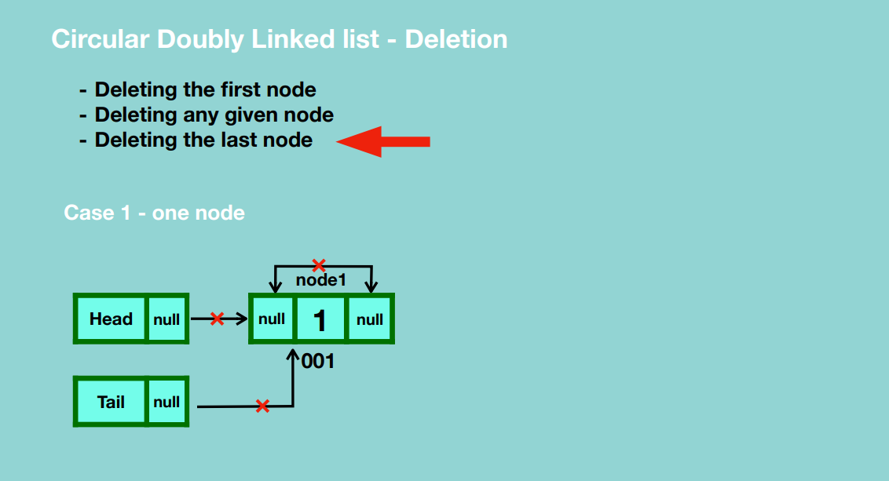

* Update the previous and next references of the node to null.
* Update the head and tail references to null.
* Garbage collection takes place.

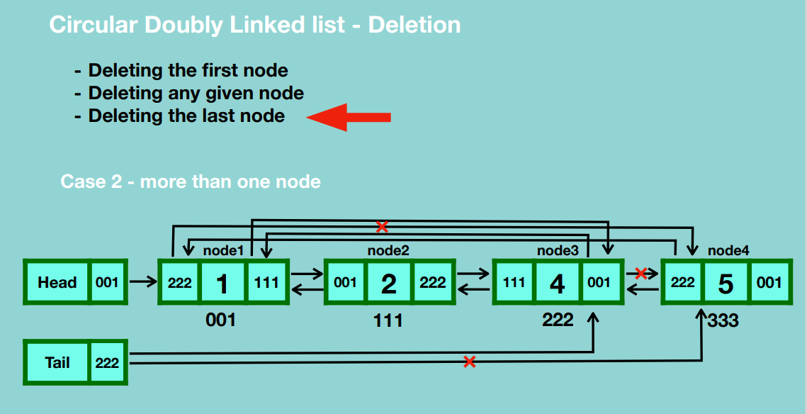

* Update the tail reference to point to the node before the last node.
* Update the next reference of the node before the last node to point to the first node.
* Update the previous reference of the first node to point to the node before the last node.
* Garbage collection takes place.

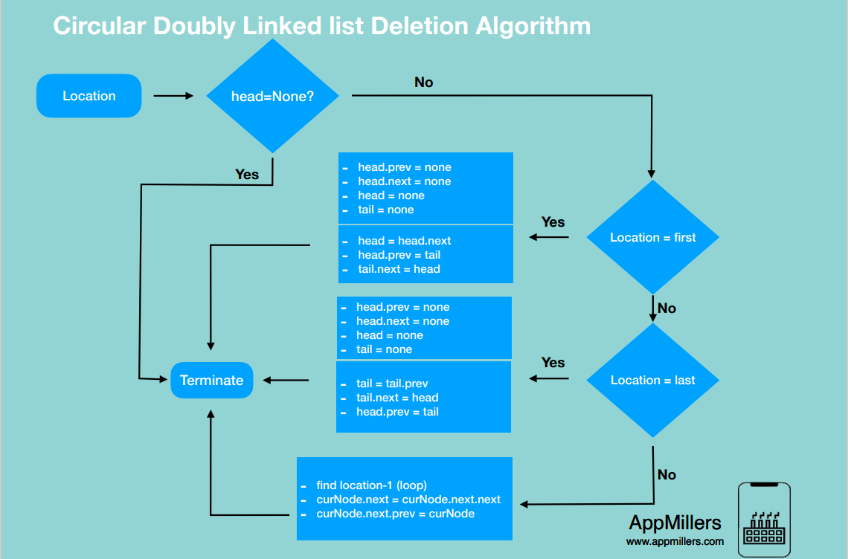

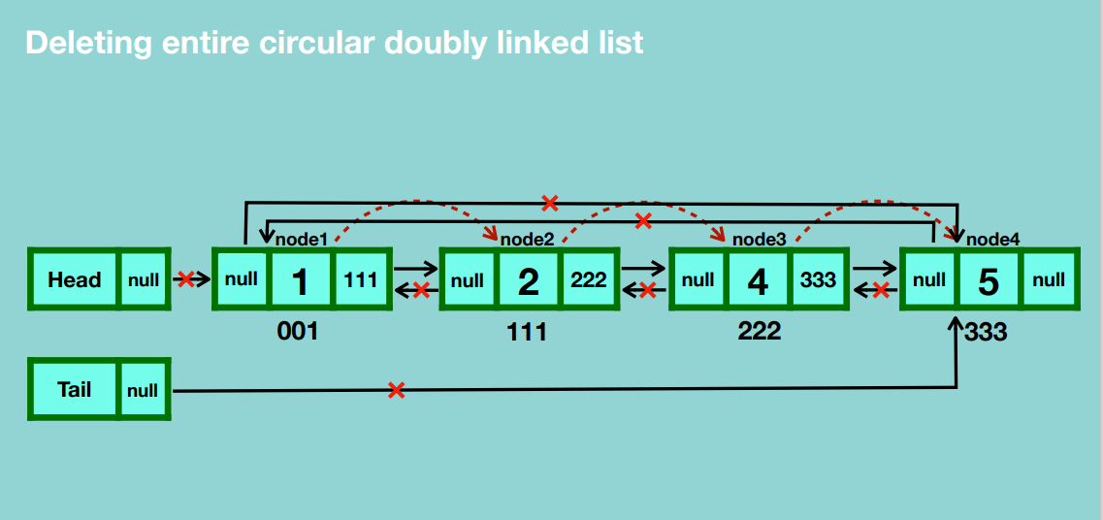

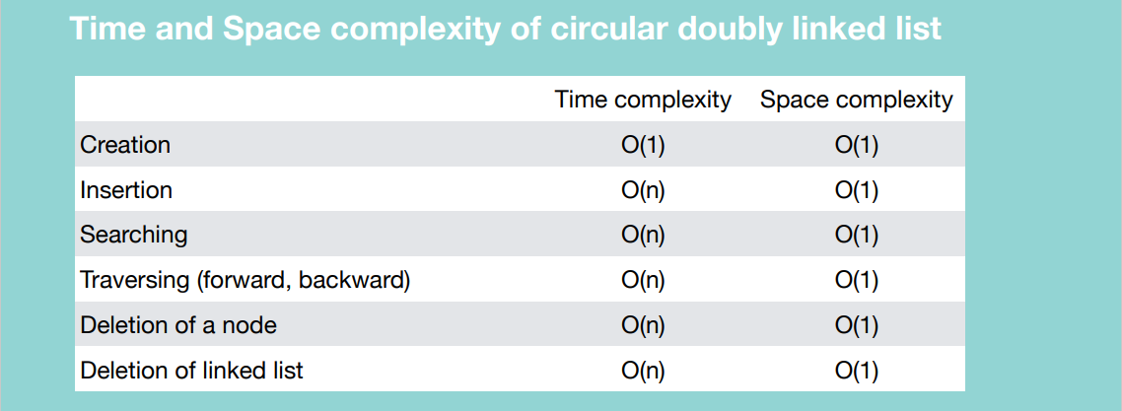

**STACK**

Stack is a data structure that stores items in a Last-In/First-Out manner.

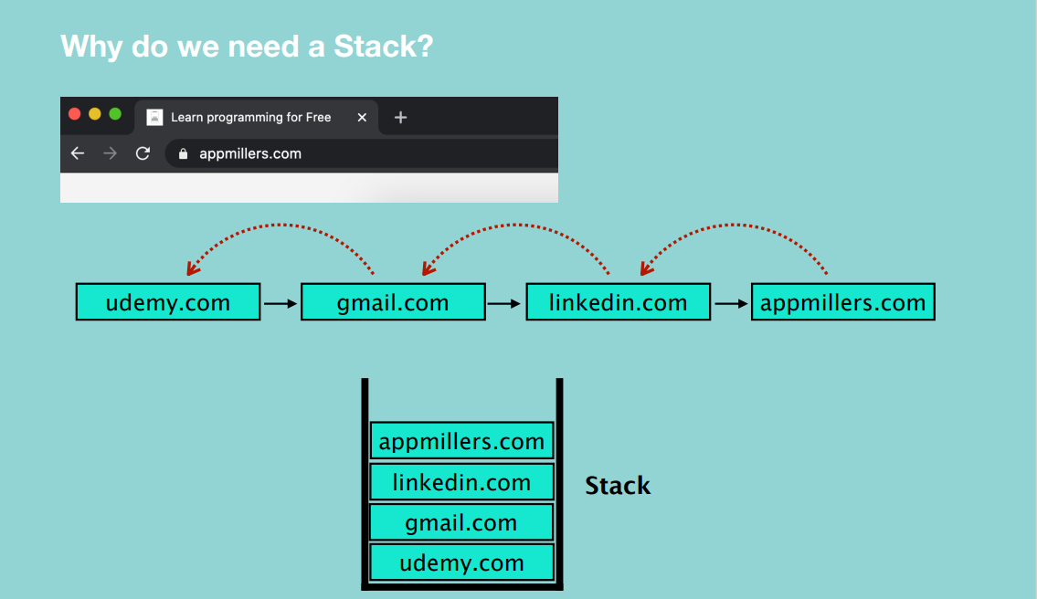

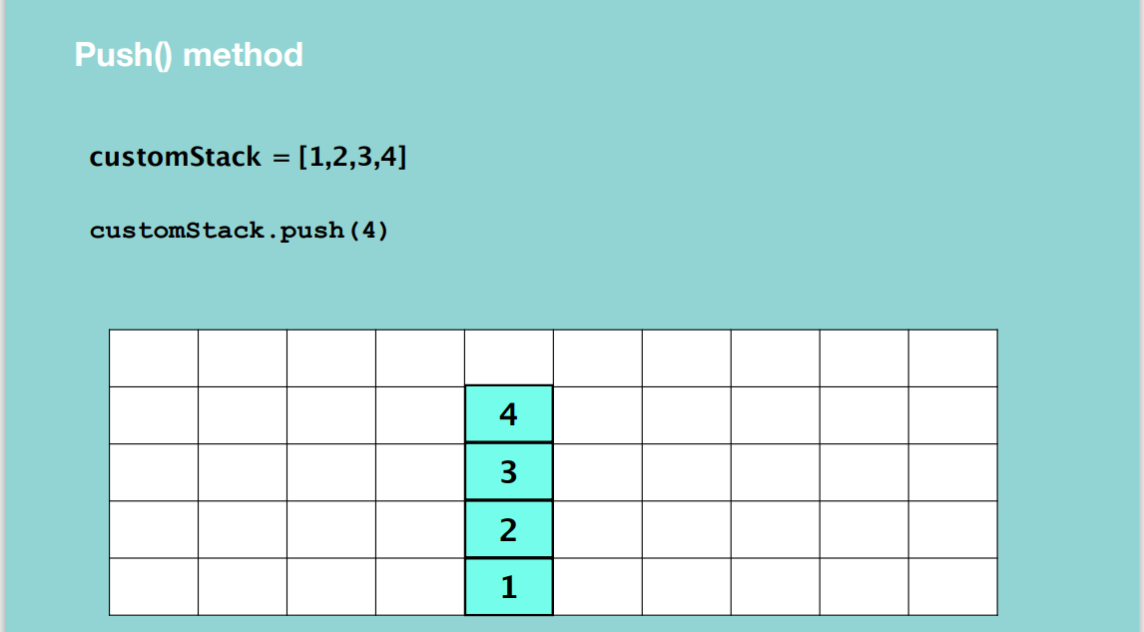

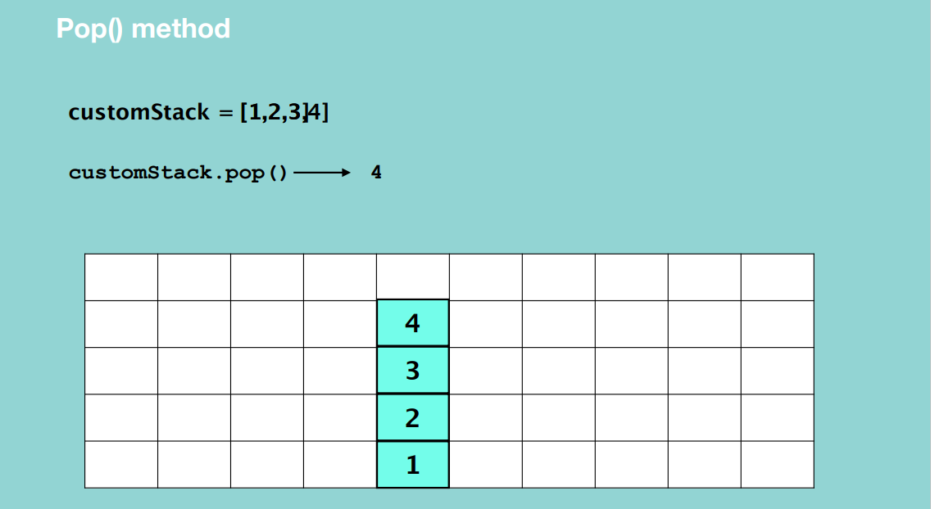

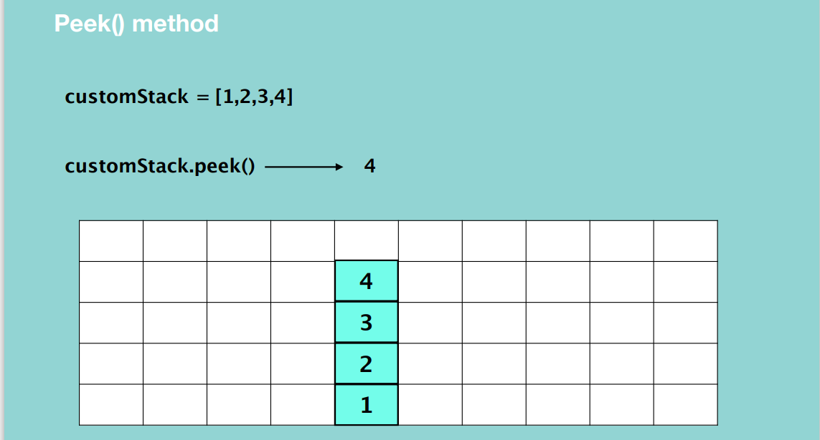

Just returns the top element of the stack DS.

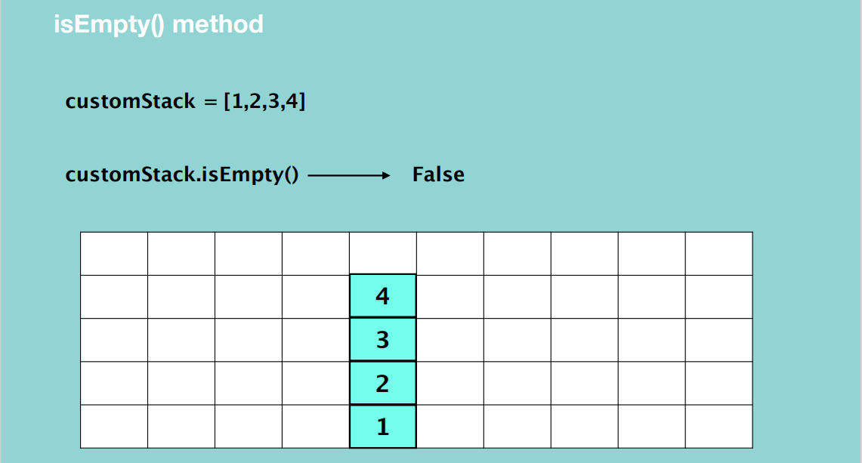

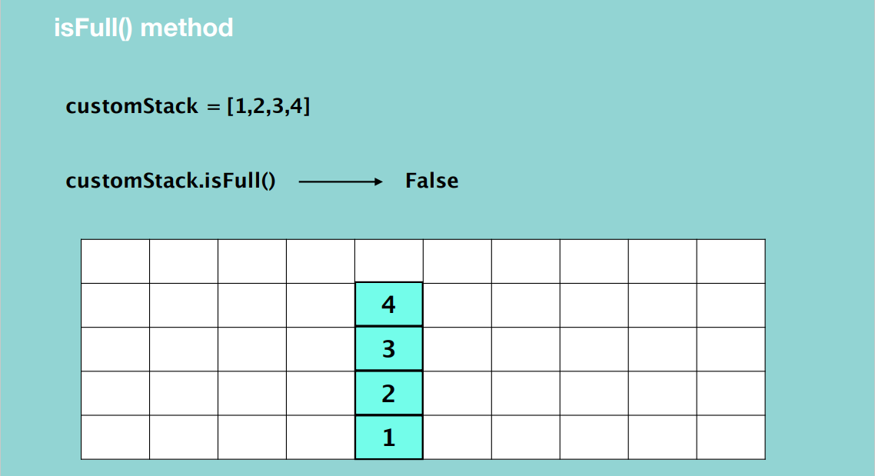

* Needed when you create a stack with size limit.

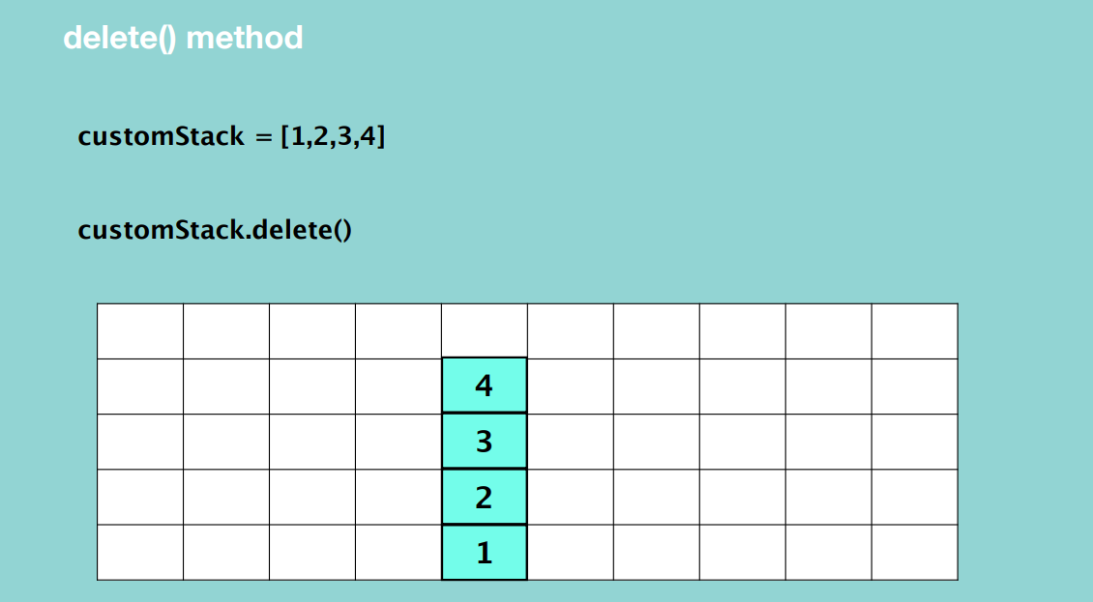

* Delete all elements from the stack.

**STACK creation**

Stack using List

* Easy to implement
* Speed problem when it grows because memory locations are contiguous hence there is an overhead for allocation.

Stack using Linked List

* Fast Performance because the memory locations are random
* Implementation is not easy

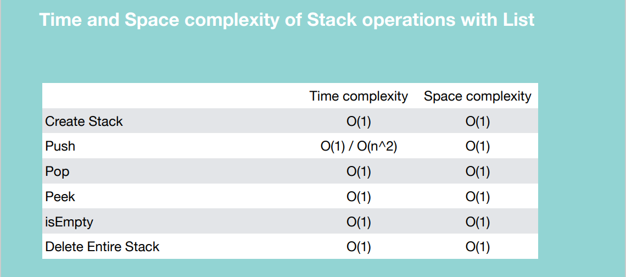

**Create a stack using linked list**

PUSH

* Create an object of the linked list class.
* Update the reference of the head reference to the new node.
* Update the reference of node 2 to the first node.
* Update the head reference to point to node.
* Update the reference of node 3 to node 2.
* Update the head reference to node 3.

Basically, you’re adding to the beginning of the linked list.

POP

* Update the head reference to the second node.
* Garbage collection takes place.

Basically, you’re deleting the node from the beginning of the linked list.

PEEK

* Just return the head value.

isEmpty()

* Just check if the head reference is None.

delete()

* Set the head reference to None.

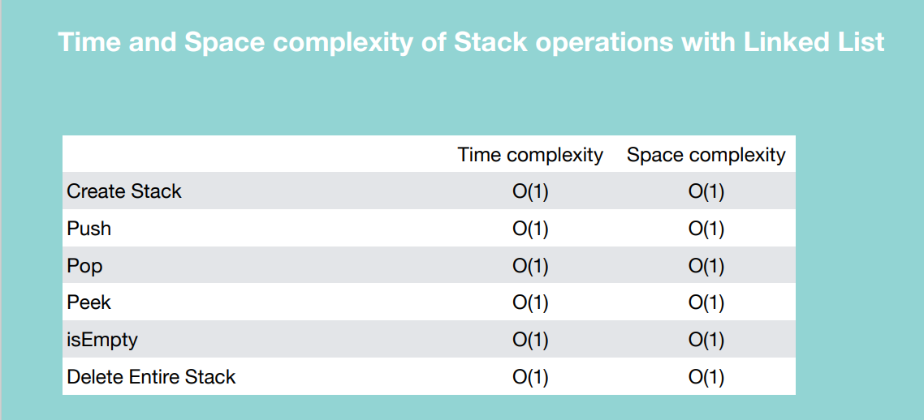

When to use / avoid Stack

Use:

* LIFO functionality
* The chance of data corruption is minimum (you cannot insert an element in the middle of the stack)

Avoid:

* Random access is not possible

**QUEUE**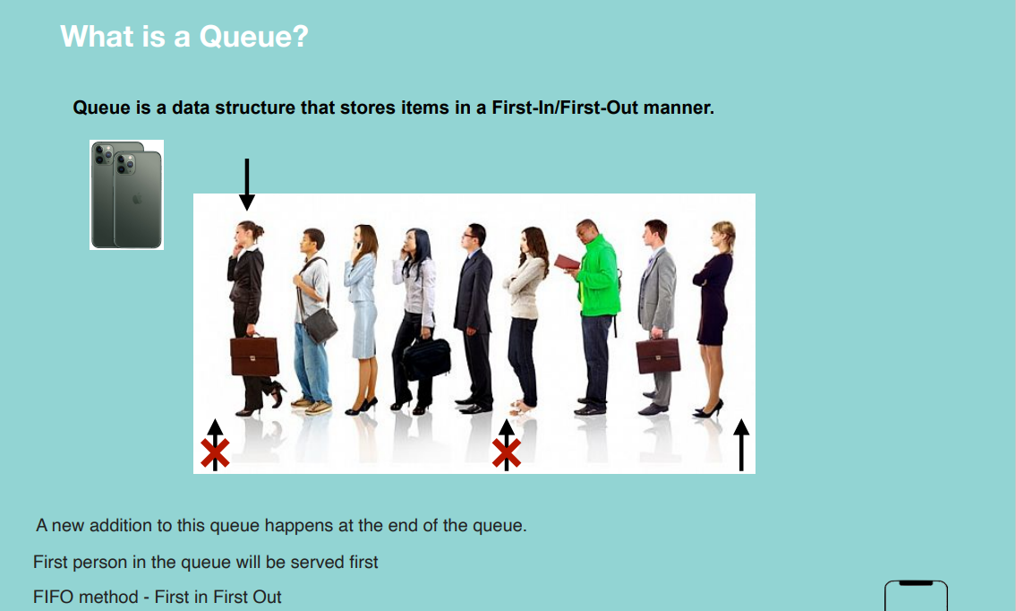

When we need Queue Data Structure?

* Point sale system of a restaurant
* Printer queue
* Call center phone systems

Implementation

1. Python List
   1. Queue without capacity (very time consuming)
   2. Queue with capacity (Circular Queue)
2. Linked List

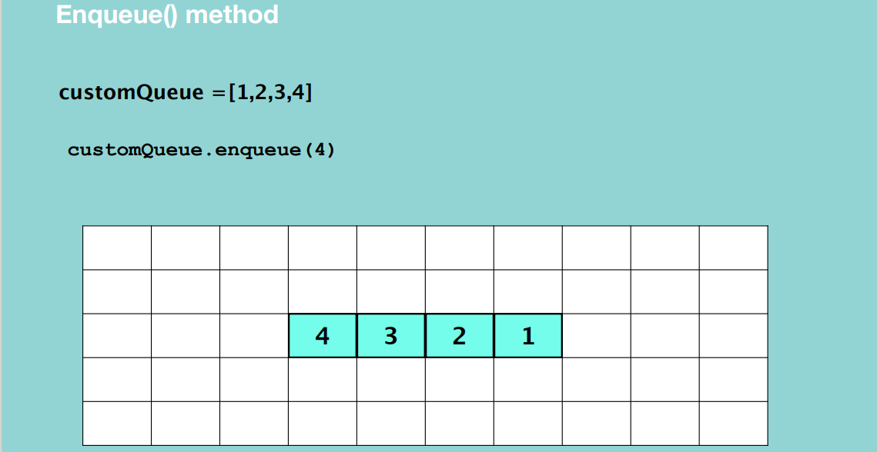

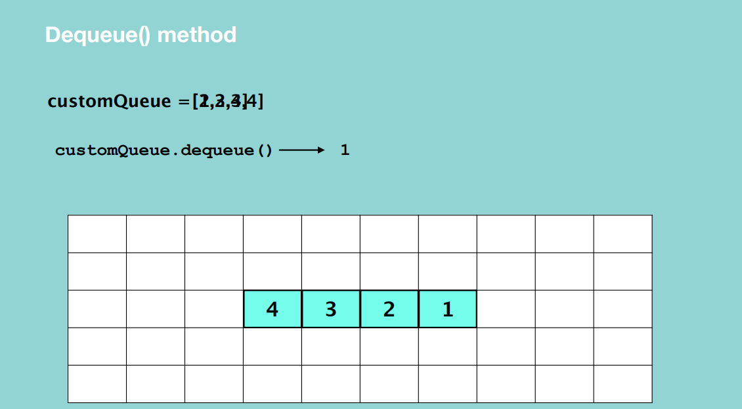

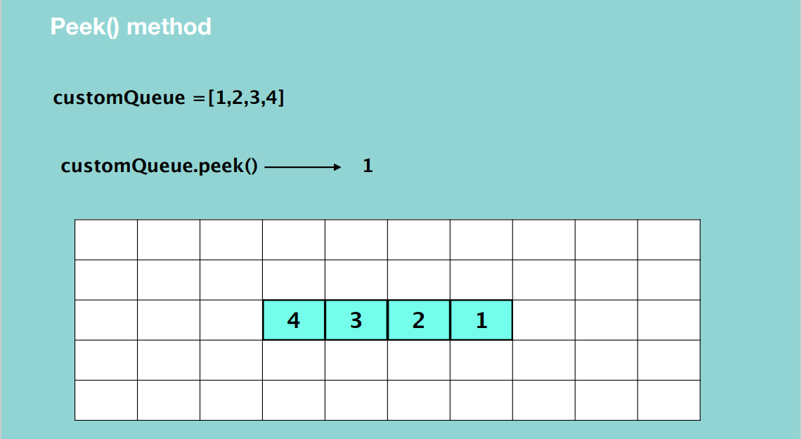

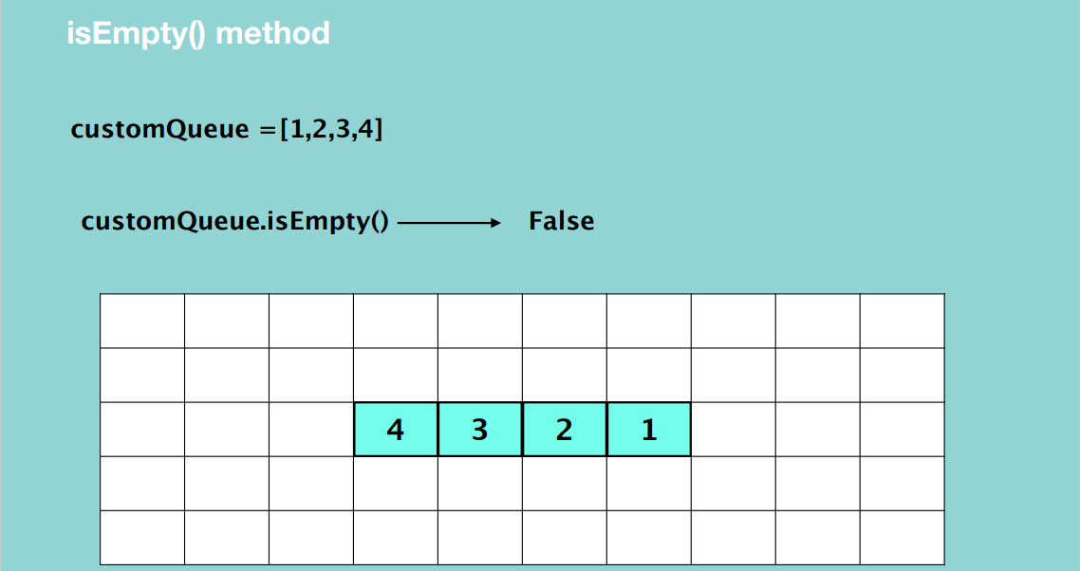

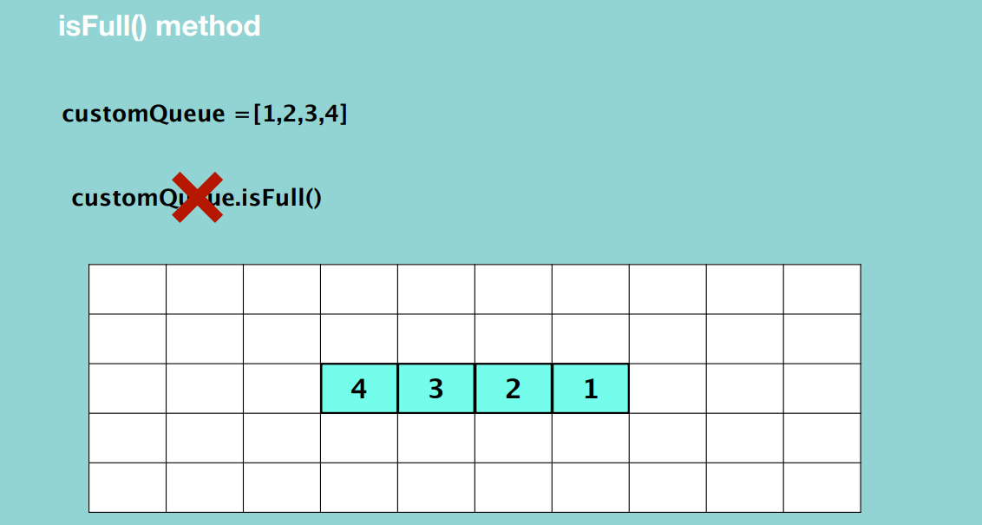

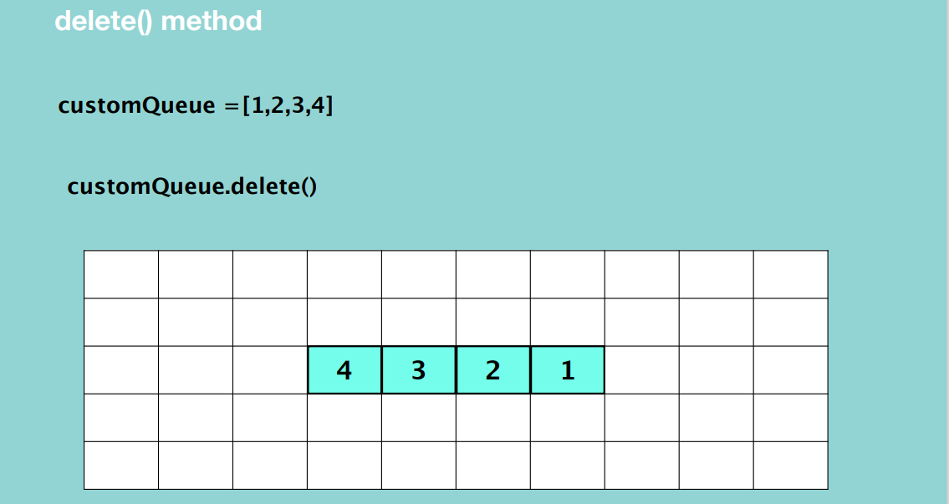

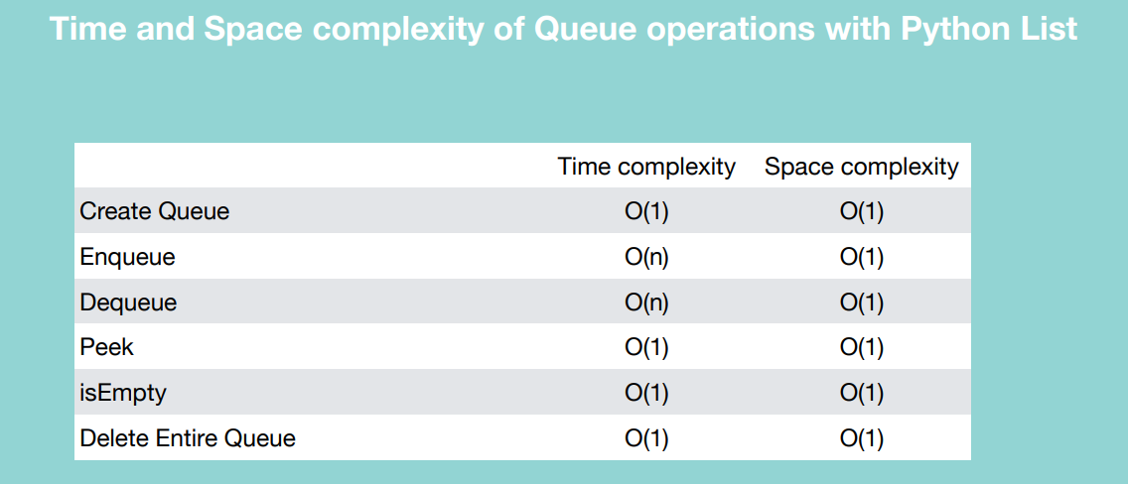

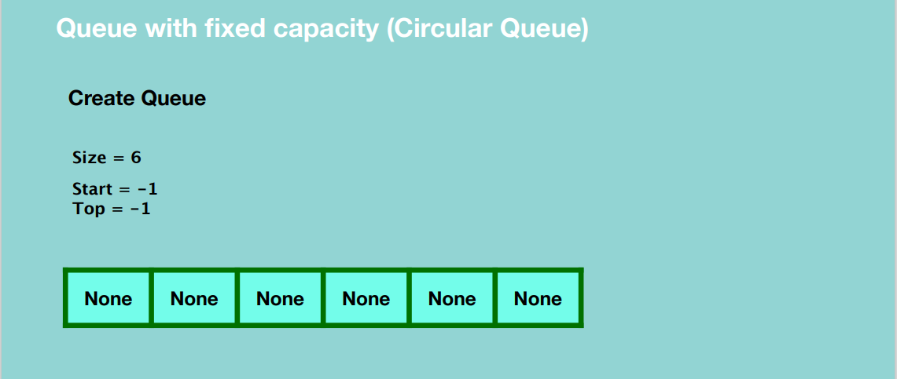

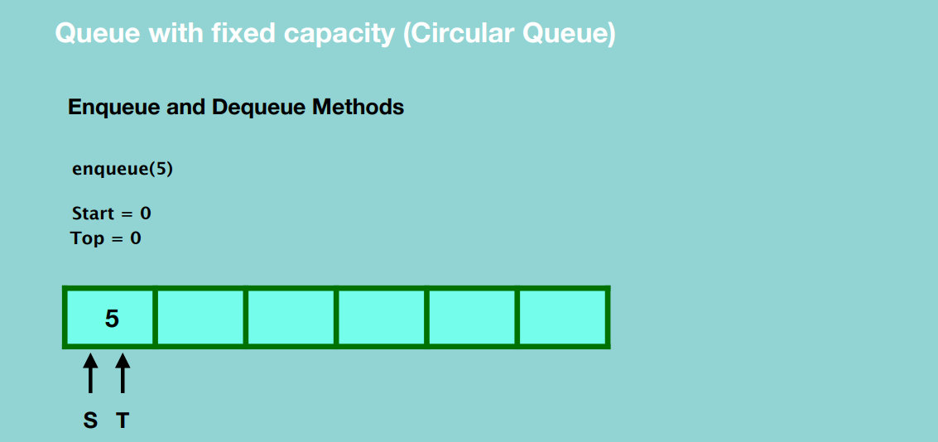

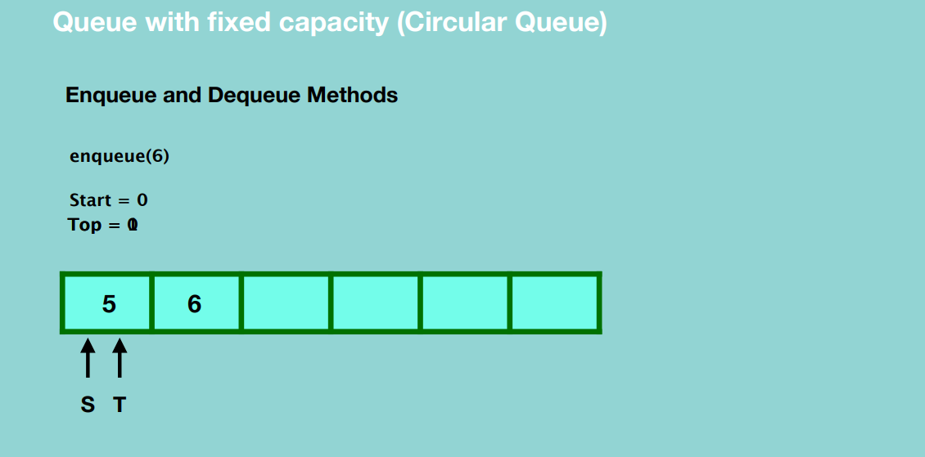

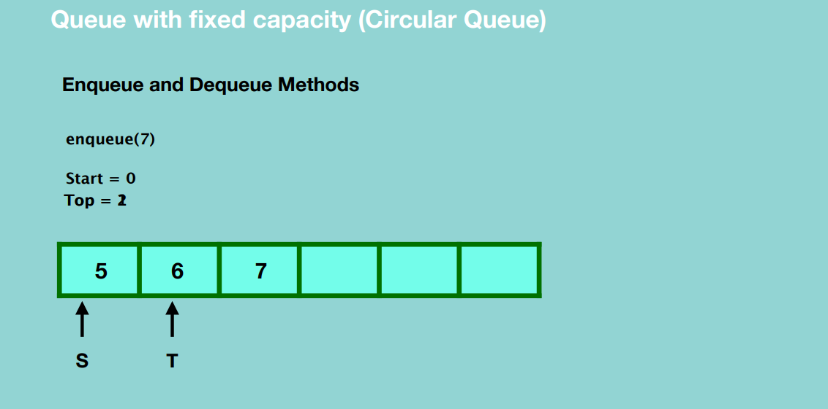

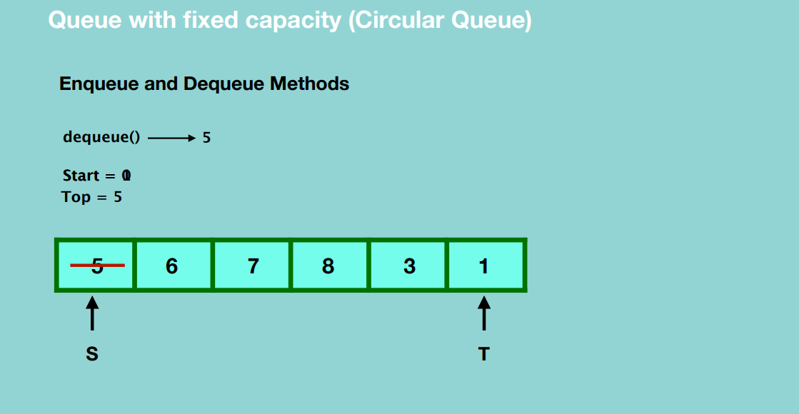

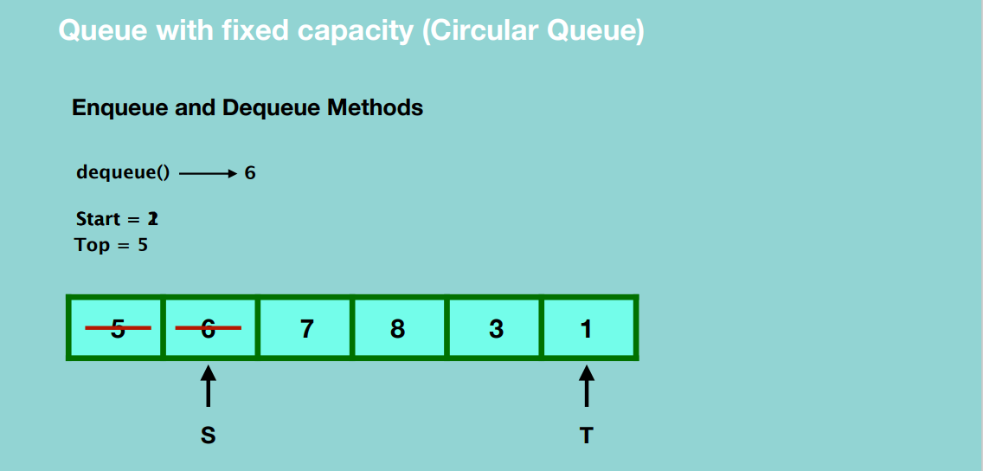

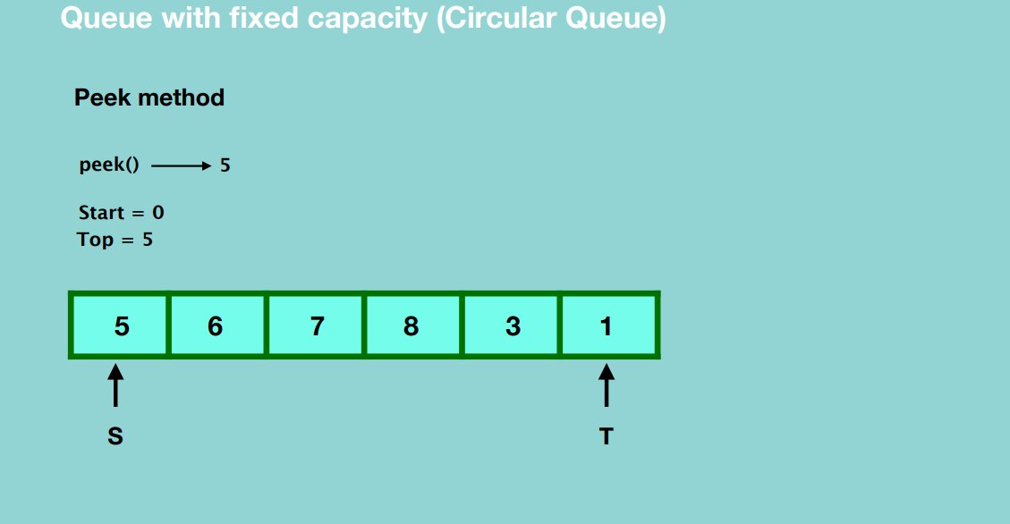

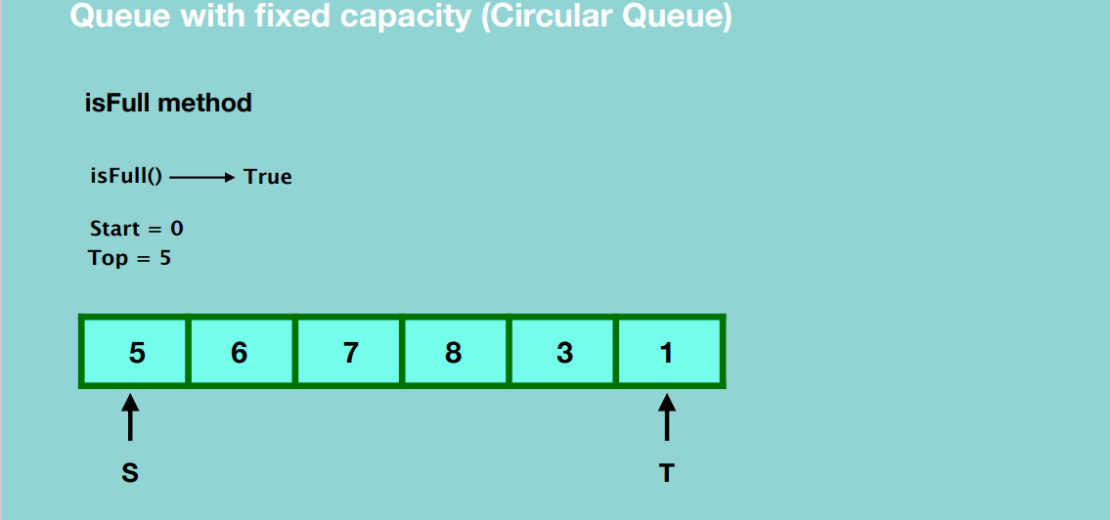

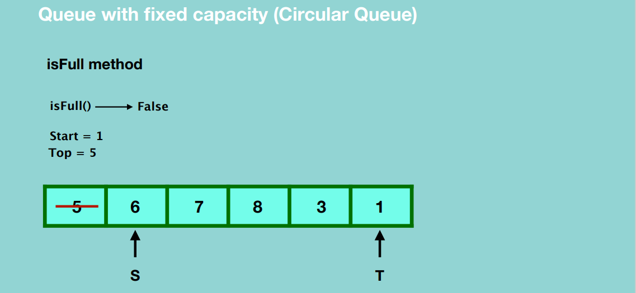

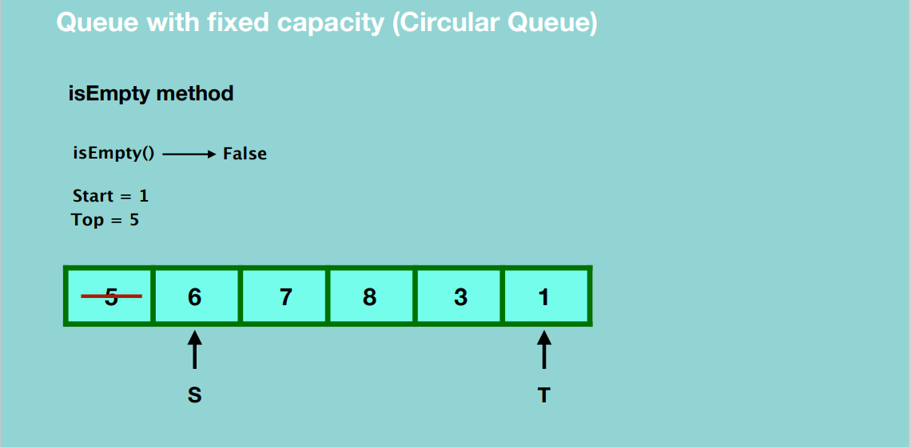

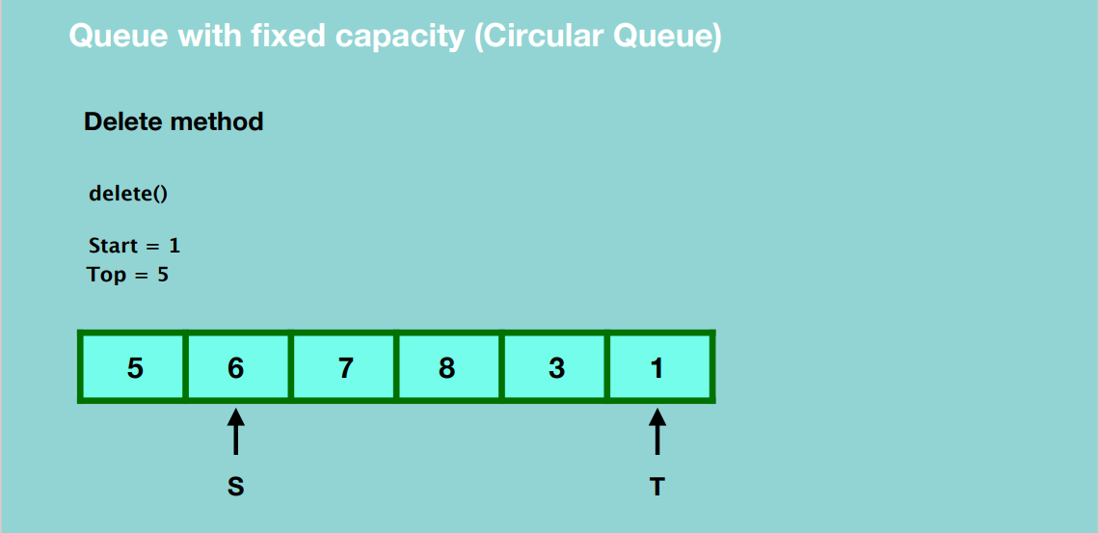

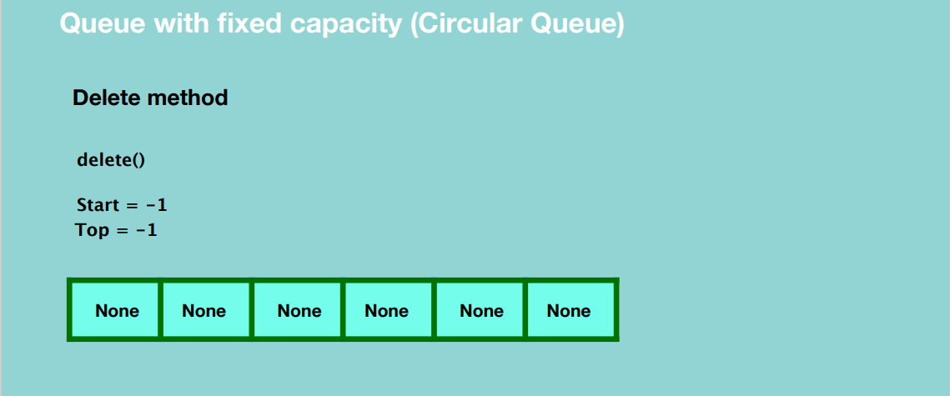

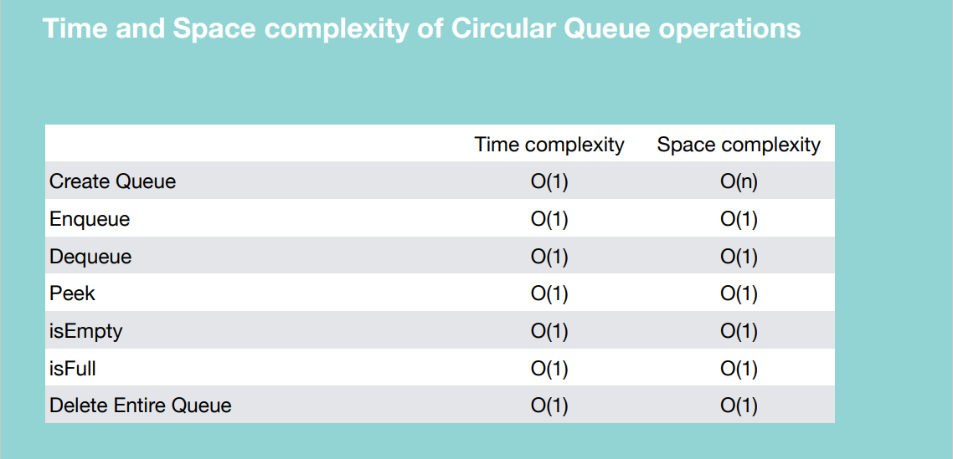

Queue using Linked List

Create a Queue

* Create an object of a linked list class

enQueue()

* Create a blank node and assign a value to it.
* Update the head reference and tail reference to point to the new node.
* To insert another node, create a new node and assign a value to it.
* Update the next reference of the first node to the new node.
* Update the tail reference to the new node.
* To insert another node, create a new node and assign a value to it.
* Update the next reference of the last node to the new node.
* Update the tail reference to the new node

So basically, you’re inserting a new node at the end of the linked list.

deQueue()

Basically, we remove the first element of the linked list.

* Update the head reference to point to the second node.
* Garbage collection takes place.

peek()

* Return the value of head.

isEmpty()

* If head is None, our queue is empty, otherwise it’s not empty.

**NOTE: We don’t have isFull method in a linked list.**

delete()

* Set the head and tail references to null.

Queue creation

Queue using List

* Easy to implement
* Speed problem when it grows

Queue using Linked List

* Fast Performance
* Implementation is not easy

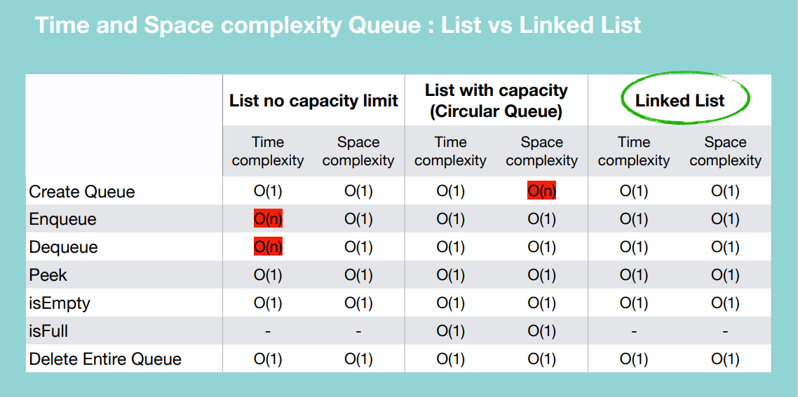

If you have few elements, you can use a list with no capacity limit. If you have many elements and don’t have to worry about space requirements, you can use the list with capacity. If you don’t want to use python lists and want efficiency throughout, use a linked list.

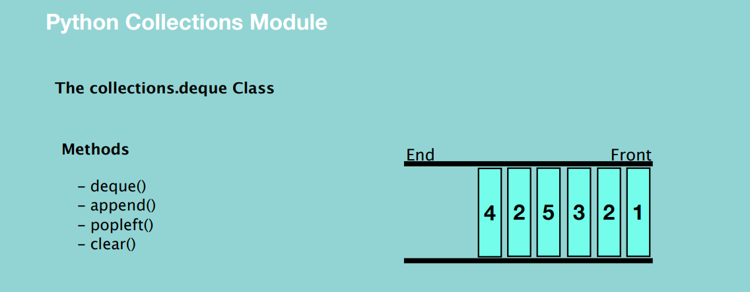

collections.deque class implements a double ended queue that allows adding and removing elements from either end. Here if the queue is full, it deletes the first element from the opposite end

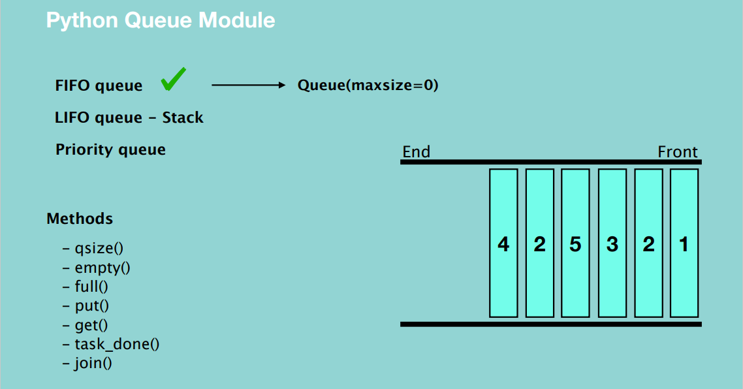

If maxSize is less than or equal to zero, then the queue size will be infinite.